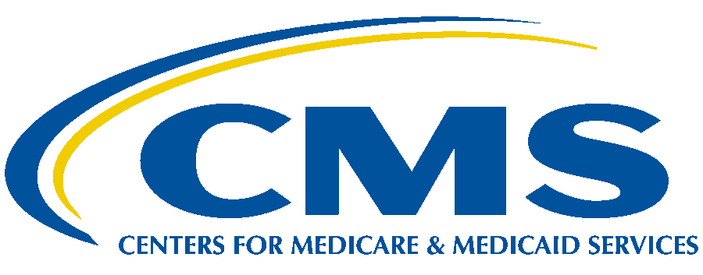

Department of Health & Human Services

Centers for Medicare & Medicaid Services

7500 Security Boulevard

Baltimore, Maryland 21244-1850

CENTER FOR MEDICARE

**ICD-10 Coordination and Maintenance Committee Update**

Department of Health and Human Services

Centers for Medicare & Medicaid Services

ICD-10-PCS Topics Open for Public Comment

Spring 2025

CMS will not be presenting the Spring 2025 ICD-10-PCS procedure code topics during a public meeting. Instead, CMS will be posting the meeting materials and soliciting public comments regarding any clinical questions or coding options consistent with the approach we have utilized as of March 2021 for the procedure code requests that involve a new technology add-on payment (NTAP) application for the administration of a therapeutic agent. The deadline to submit comments for procedure code topics being considered for an October 1, 2025 implementation is **April 18, 2025.**

Members of the public should send any questions or comments related to the procedure code topics that are under consideration for an October 1, 2025 implementation to the CMS mailbox at: [ICDProcedureCodeRequest@cms.hhs.gov](mailto:ICDProcedureCodeRequest@cms.hhs.gov) by the April 18, 2025 deadline.

All meeting materials and related documents will be made available on the CMS web site at <https://www.cms.gov/medicare/coding-billing/icd-10-codes/icd-10-coordination-maintenance-committee-materials>. Additionally, CMS will post a question-and-answer document to address any clinical or coding questions that members of the public may have submitted by the designated deadline.

**Note:**  Questions regarding the Diagnosis code topics should be directed to the Centers for Disease Control and Prevention’s National Center for Health Statistics at [nchsicd10cm@cdc.gov](mailto:nchsicd10cm@cdc.gov).