DISCRIMINATION BETWEEN LARGE AND SMALL HAIL
Final Report

Alexander Ryzhkov, Dusan Zrnic, John Krause,
Matthew Kumjian, and Scott Ganson

1. Introduction

This is one of four final reports provided by NSSL to Lincoln Laboratory. It documents work under task one and contains some material from the previous interim reports (Zrnic 2009, Zrnic 2010). We have concluded that estimation of hail size should be within the Hail Classification Algorithm (HCA). Currently the HCA has a category rain/hail which contains dry hail, wet hail, and hail mixed with rain. The challenge is to partition this category according to hail size. We propose a two phase approach. In phase one we gauge hail size of wet hail (often mixed with rain) at locations below the melting zone and have a crude estimate of size above the melting layer; this is reported herein. In phase two we will refine the algorithm in the dry hail category and extend it to include giant hail. Suggested modifications and a path towards an operational algorithm are presented.
The advantage of dual-polarization radar data in the discrimination of precipitation types has been demonstrated successfully, including the detection of hail among other precipitation echoes. Polarimetric method for hail detection is based on the assumption that differential reflectivity Z_{DR} of hail is low due to almost random orientation of hailstones, and the combination of low Z_{DR} and high reflectivity factor Z points to the presence of hail (Bringi and Chandrasekar 2001). Limited validation studies (e,g., Heinselman and Ryzhkov 2006; Depue et al. 2007) have demonstrated good overall skills of the method at S band. However, the most recent version of hydrometeor classification algorithm (HCA) for polarimetrically upgraded WSR-88D radars implies detection of “rain mixed with hail” (Park et al. 2009) and does not distinguish between large and small hail. According to the criterion of the National Weather Service, hail is considered large and capable to inflict substantial damage to property if its diameter exceeds 2.5 cm.
There were some attempts in the past to determine maximal hail size using conventional radar reflectivity factor (Witt et al. 1998) and combination of Z and Z_{DR} (Depue et al. 2006). The existing operational algorithm for hail detection utilized by single-polarization WSR-88D stipulates that maximal expected hail size (MEHS) can be estimated from the severe hail index (SHI) as (Witt et al. 1998)

MEHS=2.54 (SHI)^{0.5}, (1)

where the severe hail index is defined by
(2)

W(H) in (2) is a temperature (height) dependent weighting function (Fig. 1a) and E_{k} is the kinetic energy of hail (Fig. 1b). The NEXRAD conventional algorithm quantifies only the probability of large hail somewhere within the storm without specifying its precise location.
The advantage of the polarimetric method is that it provides better quality of hail detection and pinpoints the location of hail in the storm including its height above ground (Heinselman and Ryzhkov 2006). Depue et al. (2007) report on the polarimetric scheme for measuring hail size. These investigators used post-storm reports on the ground to build a comprehensive verification of their algorithm based on the use of hail differential reflectivity (H_{DR}) defined as (Aydin et al. 1986)

H_{DR} = Z – g(Z_{DR}) (3)
where
(4)
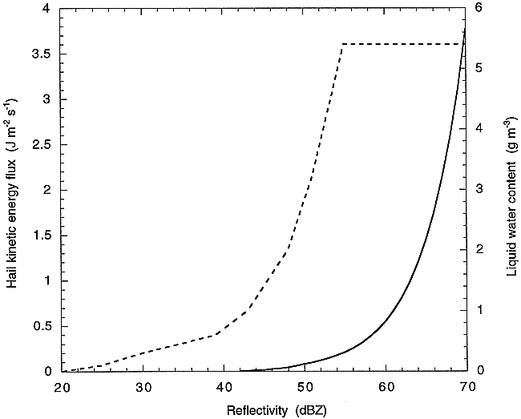
Weighting function, W(Height)
0º
-20º
1
(a) (b)
Fig. 1 a) The weighting function vs temperature (height) above ground used in predicting the threshold hail size that would be exceeded by 25% of observations on the ground. b) the hail kinetic energy (solid curve) as function of the reflectivity factor. The dashed curve is the liquid water content used in computation of the vertically integrated liquid (VIL).

Higher H_{DR} means larger hail. Fig. 2 adapted from their paper indicates maximal hail size versus the value of H_{DR} obtained from several hail events. Fig. 2 shows that on average H_{DR} > 30 dB signifies hail with size larger than 25 mm although the uncertainty associated with this simple rule is quite large.
In another study, Rowe et al. (2007) categorized hail into two groups based on the values of Z_{DR} and cross-correlation coefficient ρ_{hv}: category 1 with hail less than 1.75” in diameter and hail 1.75” or higher in diameter. The following conclusions are from the abstract of the Rowe et al. report. “RHI images revealed differences in the vertical structures of these categories; extended columns of low Z_{DR} and ρ_{hv} are observed for the larger hail. Also, vertical profiles, produced for each hail report, show a more substantial decrease in ρ_{hv} below the melting layer for hail 1.75” or larger. Although Z_{DR} appeared promising for estimating hail size, the discriminant analysis revealed that ρ_{hv} is the better variable to discriminate between the categories.”

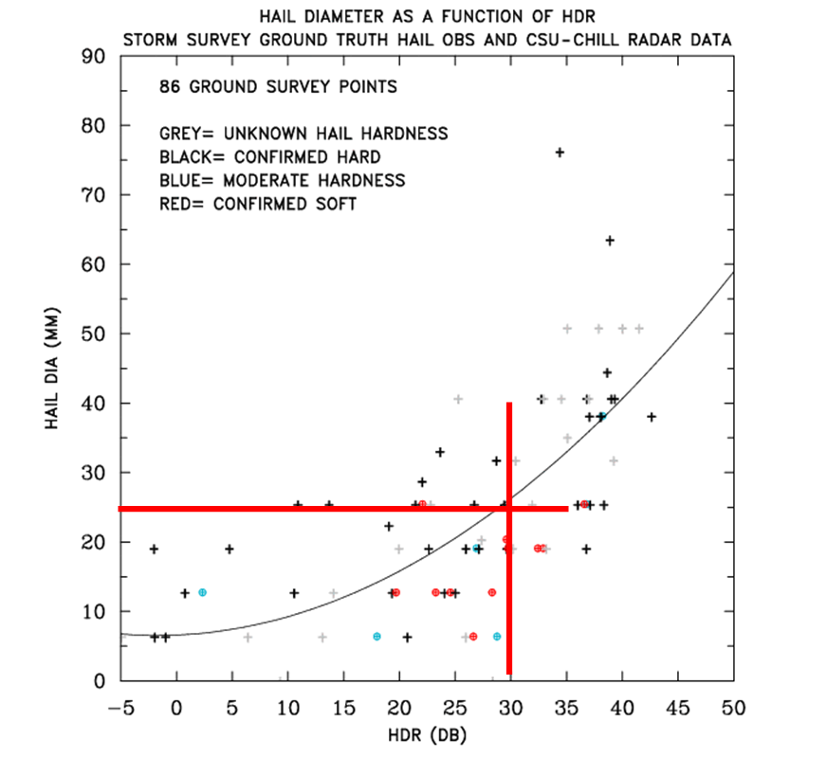
Fig. 2. Maximal hail diameter versus H_{DR} adapted from Depue et al. (2007). The gray curve is a second order polynomial fit, whereas the red straight lines (added by NSSL) partition the scattergram into region of hail larger than 25 mm and H_{DR} > 30 dB.

2. Challenges

Following the methodology and results listed in the introduction we have partitioned the Z, Z_{DR} space into regions corresponding to the three sizes (Fig. 3). This is a first guess. The 53 dBZ vertical line represents the value designated as hail in the current rainfall algorithm on the WSR-88D. The region of giant hail is implied by some observations implicating negative Z_{DR} and very large Z, although smaller Z values have also been associated with such hail. The other delineations are modified adaptations from Depue et al. (2007) and Aydin and et al. (1986). Superposed on Fig. 3 is the scattergram of data that has been classified as Hail/Rain by the HCA. The reflectivity field of this data is in Fig. 4a, where it can be seen that the storm system is comprised of a multitude of strong cells in a squall line. The field of classified hydrometeors is in Fig. 4b. The Rain/Hail (red areas) is recognized at distances from about 20 km to almost 300 km. Even at this low elevation (0.5 deg) the height of beam center in the region of 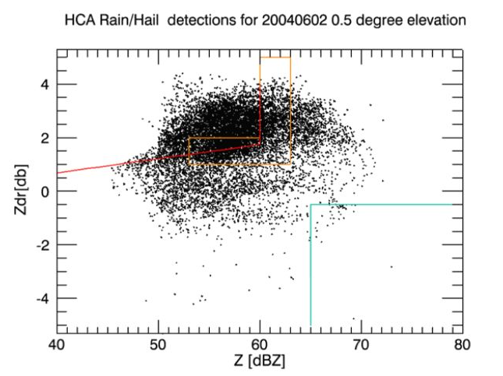
1”-2”
1”-2”
<1”
>5”
Rain
Graupel
Small Hail
Dry Hail ?
Wet Hail?
Giant Hail
Fig. 3 Scattergram Z_{DR}, Z from El = 0.5 deg of data that were classified as Hail/Rain category. Storm occurred on June 2, 2004.

Rain/Hail changes from 170 m to about 9.3 km. Therefore a substantial variety of Rain/Hail regime (sizes, wetness etc.) is expected.

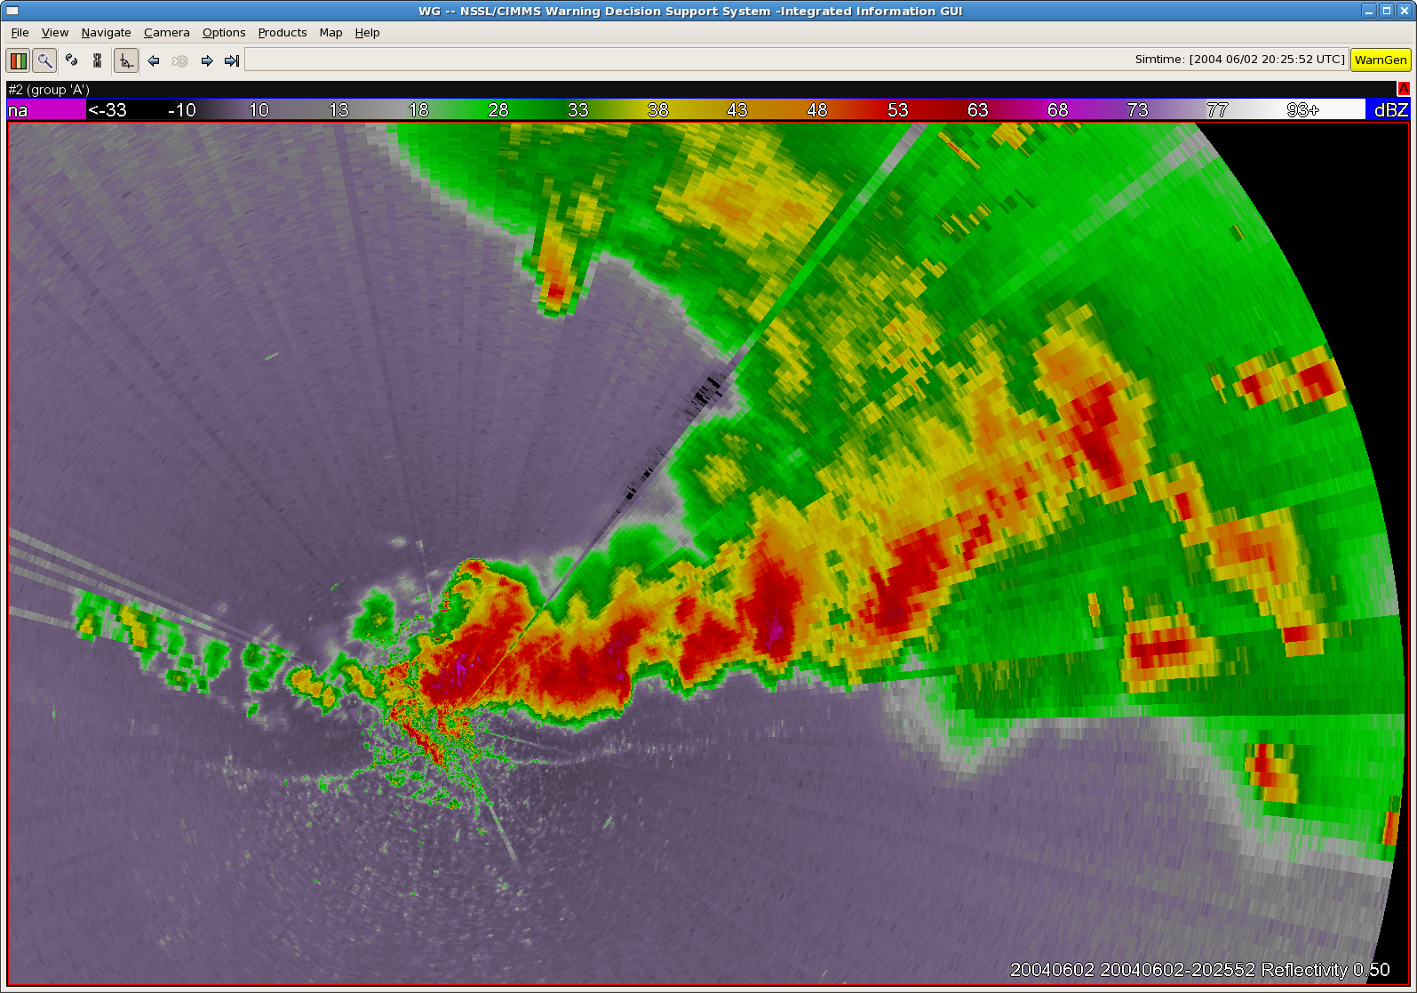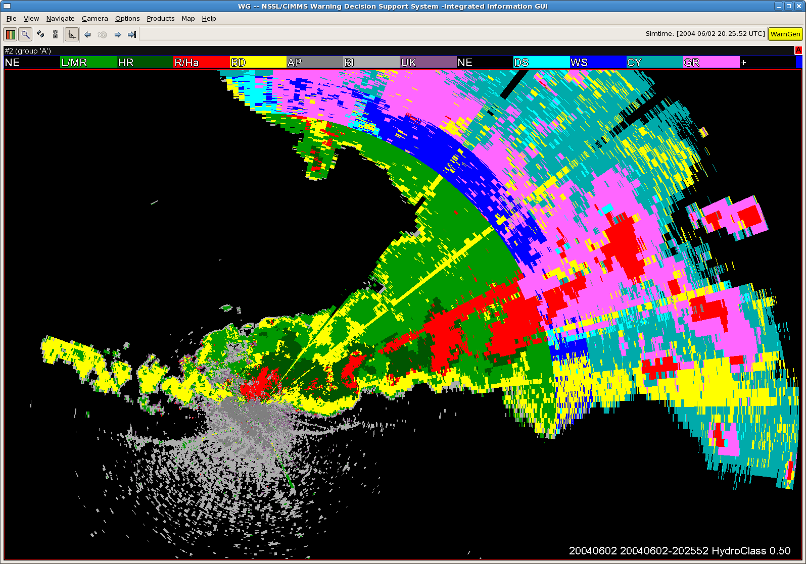

Fig. 4a). Squall line of June 2, 2004, obtained with the KOUN polarimetric weather radar. The end range is 300 km, and elevation is 0.5 deg. b) Results of the hydrometeor classification algorithm. The red color indicates Rain/Hail class.
Returning to Fig. 3 we speculate that the inverted L shaped region is where there is abundant presence of hail between 0.5 and 1”. The circled Wet Hail is a guess based on high Z and relatively modest (< 2 dB) Z_{DR}; it should be understood that these partitions are fuzzy and therefore partially overlap each other. Our location of the circle makes for a handy comparison with the scattergram from 4.5 deg (Fig. 5). Within and around the region marked with an ellipse we expect relatively dry hail, or spherical relatively small hail?
In Fig. 5 is the scattergram from elevation of 4.5 deg. Clusters within the ellipse and circle are evident. Interpretation is not! The horizontal offset of the two clusters is about 10 dB, and part of it could be due to the difference in refractivity of hail (pure ice) and water coated hail? Clearly, correct association of size with points within the Z, Z_{DR} plane is not trivial. Scattergrams like these are helping build boundaries for our decision regions. Eventually elements of fuzzy logic will be added to the decision boundaries. 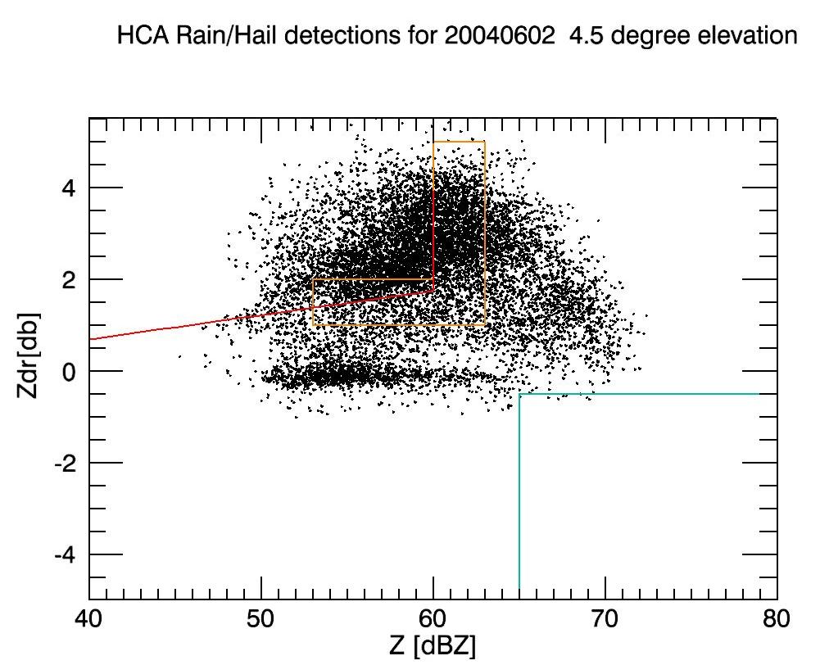
Giant Hail
Wet Hail?
Dry Hail ?
Rain
Graupel
Small Hail
1”-2”
1”-2”
>5”
<1”
Fig. 5 Scattergram Z_{DR}, Z from El = 4.5 deg of data that were classified as Hail/Rain category. In the inverted L region hail is between 0.5 and 1 inch. Storm occurred on June 2, 2004.

What emerges from Fig. 3 and 5 is that the region of Hail is fairly well defined. The mixture of Rain and Hail spans across the boundary but clues about Hail size are not obvious. Although useful to indicate Rain/Hail additional information is required to sort out the size. To illustrate this point we present in Fig. 6 scattergrams of Z_{DR}, Z from a
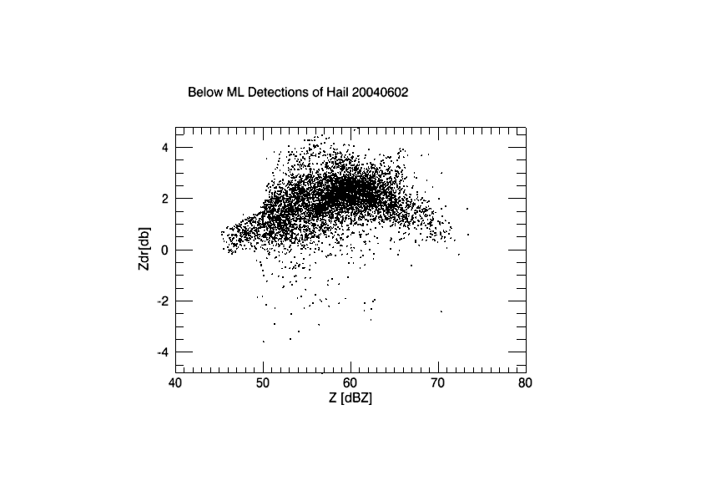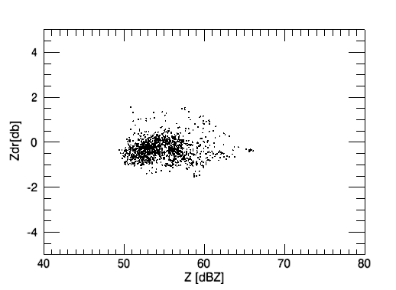
a) b)
Fig. 6 Scattergrams of Z_{DR}, Z of Rain/Hail class: a) From below the melting layer. b) From above the melting layer. Data are from a volume scan of June 2, 2004 (same as in Figs. 3 and 5).

whole volume scan but stratified by values below the melting layer (Fig. 6a) and above the melting layer (Fig. 6b). There is almost no overlap of the two scattergrams and the one from above the melting layer has significantly smaller area and hardly any contribution by rain as most Z_{DR} values are less than 0.5 dB; it is likely that some graupel, small, and large dry hail contributed to this scattergram. The scattergram from below the melting layer has contributions by rain, drops with ice cores, and melting hail spanning a large range of sizes.
Clearly the main limitations of the previous methods is that they do not take into account the process of hail melting, which has a very strong impact on the vertical profile of Z_{DR} as demonstrated in Fig. 6. Indeed, if large melting hail is mixed with rain originated from complete melting of smaller graupel / hail, the resulting Z_{DR} can easily exceed 1.74 dB in (4) and the condition H_{DR} > 30 dB is equivalent to Z > 90 dBZ, which makes little sense. This consideration indicates that the rules for determination of large hail should depend on the height of the radar resolution volume with respect to the freezing level in the storm and the method for estimating hail size should be substantiated by the retrievals from cloud models that explicitly treat microphysics of melting hail. Also, the discriminatory value of the correlation coefficient ρ_{hv} should be investigated.

3. Microphysical models of melting hail

Next we discuss two microphysical models of melting hail that we have utilized to formulate the rules for polarimetric discrimination between small and large hail. Similar to earlier works of Aydin and Zhao (1990), Aydin and Giridhar (1991), and Vivekanandan et al. (1990), one of the models (Model 1) makes use of the Rasmussen and Heymsfield (1987) study of the physics of individual melting hailstone. It assumes certain distribution of graupel / hail at the freezing level and follows the change of the size distribution of partially melted ice particles / raindrops and the corresponding polarimetric radar variables as hydrometeors (totally or partially melted) reach the ground. This is a steady state 1D model which takes into account shedding of excessive water from the surface of melting hailstones but does not allow for interactions / collisions between the particles of different original sizes.
The second model (Model 2) is the 2D nonhydrostatic mixed-phase spectral bin Hebrew University of Jerusalem Cloud Model (HUCM) (e.g., Khain et al. 2004). The model contains 7 classes of hydrometeors and each class is represented by size distribution functions in 43 size bins. As opposed to Model 1, this model explicitly describes both generation and melting of hail and takes into account all sorts of interaction between hydrometeors.
The output of both models is converted to the vertical profiles and fields of radar reflectivity Z, differential reflectivity Z_{DR}, specific differential phase K_{DP}, and cross-correlation coefficient ρ_{hv}. The scatterers are modeled as uniformly filled oblate spheroids with symmetric Gaussian distribution of orientations with respect to the vertical and variable width of the canting angle distributions σ. Aspect ratio and parameter σ of mixed-phase hydrometeors linearly depend on mass water content which changes across size spectra. The combination of simple Rayleigh formulas and T-matrix codes is used for computation of backward and forward scattering amplitudes (see details in Ryzhkov et al. 2010).

4. Polarimetric discrimination between small and large hail using Model 1

The advantage of Model 1 is that it allows studying the impact of size distribution of graupel / hailstones aloft on vertical profiles of radar variables in the most direct and straightforward way. In situ measurements of size distribution of ice particles aloft in hailstorms often reveal bi-exponential type of particle spectra with different slopes for graupel-size and hail-size hydrometeors (Smith et al. 1976; Spahn and Smith 1976). In our simulations with Model 1, we prescribe bi-exponential size distribution of graupel / hail at the freezing level as

, (5)

where subscripts “g” and “h” stand for graupel and hail respectively. The parameters N_{g} = 8000 m⁻³ mm⁻¹ and Λ_{g} = 1.6 mm⁻¹ in (5) are selected in such a way that the “graupel” part of size spectrum yields size distribution of raindrops at the surface which is close to the Marshall – Palmer and the corresponding values of Z and Z_{DR} at S band are 52.2 dBZ and 2.29 dB respectively. These are in agreement with typically observed values of Z and Z_{DR} in heavy rain without hail in Oklahoma (Ryzhkov et al. 2005).
The choice of parameters N_{h}, Λ_{h}, and D_{max} (maximal hail size) is dictated by the need to match resulting size distributions of ice cores close to the surface with the observed hail size distributions reported in literature (Ulbrich and Atlas 1982; Cheng and English 1983; Cheng et al. 1985). Parameters D_{max} and Λ_{h} at the freezing level were selected in such a way that the product of their corresponding values at the surface is equal to 7.9 – its most likely value as reported by Ulbrich and Atlas (1982). Experimental studies of Cheng and English (1983) and Cheng et al. (1985) also show that the intercept N_{h} and slope Λ_{h} are generally correlated so that

(6)

where the factor C changes from 200 for small hail to 800 for large hail if N_{h} is expressed in m⁻³mm⁻¹ and Λ_{h} is in mm⁻¹.
The computations in Model 1 have been performed assuming that the freezing level is at 4 km, temperature lapse rate is 6.5 deg/km, relative humidity is 100%, and original density of ice particles is equal to the one of solid ice (0.92 g/cm³).
Figs. 7 and 8 illustrate the dependencies of Z and Z_{DR} at different heights on maximal hail size at the freezing level. Red and blue polygons (for C and S bands correspondingly) show variability of these dependencies if the slope Λ_{g} changes from 1.6 to 1.7 mm⁻¹ and the intercept N_{h} changes by a factor of 2 for a given value of D_{max}. Although these plots do not encompass full variability of hail and rain size distributions for a given maximal hail size at the freezing level, they provide some guidance on how to define the rules for discrimination between small and large hail at S and C band at different heights of the radar sampling volume with respect to the freezing level. Note nonmonotonic behavior of Z_{DR} at lower levels with increasing hail size (Fig. 8). The presence of smaller hail tends to increase Z_{DR} at both radar wavelengths because most of smaller hailstones with initial diameters less than 15 mm melt entirely producing large raindrops with high intrinsic Z_{DR}. Bigger hailstones do not melt completely and offset high Z_{DR} associated with the rain part of the size spectrum. This fact also explains the reduction in the difference between Z_{DR} at S and C bands for larger hail sizes. Significantly higher Z_{DR} at C band compared to S band is attributed to stronger effects of resonance scattering
Using the dependencies in Figs. 7 and 8, we can formulate simple rules on how to distinguish between large (D > 25 mm) and small (D < 25 mm) at different heights below the freezing level using measurements of Z and Z_{DR}. The following set of rules can be recommended at S band. Large hail is identified if

Z > 60 dBZ if H > H_{FL}

Z > 60 dBZ and Z_{DR} < 0.5 dB if 0 < H_{FL} – H < 1 km

Z > 62 dBZ and Z_{DR} < 1.5 dB if 1 < H_{FL} – H < 2 km (7)

Z > 59 dBZ and Z_{DR} < 1.9 dB if 2 < H_{FL} – H < 3 km

Z > 57 dBZ and Z_{DR} < 2.3 dB if H_{FL} – H > 3 km

where H_{FL} is the height of the freezing level and H is the height of the center of the radar resolution volume.

5. Polarimetric discrimination between small and large hail using Model 2

The model 2 with explicit microphysics does not prescribe any particular form of hydrometeor size distributions and is expected to simulate more realistic size distributions of hail compared to a more idealistic Model 1. A hailstorm observed in central Oklahoma with the NSSL KOUN S-band polarimetric radar on 10 February, 2009
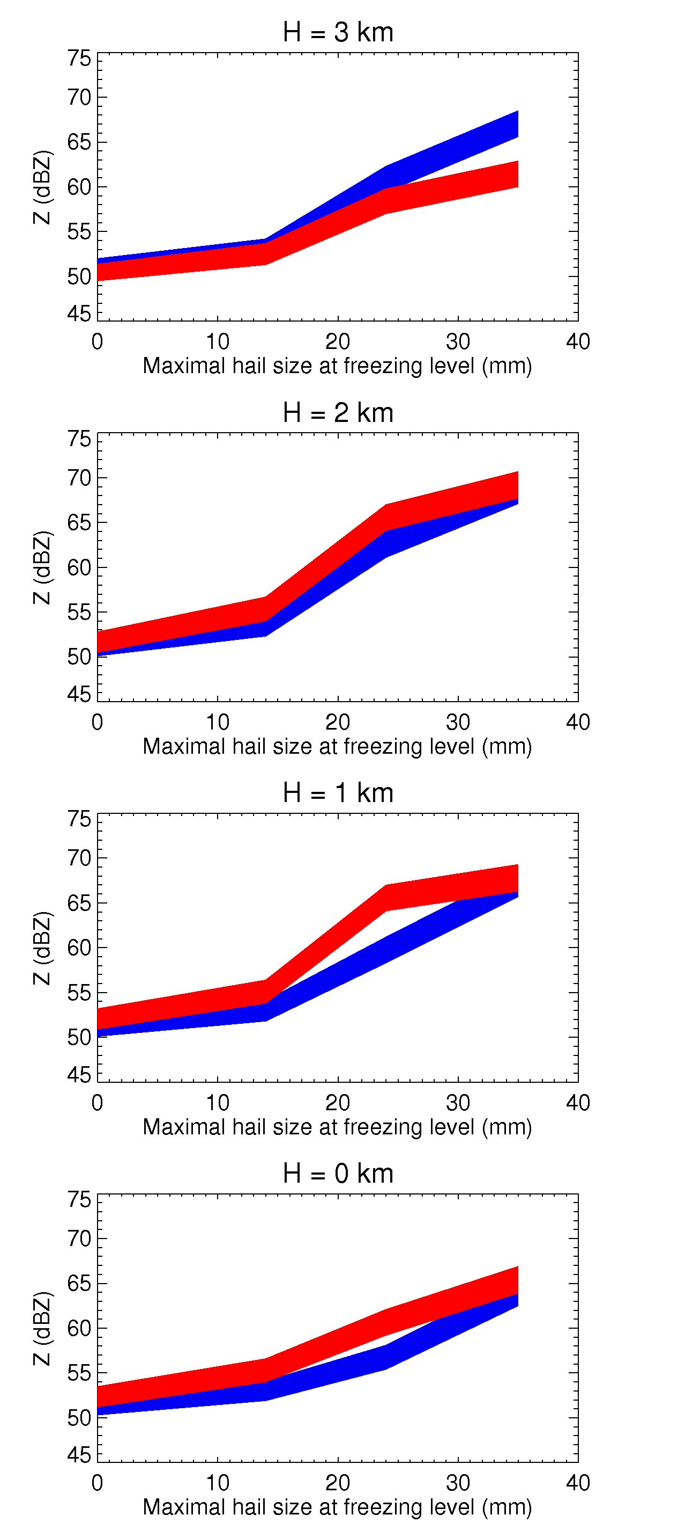
Fig. 7. Dependencies of Z on maximal hail size at the freezing level for variable Λ_{g} and N_{h}. It is assumed that Λ_{h}D_{max} = 7.9 (Ulbrich and Atlas 1982). Blue and red polygons depict results of simulations for S and C bands respectively.

was selected for simulation using the Model 2. During the afternoon of that day, a line of several damaging supercell thunderstorms developed across the western and northern portions of the Oklahoma City metro area. From 2109 UTC to 2125 UTC, the radar reflectivity measured by KOUN increased to about 72 dBZ. Hail up to 7 cm in diameter was reported on the ground. The height of the freezing level H_{FL} was about 3 km on that day. A detailed analysis of simulation results and their comparison with KOUN measurements are described in the paper by Ryzhkov et al. (2010).
Comparison with radar measurements shows that the HUCM cloud model combined with the radar observation operator developed at NSSL (Model 2) produces realistically looking fields of polarimetric radar variables and captures quite well polarimetric signatures commonly observed in severe convective storms. These include the transition from frozen to liquid hydrometeors within the melting layer, Z_{DR} columns associated with convective updrafts, and signatures of melting hail in the downdraft areas. The model reproduced realistic size distributions of rain and hail with hailstones of several centimeters in diameter observed on the
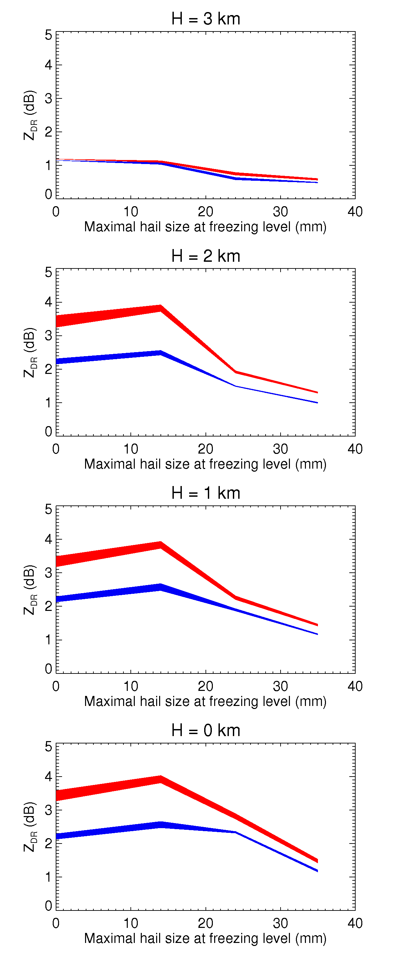
Fig. 8. Same as in Fig. 7 but for Z_{DR}
ground as well as very high values of reflectivity measured by the radar. The results of simulations underscore the importance of accurate treatment of the process of melting which implies taking into account the variability of mass water fraction across size spectra of melting particles. The model confirms an enhancement in the concentration of largest raindrops as a result of hail shedding which was first emphasized by Ryzhkov et al. (2009). Such an enhancement has strong impact on the polarimetric radar variables.

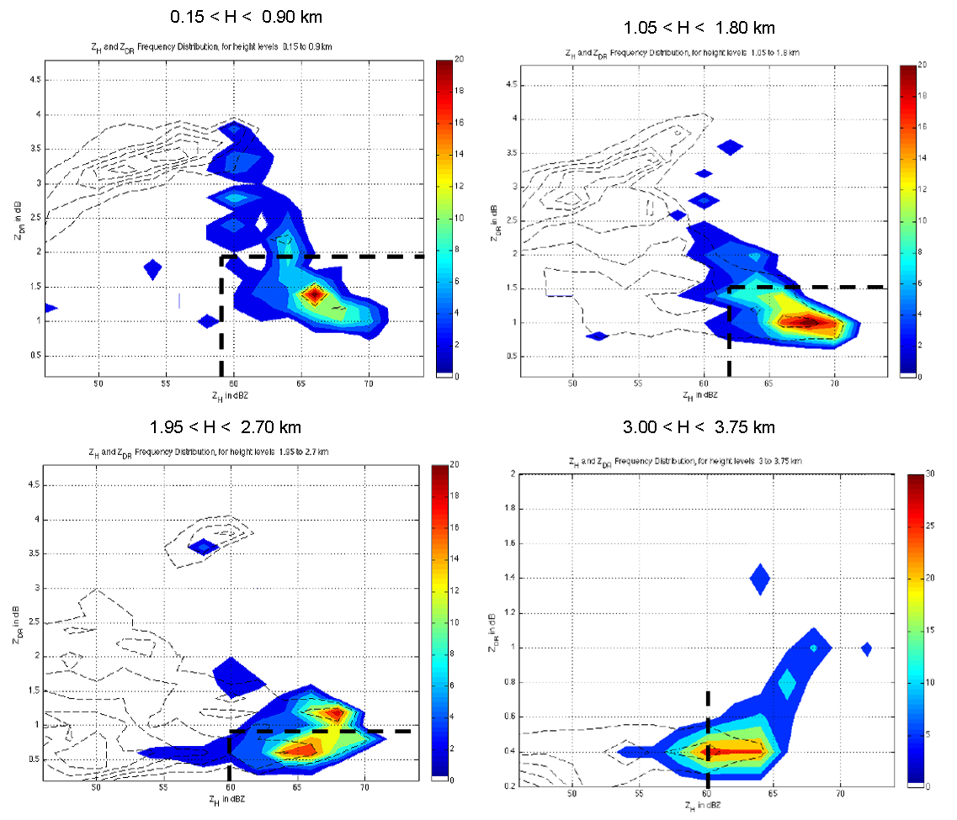
Fig. 9. 2D frequency distributions of Z and Z_{DR} occurrence in grid cells that contain appreciable LHM (large hail mass - shaded contours) and SHM (small hail mass - dashed contours) are plotted in Fig. 5 for different height (H) intervals as retrieved from the HUCM model for the simulated case of February 10, 2009. The height of the freezing level was about 3 km AGL. Dashed lines correspond to discrimination rules (7).

To quantify the amount of large hail, the output from the HUCM was converted to mass and the mass bins for hail larger than 2.5 cm (1”) were summed to obtain what we call the large hail mass (LHM). A certain LHM threshold was selected to exclude from statistics the model grid cells with very small (practically insignificant) large hail mass. The minimum threshold was chosen quasi-subjectively based on the large hail total concentration: one hailstone per grid cell in the model (0. 35 x 0.15 km). This is equivalent to assuming a minimum total number concentration of large hailstones of 10⁻⁵ m⁻³ which is consistent with similar definition (expressed via hail flux) of Milbrandt and Yau (2006). Similar to large hail mass, the small hail mass (SHM) was determined as the total mass of hailstones with sizes between 1 and 2.5 cm.
Z and Z_{DR} were computed for each model grid cell (after several hours of model run) and the 2D frequency distributions for Z and Z_{DR} occurrence in grid cells that contain appreciable LHM and SHM are plotted in Fig. 9 for different height intervals. The shaded colors indicate the frequency of occurrence of large hail, whereas the dashed black contours indicate the small hail mass frequencies. The dashed bold lines enclose the box delineating large hail according to the suggested algorithm (7) for discrimination between large and small hail. Fig. 9 shows that the HUCM cloud model retrievals confirm the inferences from 1D simpler model. It also illustrates the differences between polarimetric characteristics of the storm areas containing small and large hail which are especially well pronounced at lower levels.
The scattergrams presented in Fig. 10 are from the 1 June 2008 supercell storm that produced hail up to the size of grapefruit. Different panels correspond to different
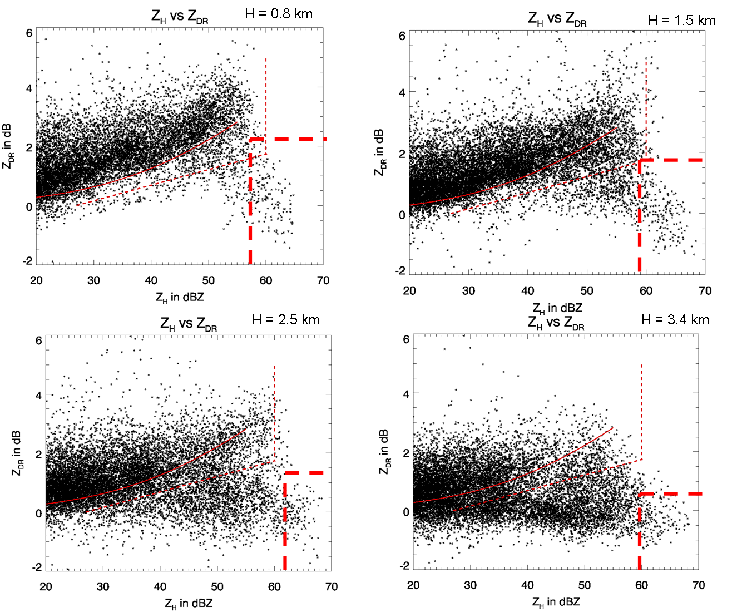
Fig. 10. Scatterplots of measured Z and Z_{DR} at different height levels for the storm on June 1, 2008 which produced grapefruit-size hail. The red dots lines delineate the discriminator from Aydin et al. (1986) and the red curve is from Cao et al. (2008).

heights of the center of the radar resolution volumes above ground. The environmental melting level is at 4.3 km AGL. The updraft-perturbed melting layer following a surface-based parcel is closer to 5.2 km AGL. This case is selected because the data were collected in rapid-scan mode, providing only 6 seconds between each elevation angle. This adds strong credibility to comparisons of scans from different heights, as fewer changes in storm structure are expected over such small time periods. A more detailed description of the storm on June 1, 2008 case is contained in Kumjian et al. (2010). The Z – Z_{DR} scatterplots from observations are in good agreement with the modeled one in Fig. 9.

6. Example

For illustration we present in Figs. 11 and 12 the results of the large hail detection
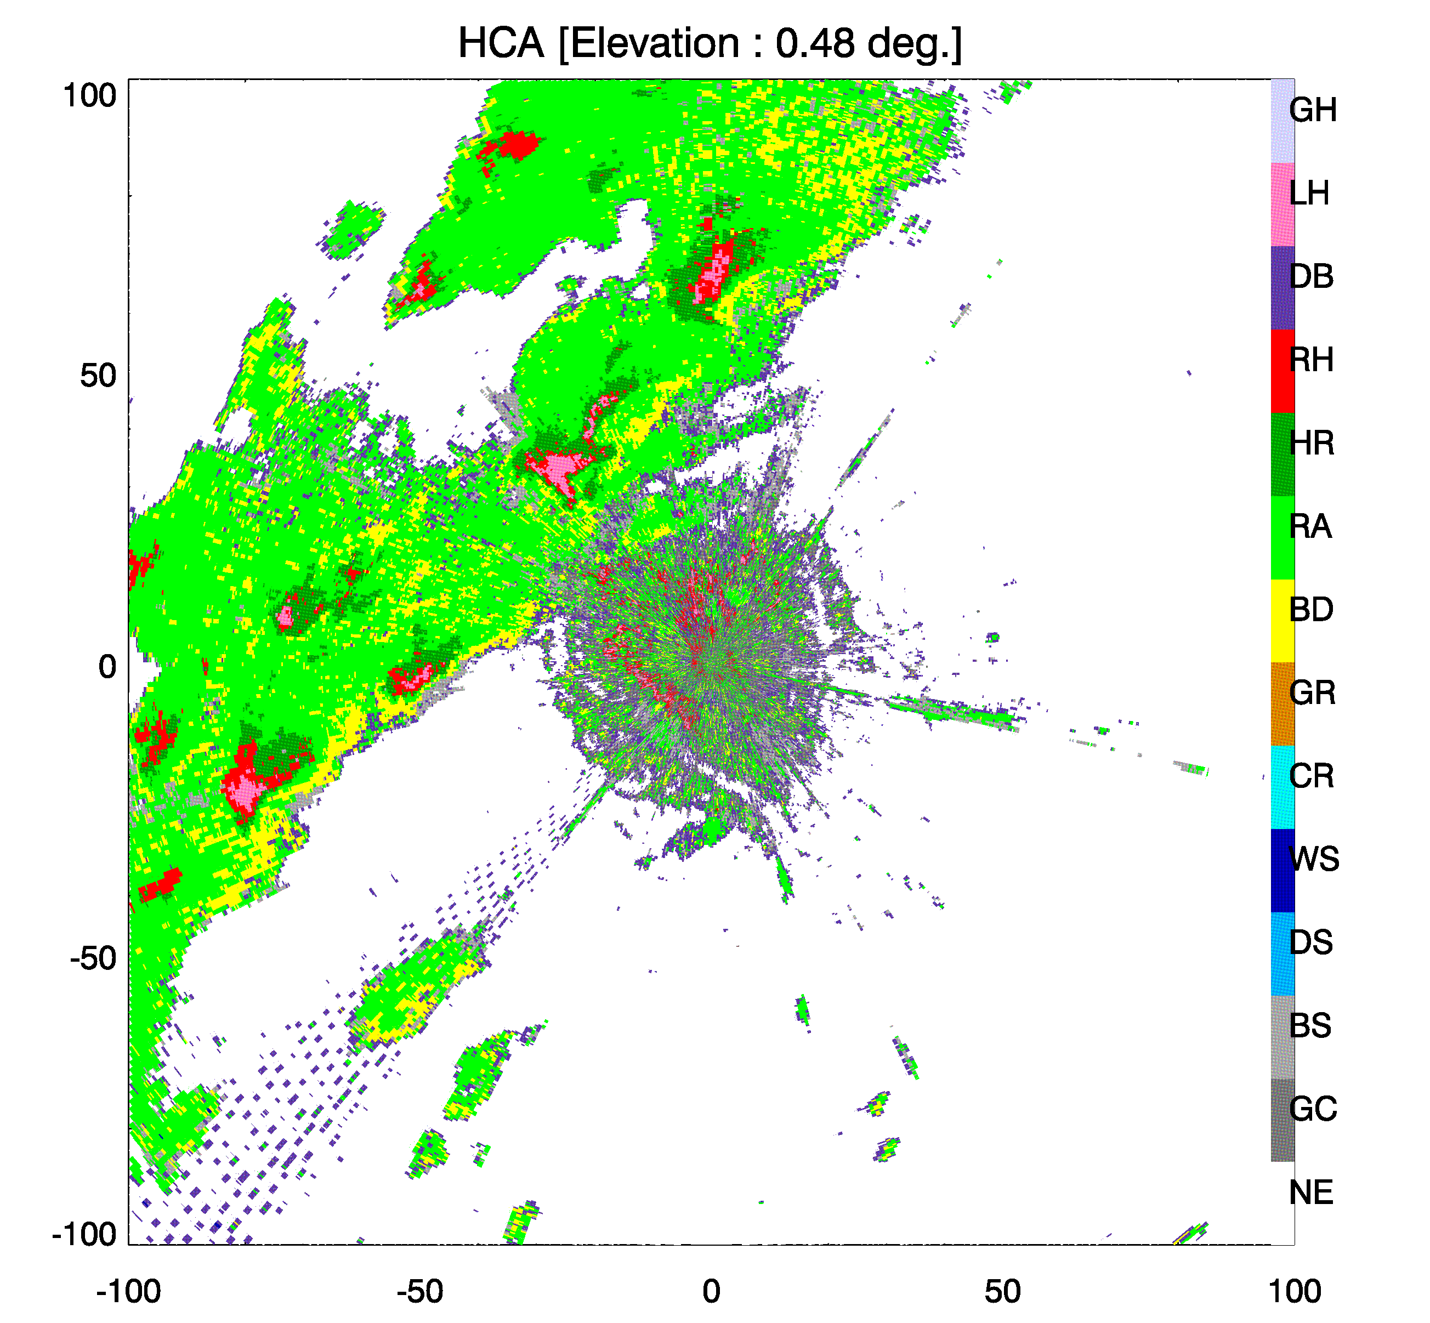

Fig. 11. Hail classified as >1” (LH, pink areas) by the algorithm at the 0.48 deg elevaltion. Date is February 10, 2010. The categories are: GC=ground clutter; BS=biological scatterers; DS=dry snow; WS=wet snow; CR=crystals; GR=graupel; BD=big drops; RA=rain; HR=heavy rain; RH=rain/hail mixture; DB=double category; LH=large hail; GH=giant hail (not included in the current algorithm).

algorithm. Several but not all of the cells in Fig. 11 contain the > 1” hail size depicted with the pink areas. This is satisfying in that the algorithm recognizes the differences between the cells, although it is not a proof that it works well.
The hydrometeor classification algorithm recognizes the interference to the southwest of the radar as a double category (DB), which happens if two classes clash and can not be reliably separated. The HCA also misclassifies some ground clutter (near the radar) into rain, rain/hail, and even large hail. This would be avoided if ground clutter filters were applied to the data. The giant hail category (GH) is awaiting development and test of appropriate thresholds. 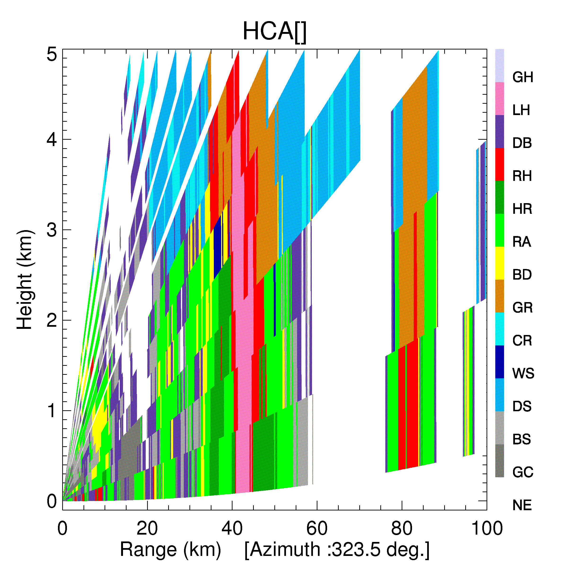
Fig. 12. Vertical cross section of the classified hydrometeors. The cross section is a construct from conical scans. The day is February 10, 2010 as in Fig. 11.

The vertical cross section of classified hydrometeors (Fig. 12) has an elongated column of large hail in the midst of the hail/rain category. This and the continuity with height demonstrate skill. Thus the overall performance is promising. To validate the algorithms independently is almost impossible because there are no platforms which can penetrate into strong hail cores. Nonetheless, scattergrams, and plots similar to the ones in Figs. 11 and 12 provide indirect assessments which can be compared with reports on the ground. This and model studies should guide the evolution of the algorithm into an operationally valuable tool.

Polarimetric Radar Detection of Large (> 1’’) Hail
(Functional Description)

- Run existing HCA and identify the areas recognized as “rain / hail mixture”
- Identify large hail in the areas of rain / hail mixture using the following rules.

- Determine the height of freezing level (H_{FL}) either as a height of the melting layer top from the WSR-88D MLDA or from the RUC model.
- Determine the height of the center of the radar resolution volume H using range and elevation.
- Use different rules for recognizing large hail for different values of the difference H – H_{FL}:

Large hail is recognized if

Z > 60 dBZ if H > H_{FL}

Z > 60 dBZ and Z_{DR} < 0.5 dB if 0 < H_{FL} – H < 1 km

Z > 62 dBZ and Z_{DR} < 1.5 dB if 1 < H_{FL} – H < 2 km

Z > 59 dBZ and Z_{DR} < 1.9 dB if 2 < H_{FL} – H < 3 km

Z > 57 dBZ and Z_{DR} < 2.3 dB if H_{FL} – H > 3 km

References

The list contains articles referred to in the report as well as other relevant publications dealing with hail but not mentioned in the main text.

Aydin, K., T.A. Seliga, and V.Balaji, 1986: Remote sensing of hail with a dual linear polarization radar. J. Climate Appl. Meteor., 25, 1475-1484.

Aydin, K., and Zhao, Y., A computational study of polarimetric radar observables in hail. IEEE Trans. Geosci. Remote Sens., 28, 412 – 422.

Aydin, K., and V. Giridhar, 1991: Polarimetric C-band radar observables in melting hail: a computational study. Preprints. 25th Int. Conf. Radar Meteor. Paris, 733 – 736.

Balakrishnan, N., and D.S. Zrnic, 1990: Use of polarization to characterize precipitation
and discriminate large hail, J. Atmos. Sci., 1525-1540.

Barge, B.L., and G.A. Isaac, 1973: The shape of Alberta hailstones. J. Rech, Atmos. 7, 11-20.

Cao, Q., G. Zhang, E. Brandes, T. Schuur, A.V. Ryzhkov, and K. Ikeda, 2008: Analysis of video disdrometer and polarimetric radar data to characterize rain microphysics in Oklahoma. J. Appl. Meteor. and Climatology, 47, 2238-2255.
Brandes, E.A., and A.V. Ryzhkov, 2004: Hail detection with polarimetric radar. Preprints, 11th Conf. on Aviation, Range, and Aerospace Meteorology, Hyannis, MA, Amer. Meteor. Soc., CD-ROM, P5.10.

Bringi, V.N., and V. Chandrasekar, 2001: Polarimetric Doppler Weather Radar. Principles and Applications. Cambridge University Press, 636 pp.

Cheng, L., and M. English, 1983: A relationship between hailstone concentration and size. J. Atmos. Sci., 40, 204 – 213.

Cheng, L., M. English, and R. Wong, 1985: Hailstone size distributions and their relationship to storm thermodynamics. J. Appl. Meteorol., 24, 1059 – 1067.

Depue, T., P. Kennedy, and S. Rutledge, 2007: Performance of the hail differential reflectivity (H_{DR}) polarimetric hail indicator. J. Appl. Meteor. Clim. 46, 1290 – 1301.

Heinselman, P., and A. Ryzhkov, 2006: Validation of polarimetric hail detection. Wea. Forecasting, 21, 839 – 850.

Higgins, W., et al., 2006: The NAME 2004 field campaign and modeling strategy. Bulletin of the Amer. Meteor. Soc., 87, 79-94.

Khain, A., A. Pokrovsky, M. Pinsky, A. Seifert, and V. Phillips, 2004: Effects of atmospheric aerosols on deep convective clouds as seen from simulations using a spectral microphysics mixed-phase cumulus cloud model. Part I: Model description. J. Atmos. Sci., 61, 2963 – 2982.

Knight, N.C., 1986: Hailstone shape factor and its relation to radar interpretation of hail. J. Clim. Appl. Meteorol., 25, 1956-1958.

Kumjian, M., A. Ryzhkov, V. Melnikov, and T. Schuur, 2009: Rapid-scan super-resolution observations of a cyclic supercell with a dual-polarization WSR-88D. Accepted by Monthly Weather Review.

Leitao, M.J., and P.A. Watson, 1984: Application of dual linearly polarized radar data to prediction of microwave path attenuation at 10-30 GHz. Radio Sci., 19, 209-221.

List, R., 1985: Properties and growth of hailstones. Thunderstorm Dynamics and Morphology, E. Kessler, Ed., University of Oklahoma Press, 259-276.

Matson, R. J. and A. W. Huggins, 1980: The direct measurement of the sizes, shapes, and kinematics of falling hailstones. J. Atmos. Sci., 37, 1107-1125.

Milbrandt, Y., and M. Yau, 2006: A multimoment bulk microphysics parametrization. Control simulation of hailstorm. Pt III. J. Atmos. Sci., 62, 3114 – 3137.
Morgan, G.M., and P. W. Summers, 1985: Thunderstorm Dynamics and Morphology, E. Kessler, Ed., University of Oklahoma Press, 237-257.

Park, H.-S., A. Ryzhkov, D. Zrnic, and K.-E. Kim, 2009: The hydrometeor classification algorithm for the polarimetric WSR-88D. Description of application to an MCS. Weather and Forecasting, 24, 730 – 748.

Rasmussen, R. M., and A. J. Heymsfield, 1987: Melting and shedding of graupel and hail. Part I: Model physics. J. Atmos. Scie. 44, 2754-2763.

Rowe, A., 2007: Estimating hail size using polarimetric radar. Report to NSSL, also provided to Lincoln Lab. 24 pp.

Ryzhkov, A.V., S.E. Giangrande, V. M. Melnikov, and T.J. Schuur, 2005: Calibration issues of dual-polarization radar measurements. J. Atmos. Oceanic Technol., 22, 1138 -1155.

Ryzhkov, A. S. Ganson, A. Khain, M. Pinsky, and A. Pokrovsky, 2009: Polarimetric characteristics of melting hail at S and C bands. 34th Conference on Radar Meteorology, Williamsburg, VA, Amer. Meteor. Soc., 4A.6. Available online at [http://ams.confex.com/ams/pdfpapers/155571.pdf]

Ryzhkov, A., M. Pinsky, A. Pokrovsky, and A. Khain, 2010: Polarimetric radar observation operator for a cloud model with spectral microphysics. Accepted by J. Appl. Meteor. Climatol.

Smith, P., D. Musil, S. Weber, J. Spahn, G. Johnson, and W. Sand, 1976: Raindrop and hailstone distributions inside hailstorms. Preprints. Int. Conf. Cloud Physics, Boulder, CO, 252 – 257.

Spahn, J. and P. Smith, 1976: Some characteristics of hailstone size distributions inside hailstorms. Preprints, 17th Conf. Radar Meteor., Seattle, WA, 187 – 191.

Ulbrich, C. and D. Atlas, 1982: Hail parameter relations: a comprehensive digest. J. Appl. Meteor., 21, 22 – 43.

Vivekanandan, J., V. Bringi, and R. Raghavan, 1990: Multiparameter radar modeling and observation of melting ice, J. Atmos. Sci., 47, 549 – 563.

Witt, A., M.D. Eilts, G.J. Stumpf, J.T. Johnson, E. D. Mitchell, and K.W. Thomas, 1998: An Enhanced hail detection algorithm of the WSR-88D. Weather and Forecasting, 13, 286-303.

Zrnic, D.S., 2009: Hail size. Interim report No 1, for Lincoln Laboratory.

Zrnic, D.S., 2010: Hail size. Interim report No 2, for Lincoln Laboratory.

