Three-Body Scattering Signatures in Polarimetric Radar Data

MATTHEW KUMJIAN, JOSEPH PICCA, SCOTT GANSON, ALEXANDER RYZHKOV, AND DUSAN ZRNIĆ

National Severe Storms Laboratory and Cooperative Institute for Mesoscale Meteorological Studies, University of Oklahoma, Norman, Oklahoma

1. Introduction

The term “three-body scatter signature” (TBSS) was coined by Zrnić (1987), who first quantified and explained these radial protrusions of Z_{H} behind the cores of strong hail-bearing storms. Recently, Zrnić et al. (2010) have explored the possibility of determining hail size from single-polarization TBSS observations. Their analysis concluded that single-polarization observations of the TBSS are limited due to fundamental ambiguities in size retrieval resulting from resonant scattering effects.
To date, the only paper investigating the dual-polarization TBSS is Hubbert and Bringi (2000), who quantified Z_{DR} signatures behind the hail cores using model calculations. However, much of their study focuses on modeling contributions from the ground and on the negative Z_{DR} sometimes observed at low levels in hail cores. Here, we present theory, observations, and modeling in an analysis that focuses on the polarimetric TBSS aloft, which is characterized by extremely high Z_{DR} and very low ρ_{HV} located just behind high-Z_{H} cores in hail-bearing storms. We provide suggestions regarding the applicability of the polarimetric TBSS in detecting moderate- to large-sized hail aloft as well as explore the possibility of hail size discrimination.

2. Polarimetric TBSS – Description and Explanation

The polarimetric TBSS is herein defined as the beginning portion of the TBSS marked by high Z_{DR} and very low ρ_{HV} located (radially) behind high-Z_{H} hail cores. Figure 1 provides an example of the polarimetric TBSS, marked by Z_{DR} in excess of 5 dB and ρ_{HV} less than 0.5. Note that the traditional radial “spike” in Z_{H} is obfuscated by the presence of another storm. This highlights the utility of the polarimetric TBSS in identifying hail aloft. Nonetheless, one must include ρ_{HV} in the analysis, as the polarimetric TBSS may be confused with the Z_{DR} column and Z_{DR} ring (e.g., Kumjian and Ryzhkov 2008) located to its southeast.
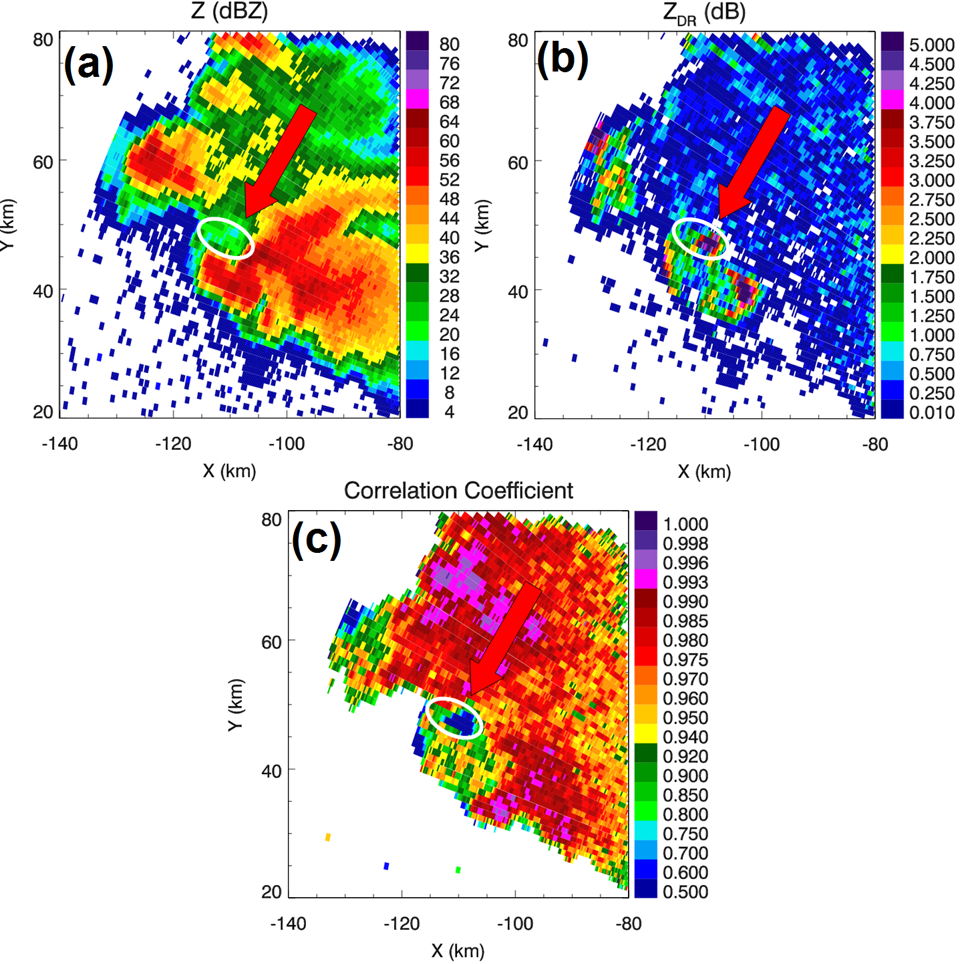
Fig. 1: Example of a polarimetric TBSS from 1 June 2008 at 0303:17 UTC at 2.2° elevation. The three panels show observed fields of (a) reflectivity factor Z_{H}, (b) differential reflectivity Z_{DR}, and (c) co-polar cross correlation coefficient ρ_{HV}. The TBSS is identified by a large red arrow and is circled with a white oval.

The polarimetric TBSS can be explained readily considering simple scattering theory. Assume a hailstone oriented with its minor axis in the vertical (i.e., no canting). Under the Rayleigh approximation, one can model the hailstone as having two dipoles aligned with its major and minor axes (Fig. 2), which coincide with the horizontal (H) and vertical (V) polarization vectors of the incident electromagnetic wave for a radar transmitting at low elevation angles.

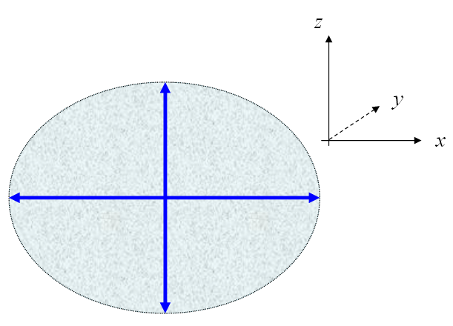
Fig. 2: Schematic of a spheroidal hailstone of arbitrary aspect ratio and size. The stone is represented as crossed dipoles (blue arrows).
Consider now that the hailstone is illuminated by an incident plane wave of H polarization that is propagating in the +y direction. The H dipole of the hailstone becomes excited, emitting secondary radiation in the pattern displayed in Fig. 3. Note that the pattern is similar to a doughnut or torus, with nulls in the ± x directions. Similarly, we can consider an incident plane wave with V polarization. The resulting dipole radiation pattern of the hailstone is shown in Figure 4. We see a similar torus shape, though rotated 90°. Thus, the nulls now extend in the ± z direction from the dipole.

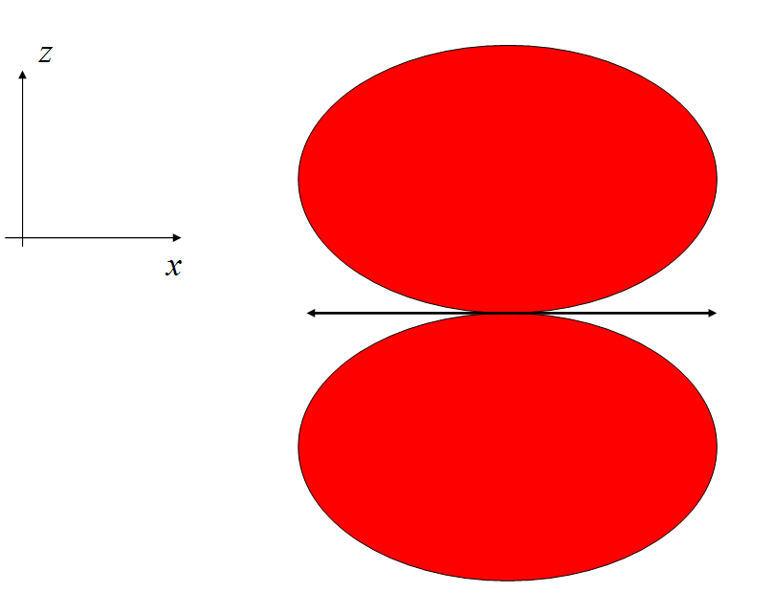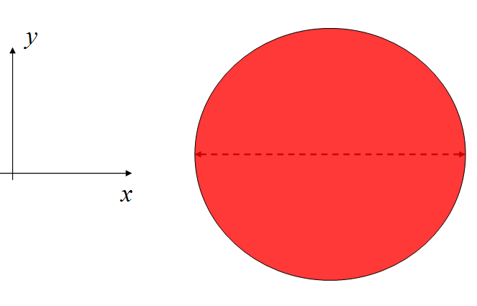
Fig. 3: Radiation pattern from the excited H dipole of the hailstone shown in an x-z cross-section (left) and in plan view (right). The red shading represents the radiation pattern, the double arrow is the dipole.

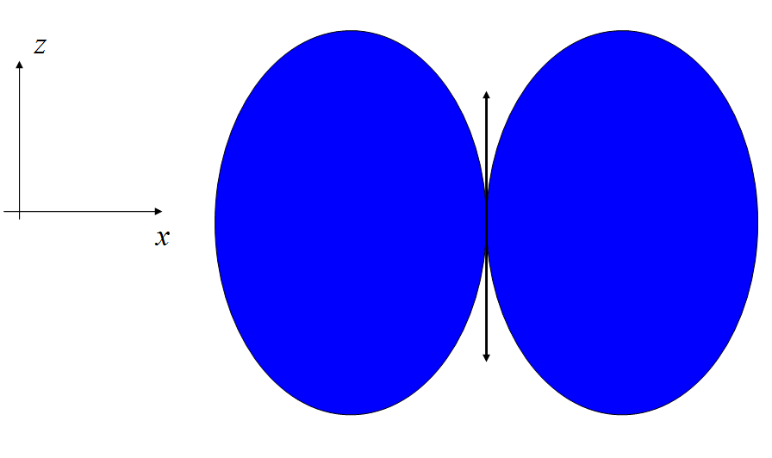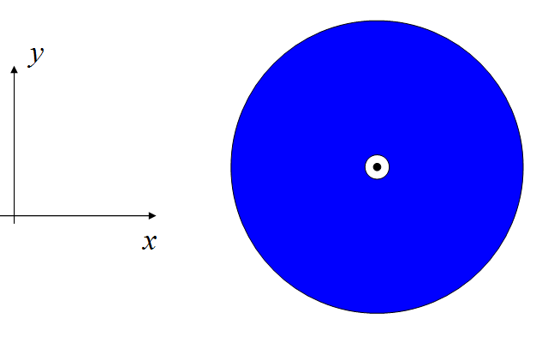
Fig. 4: Radiation pattern from the excited V dipole of the hailstone shown in an x-z cross-section (left) and in plan view (right). The blue shading represents the radiation pattern, the double arrow is the dipole.

Now, if a hailstone is illuminated by an incident wave with both horizontal and vertical polarizations, backscattered radiation is dependent on the size, shape, composition, etc. of the hailstone. For the polarimetric TBSS, however, some energy is scattered to the ground, back to the hailstone, and then back to the radar (Fig. 5). If the only energy contributing to the polarimetric TBSS came from directly beneath the hailstone, it would only have an H-polarized component. Recall that the V dipole pattern has a null in the –z direction. Thus, the returned power from the polarimetric TBSS radiation would have Z_{DR} of positive infinity and ρ_{HV} of zero. However, in real life the polarimetric TBSS is comprised of returns from a conical region beneath the hailstones (Fig. 6). So, the V-polarized component is nonzero, but considerably smaller than the H-polarized component. Thus, Z_{DR} is large and positive and ρ_{HV} is very low. Throughout the remainder of this report, the ratio of the powers of radiation scattered downwards from the hydrometeor (from incident H polarization and incident V polarization) will be called the bistatic Z_{DR} (e.g., see Aydin et al. 1998 for an investigation of bistatic dual-polarization scattering).

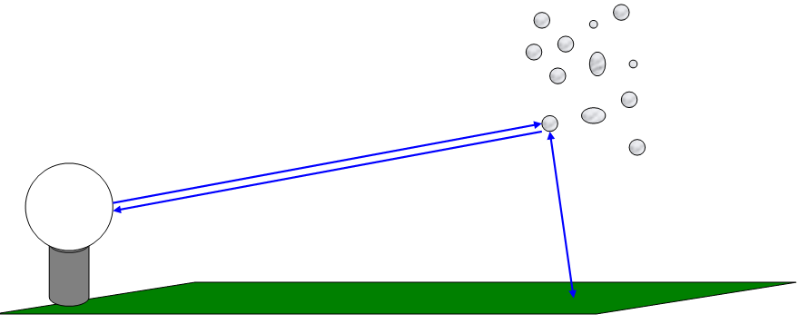
Fig. 5: Schematic illustrating the path of the electromagnetic radiation that contributes to the polarimetric TBSS pattern: from the radar to the hailstones, from the hailstones to the ground, from the ground back up to the hailstones, and then back to the radar.

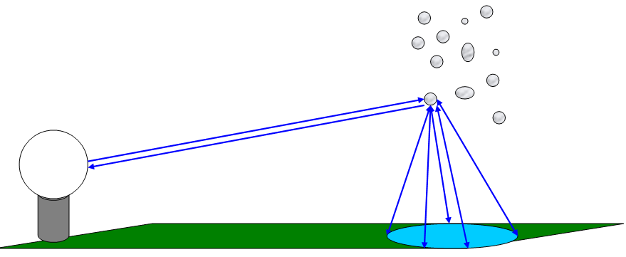
Fig. 6: As in Fig. 5, but for the more realistic case of polarimetric TBSS returns coming from a conical region beneath the hailcore.

3. Polarimetric TBSS – Observations

With the above explanation in mind, one should expect that the highest Z_{DR} values in the polarimetric TBSS are found just beyond the hail core for the following reasons. The transmitted H electric field is scattered very strongly straight down towards the ground whereas the transmitted V field is scattered very weakly (if at all) in that same direction. Thus there is a large difference between the two components reaching the ground (i.e., large bistatic Z_{DR}). The reflection coefficients of the ground for the each component are, on the average, equal. Therefore reflection does not change the ratio of the two components. Scattering by hail of the two components back to the radar enhances again the horizontal component, increasing the Z_{DR}.
Several storm cases were selected for analysis in this report (31 March 2008 tornadic supercell; 1 June 2008 nontornadic supercell; 27 March 2009 severe storm). Simply comparing the approximate height of the radar beam where it samples the maximum Z_{H} in the hail core and the separation between this maximum Z_{H} and the maximum Z_{DR} in the polarimetric TBSS provides a rough test of our explanation. Indeed, the two estimates are positively correlated (r = 0.83, Fig. 7). The correlation is reduced due to at least three sources of error: 1) the storms are located at considerable distances from the radar such that the width of the sampling volume in the vertical dimension exceeds about 1 – 2 km, whereas the beamheight estimate is a single point; (2) there are contributions to the signature aside from signals scattered downwards (i.e., not exactly perpendicular to the ground) ; (3) the explanation invoked above considers spherical Rayleigh scatterers, though increasingly large hail becomes more and more non-Rayleigh and is non spherical.
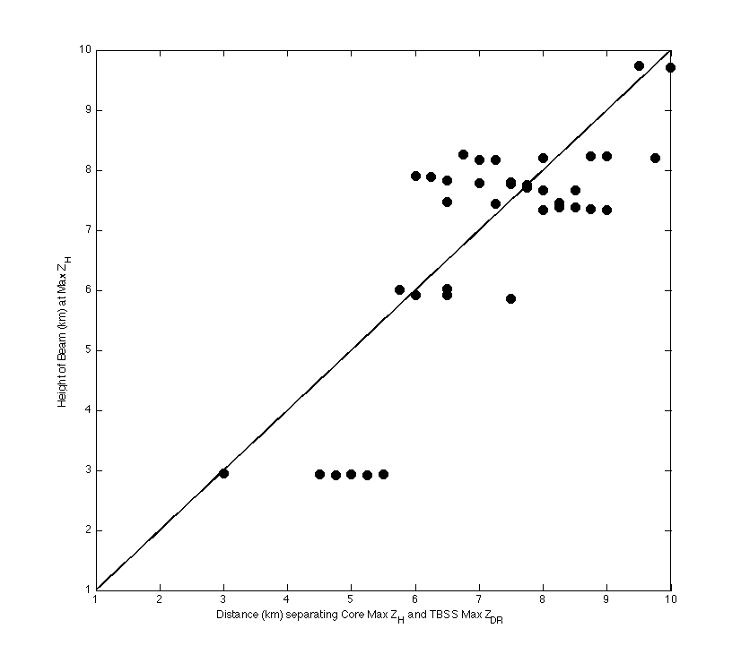
Fig. 7: Scatterplot of distance separating the core maximum Z_{H} and the polarimetric TBSS maximum Z_{DR} versus the estimated beamheight of the maximum Z_{H} in the core. The one-to-one line is overlaid. Data from several cases are used.

Next, we investigate the characteristics of the polarimetric TBSS itself and the hail cores that cause the signatures. The maximum Z_{DR} and minimum ρ_{HV} in the polarimetric TBSS are shown in Fig. 8. The data reveal a moderate negative correlation (r = -0.61), which is expected based on the explanation presented above. Note that the observed ρ_{HV} minima are all below 0.7 and thus will not be confused with meteorological scatterers. The Z_{DR} maxima are larger than 2 dB, reaching nearly 10 dB in some cases.

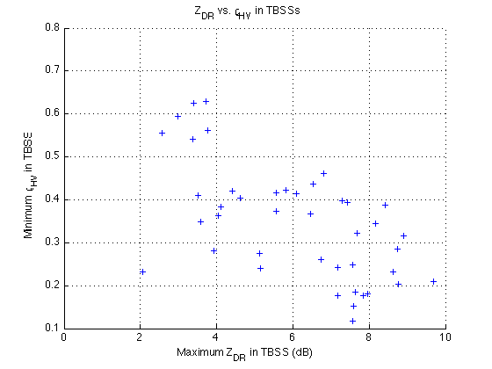
Fig. 8: Scatterplot of the maximum Z_{DR} in the TBSS versus the minimum ρ_{HV} in the TBSS.

The relation between the maximum Z_{H} in the hail core and the maximum Z_{DR} in the polarimetric TBSS is nonexistent (Fig. 9). Similarly, there is no discernable relation between the hailcore maximum Z_{H} and the polarimetric TBSS minimum ρ_{HV} (not shown).
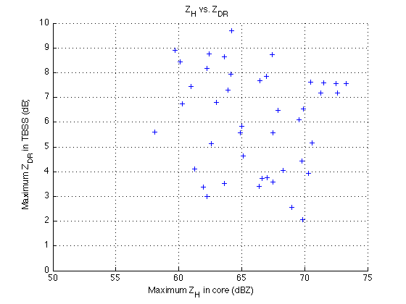
Fig. 9: Scatterplot of the maximum Z_{H} in the hail core versus the maximum Z_{DR} in the TBSS.

The polarimetric properties of the hail cores that produced polarimetric TBSSs and those that did not are analyzed next. To compare the polarimetric TBSS cores to the “null cores,” data were only selected from one storm case, albeit from several elevation angles and times. This was done to alleviate any problems with radar miscalibration between different datasets. Thus, “null” data come from radials in the same storm at the same elevations and times as those that produced a polarimetric TBSS. A case was considered null if (i) the maximum Z_{H} in the core exceeded about 55 dBZ, and (ii) there was no apparent increase in Z_{DR} behind the hail core. Similarly, the TBSS core was determined by (i) the maximum Z_{H} in the core exceeded about 55 dBZ, and (ii) there was an apparent Z_{DR} increase behind the core. In this way, the characteristics of hail cores that produce polarimetric TBSSs could be compared to those that do not.
Figure 10 shows the Z_{H}-Z_{DR} scatterplot for polarimetric TBSS and null cases. Despite significant overlap between the two datasets, there are a few differences of note. First, virtually all null cases occur for Z_{H} below 65 dBZ, whereas there are numerous polarimetric TBSS cases with Z_{H} in excess of 65 dBZ. Second, there are more negative-Z_{DR} points for polarimetric TBSS cases than for null cases. Third, there are no polarimetric TBSS cores with Z_{DR} in excess of about 0.5 dB, whereas there are several points even over 1.0 dB for the null cases.
In Figs. 11-12, scatterplots for Z_{H}-ρ_{HV} and Z_{DR}-ρ_{HV} are shown. From Fig. 11 it is evident that ρ_{HV} remains fairly high (> 0.95) for many of the high-Z_{H} points in the polarimetric TBSS cases. In null cases, the ρ_{HV} tends to be below 0.95 for Z_{H} above 60 dBZ. This may indicate less chaotic orientation of hailstones in the polarimetric TBSS cases; in other words, the regions of the storm that have hailstones with less chaotic orientation may be more conducive to polarimetric TBSSs. This speculation is consistent with the qualitative explanation of the polarimetric TBSS presented above. More chaotic orientation would tend to limit the amount of preferred H-polarization radiation scattered towards the ground, which is necessary for a pronounced polarimetric TBSS. In Fig. 12, we see that many of the high-ρ_{HV} points for the polarimetric TBSS cases have negative Z_{DR} values. If it is true that the higher ρ_{HV} values indicate more-aligned hailstones, the negative Z_{DR} values could indicate larger (> 5 cm) oblate hailstones. Note that negative Z_{DR} values are associated with smaller (< 4 cm) prolate hailstones or larger oblate hailstones (e.g., Aydin and Zhao 1990; Balakrishnan and Zrnić 1990). Because the H-polarization radiation is scattered downwards preferentially (at least in the Rayleigh approximation), and because Z_{H} values are quite high (up to 70 dBZ for some of these points), we favor the explanation of oblate hailstones leading to the polarimetric TBSS signatures in this case.
Thus, this analysis suggests that polarimetric TBSSs are most likely behind cores that have higher Z_{H} and ρ_{HV}, and lower (more negative) Z_{DR} values, possibly indicative of larger oblate hailstones. Additionally, the stones in polarimetric TBSS cases may be better aligned than in the null cases.

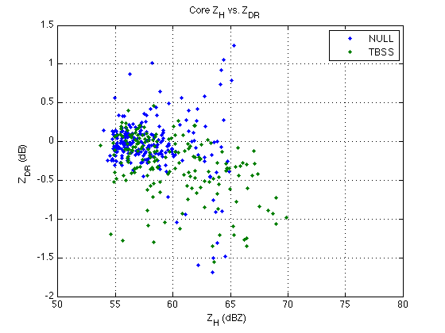
Fig. 10: Z_{H} versus Z_{DR} in the cores of the 1 June 2008 storm, from radials in which a polarimetric TBSS was observed (“TBSS”, in green) and those in which no TBSS was observed (“NULL”, blue).

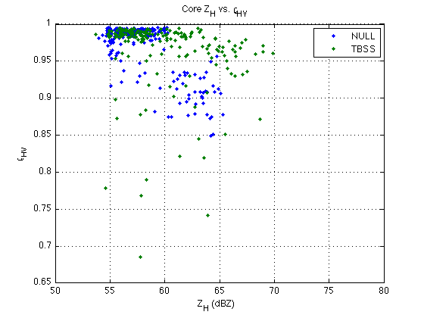
Fig. 11: As in Fig. 10, except Z_{H} versus ρ_{HV} is shown.

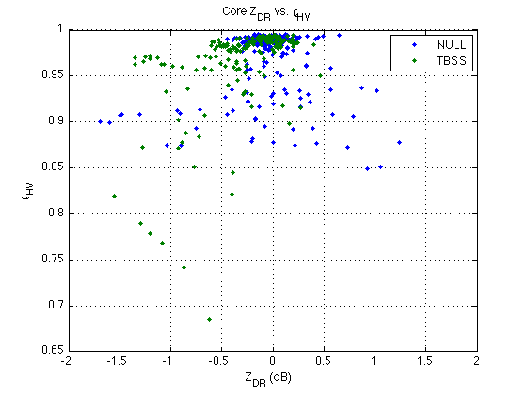
Fig. 12: As in Figs. 10 and 11, except Z_{DR} versus ρ_{HV} is shown.

4. Theoretical formulation

T-Matrix calculations were performed to determine the scattering characteristics at the scattering angle of 90 deg of hailstones of various sizes at S and C bands. Specifically, the bistatic Z_{DR} of spherical hailstones was computed for both radar wavelengths (Fig. 13). The resulting values are only slightly enhanced for oblate hailstones (not shown). Immediately evident is that the largest values of bistatic Z_{DR} are found for smaller hailstones. This is because the smaller hailstones are better approximated by the Rayleigh condition. Also of note is that the hail size for which the bistatic Z_{DR} drops to zero (at C band) is about 2.8 cm, which is approximately the threshold of “severe” hail used by the U.S. National Weather Service. Thus, one would expect a minimal polarimetric TBSS (just behind the core) for severe hail at C band. Conversely, if a strong enhancement of Z_{DR} is found behind the hail core at C band, it is likely that the hail contributing to this signature is of relatively small size. Because most convective storms produce small hail, at least aloft, routine observations of the polarimetric TBSS at C band would indicate that these small stones produce enough of a downscattered signal to generate a polarimetric TBSS. On the other hand, if this signature is not routinely observed in convective storms at C band, it may indicate that the small hail does not produce enough downscattered power for the polarimetric TBSS to be observed.
For S band, the size where bistatic Z_{DR} drops to zero is about 5.5 cm. Routine observations of convective storms at S band using the polarimetric prototype WSR-88D in Norman (KOUN) have been made for several years. Ordinary convective storms and mesoscale convective systems tend to not exhibit a polarimetric TBSS, whereas many supercell storms do. The observations shown above reveal the maximum Z_{DR} in the polarimetric TBSS rarely exceeds about 10 dB. Based on the lack of observations of a polarimetric TBSS at S band in a sample of ordinary convective storms (which almost always produce some small hail aloft), we hypothesize that the small hailstones do not produce enough downscattered power to generate a polarimetric TBSS. On the other hand, very large hail (> 5 cm) does not produce an appreciable positive bistatic Z_{DR}; thus, we speculate that the hail producing the polarimetric TBSS tends to be of moderate to large size (i.e., 2 – 5 cm). It is important to note that the largest hailstones may not contribute to the polarimetric TBSS because of their lack of a large bistatic Z_{DR}. Thus, the polarimetric TBSS may not provide the maximum hail size in storms, but it may help provide a lower bound to estimates of maximum hail size.
Comparing simultaneous polarimetric observations at S and C bands may provide further information about hail size. For instance, if a polarimetric TBSS is prominent at S band but not at C band, then the range of hailstone sizes responsible for the signature is narrowed.

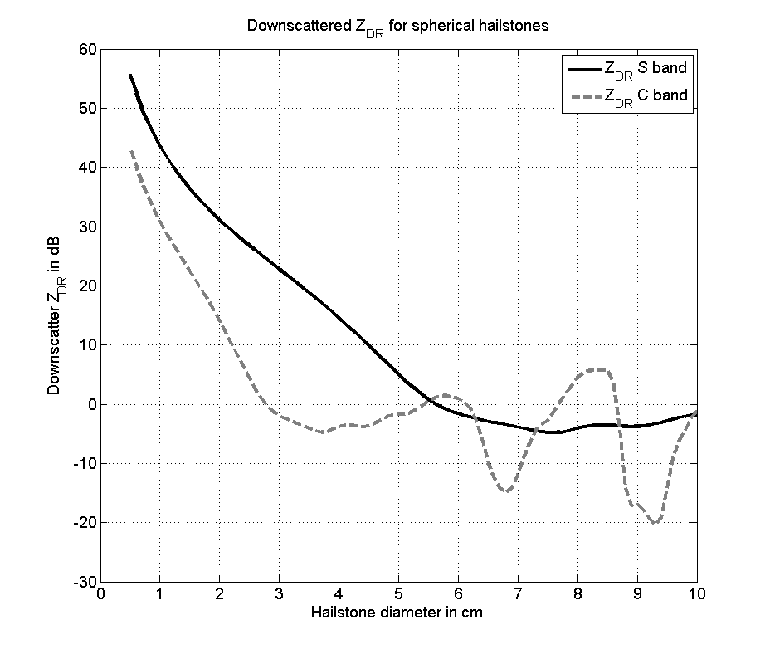
Fig. 13: The bistatic Z_{DR} for spherical hailstones (between incident H and V polarizations), computed for radar frequencies of S band (solid black curve) and C band (dashed gray curve).

5. Conclusions

The following are some preliminary conclusions based on the analysis above.

- The polarimetric TBSS (defined as the band of very high Z_{DR} and very low ρ_{HV} behind the hail core) may appear behind parts of the storm where hailstones are more aligned, deduced from higher ρ_{HV} in the core for the TBSS cases. This is in agreement with the theoretical model, where more chaotically-oriented hailstones would produce smaller Z_{DR} than those in common alignment.
- Cores which cause the polarimetric TBSS tend to have higher Z_{H} and lower (more negative) Z_{DR} than those that do not produce the polarimetric TBSS.
- Based on the scattering calculations, the largest hail (maximum hail size) probably DOES NOT contribute to the polarimetric TBSS in many cases, making it difficult to use the polarimetric TBSS to gauge maximum hail size.
- However, the lack of significant polarimetric TBSSs in most convective storms (where small hail almost always exists) suggests that the smaller stones do not produce enough downscattered power to generate the polarimetric TBSS. This narrows the range of sizes responsible for the polarimetric TBSS.
- Therefore, it is likely that the hailstones responsible for the polarimetric TBSS are of the moderate-to-large size, say, greater than 1-2 cm but smaller than about 5-6 cm (at S band).
- At C band, hailstones larger than about 2.8 cm (close to the NWS “severe” threshold) likely will not contribute to the polarimetric TBSS.
- Simultaneous measurements at S and C bands can help narrow the range of sizes further, especially if a polarimetric TBSS is present at one frequency but not the other.

References

Aydin, K., and Y. Zhao, 1990: A computational study of polarimetric radar observables in hail. IEEE Trans. Geosci. Remote Sens., 28, 412-422.

Aydin, K., S.H. Park, and T.M. Walsh, 1998: Bistatic dual-polarization scattering from rain and hail at S- and C-band frequencies. J. Atmos. Oceanic Techol., 15, 1110-1121.

Balakrishnan, N. and D.S. Zrnić, 1990: Use of polarization to characterize precipitation and discriminate large hail. J. Atmos. Sci., 47, 1525-1540.

Hubbert, J.C., and V.N. Bringi, 2000: The effects of three-body scattering on differential reflectivity signatures. J. Atmos. Oceanic Technol., 17, 51-61.

Kumjian, M.R., and A.V. Ryzhkov, 2008: Polarimetric signatures in supercell thunderstorms. J. Appl. Meteor. and Climatology, 47, 1940-1961.

Zrnić, D.S., 1987: Three-body scattering produces precipitation signatures of special diagnostic value. Radio Sci., 22, 76-86.

Zrnić, D.S., G. Zhang, V. Melnikov, and J. Andrić, 2010: Three-body scattering and hail size. J. Appl. Meteor. and Climatology, 49, 687-700.

