Processing to obtain Polarimetric Variables on the ORDA

DO NOT DESTROY – version
July 2008

Dusan S. Zrnic, Valery M. Melnikov, and Igor Ivic

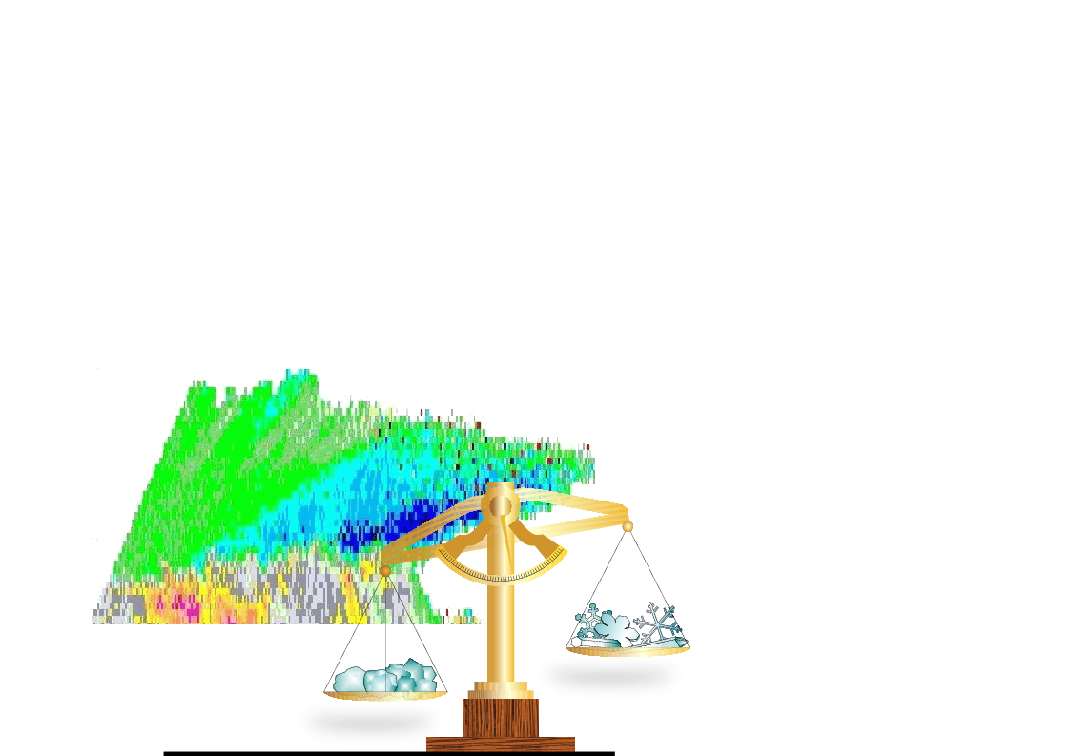

Preamble

This report is the last of the living and evolving document. It is the guide to NWS and its contractor on how to integrate computations of dual polarimetric variables into the architecture of the Open Radar Data Acquisition (ORDA) system. Consideration is given to mitigation of range and velocity ambiguities, to recovering loss of sensitivity, and computation of polarimetric variables. Self sufficient appendices further justify the recommendations and also present alternatives to current processing schemes. The pertinent details (equations, flow charts) are included and explained so that these could be programmed on the system. We give some examples (or indicate by pointing to previous reports where these are) of what we have tested on data and what still remains to be verified as well as what issues remain to be resolved. The technique of oversampling and whitening is purposely omitted because there is no time to implement these on the initial system; these will be part of subsequent upgrades. There is a separate document (in preparation) describing the super resolution as proposed for “build 10” (hardware/software modifications in 2008) which also applies to single polarization radar.
This final version is appropriately named “Do Not Destroy”. It contains a heretofore not available section 2.2 wherein the thresholds for improving detection are given. These should be updated at the end of each volume scan.
Initially the intent of the authors, as implied by the name "Destroy", was to replace (destroy) each version with an updated version. Meanwhile the project dynamics and experience of the undiscovered “Philosopher - author” destroyed this initial intent. The contract for dual polarization upgrade has been issued hence a more stable and less intimidating preamble was required. Therefore, some permanency became desirable. We also realized that important aspects in dual polarization upgrade (such as ground clutter issues exemplified with choice of H or V channel for dictating clutter removal and adaptive recognition of ground clutter, and recombination of supper resolution data) would fill too much space. These deficiencies are one important reason the “Philosopher” has not yet been discovered. Armed with new experience and education the “wish to be Philosopher” decided to change the name and help readers track the small changes (corrections) by adding on the cover the months and year the latest changes have been made.
A new report will contain NSSL’s recommendations on how to compute the polarimetric variables, filter ground clutter, and deal with supper resolution issues.

TABLE OF CONTENTS

1. Introduction..................................................................................................... .........1
2. Mitigation of sensitivity loss in the dual polarization WSR-88D.............................4
2.1. The problem....................................................................................................4
2.2. The solution....................................................................................................5
a) Notation and Computations............................................... .....................5
b) Reflectivity..................................................................................... .........6
c) Velocity and spectrum width.............................................. ...................11
2.3. Computation of thresholds for various M and N_{v}/N_{h}.....................................17
3. Computation of polarimetric variables for the SHV scheme..................................25
3.1. Standard method from time series data.........................................................25
a) Estimation of reflectivity factor.............................................................25
b) Differential reflectivity Z_{DR}...................................................................26
c) Differential phase Φ_{DP}...................................................................26
d) Mean Doppler Velocity v.......................................................................27
e) Spectrum width σ_{v}..................................................................................27
f) Correlation coefficient at zero lag ρ_{hv}(0)...............................................27
3.2. Method based on autocovariances................................................................28
3.3. Spectral Computations.............................................................. ...................29
3.4 Estimation of the noise powers.....................................................................30
4. Polarimetric measurements and mitigation of ambiguities......................................31
4.1 Processing flow in the RDA..........................................................................31
4,2 Polariometric variables..................................................................................34
4.2.1 Standard VCP..........................................................................................34
4.2.2 Phase coding..............................................................................................34
a) Surveillance scan..................................................................................35
b) Doppler scan..........................................................................................35
c) Ground clutter filter and polarimetric variables...................................36
4.2.3 Staggered PRT..............................................................................................37
4.4. Filtering ground clutter...................................................................................37
4.5 Phase coding and computation of polarimetric variables................................38
a) Assumptions and notation......................................................................39
b) Algorithm ..............................................................................................40
5. Recommendations for initial implementation of polarimetric capability................42
5.1 Calibration........................................................................................................42
5.2 Determination of noise level and threshold of the variables............................42
5.3 Computations of polarimetric variables...........................................................42

Appendix A
Probability of false alarm for the Legacy Threshold scheme of the Z field..........44
Appendix B
Combinations of correlation functions for censoring radar data ..........................46
Appendix C
Computation of the noise level..............................................................................52
Testing if noise is white..............................................................................52
Requirement for the correlation coefficient...............................................52
Requirement for the differential reflectivity...............................................53
Discussion..................................................................................................54

References.........................................................................................................................55

1. Introduction

Four significant innovations are planed for the National network of the WSR-88D radars. One is inclusion of schemes for mitigating range/velocity (R/V) ambiguities, for which the phase coding scheme is being tested in real time by the Radar Operation Center (ROC). Two is super resolution. Three is addition of polarimetric capability. Four is processing of oversampled signals in range. Specifics on how to integrate these harmoniously are presented and various issues are brought out. The processing of oversampled signals including the effects of windowing is mentioned lightly because a separate report on the subject has been prepared.

The weather radar users rightfully expect that the polarimetric WSR-88Ds would produce significantly improved data and yield superior quantitative precipitation estimates without compromising the capability of the present radars. This consideration influenced our decision to propose simultaneous transmission and reception of horizontally (H) and vertically (V) polarized waves, the SHV mode (Doviak and Zrnic 1998). In this mode all polarimetric variables are decoupled from Doppler variables (velocity and spectrum width) so that in schemes for mitigating range velocity ambiguities these can be treated the same as reflectivity factor Z_{h}. Thus the phased coding and staggered PRT apply equally well to differential reflectivity Z_{DR}, differential phase Φ_{DP}, and correlation coefficient ρ_{hv}. Details on how to efficiently compute Z_{DR}, Φ_{DP}, and ρ_{hv} depend on the specific path within a technique. And the computing path can be data dependent in that some require clutter filtering or separation of overlaid echo and some do not. These details are brought out. In the alternate (switched) mode for polarimetric measurements the Doppler variables are coupled with ρ_{hv}.

One concern by meteorologists is the loss of sensitivity in the SHV mode. It amounts to 3 dB per channel. This loss has been identified in the report by Doviak and Zrnic (1998) who also proposed how to partially mitigate its effects. The report by Melnikov and Zrnic (2004) suggests several alternatives for mitigation and quantifies some of these.

In Section 2 are the recommendations for recapturing most of the loss in sensitivity. These require combining the autocorrelations of the Horizontal and Vertical signals at lag 1 for estimation of velocities. This increases the sensitivity by about 1.5 to 2 dB. The gain comes at low signal to noise ratios (SNRs) because the noises in the two channels are uncorrelated. Further, at low SNR’s the recommendation is to use the powers in both H and V channels, the autocorrelation functions at lag 1 (both H channel and V channel), and the cross correlation function between the H and V voltages. Linear combinations of the magnitudes of these correlations and powers are tested against a threshold and at a tolerable false alarm rate. This is done at SNR’s which in the Baseline system (ORDA build 8) would not pass the threshold; otherwise the accepted Baseline thresholds are in place. This procedure is recommended for all three spectral moments. Qualitative impressions of performance exemplified in fields of reflectivity and Doppler velocity are presented.

Although the desired evolutionary path of the WSR-88D over the next five years is fairly well established (Zrnic and Zahrai 2003) the specifics will depend on the priorities. These would have to balance the capability of the signal processor, the time available to the developers, the maturity of the techniques, and budgetary constraints. At the moment, the maximum computational load of the ORDA is about 25 %. If dual polarization is added this load would more than double, to over 50 %. Another doubling required for oversampling by a factor of only two would saturate the system. Clearly the current ORDA does not have the computational resources to accommodate dual polarization together with oversampling with a smallest possible factor (two). Moreover, there are demands for additional computations and data manipulations on the RDA including placing some of the burden from the RPG to the RDA. This presents a dilemma to the decision makers who face at least the following four options. 1) Leave the processor as is and forgo oversampling in the dual polarization mode until after the upgrade. 2) Replace one board or processor chip on the board with a more powerful one. 3) Replace the processor with the next generation processor which according to the manufacturer should be ready by 2009. 4) Extract time series data from the current ORDA into an additional powerful signal processor as was done by Lincoln Laboratory for the TDWR radars.

The signal processing on the upgraded WSR-88D will be greatly influenced by available hardware. A good choice for the oversampling factor is five but at the moment it is not known if this will be feasible. There are also many other details which can influence the overall architecture of signal processing in the dual polarization mode. Such is the possibility to instantaneously (radial by radial) decide if clutter or other artifacts are present in the data and to remove these. Ultimately spectral processing coupled with decision making in the RDA would comprise these advanced concepts. Herein we stop short on these topics. Rather we present recommendations for implementations at the time of the upgrade (year 2009).

Another issue concerns determination of the noise powers N_{h} and N_{v}, in the two receivers; these must be estimated. The preferred way to estimate these is on each radial of data. This could be done in the spectral domain by identifying the white noise contribution using a technique like in the GMAP clutter filter. Or it could be in the time domain by locating the delays where signal is absent. Nonetheless, such advanced techniques might not be ready for implementation by the time of the upgrade.

In Section 3 we list three ways for computing polarimetric variables. The standard way is a likely candidate for surveillance scans and for any scans in which the noise powers are estimated on each radial. If there is uncertainty in the noise powers, estimates from covariances are preferred because these are not biased by white noise. Computations of the polarimetric variables from complex spectra offer adaptive filtering. These computations are required in cases of ground clutter filtering regardless of what kind of range velocity mitigation scheme is operating (i.e., phase coding, staggered PRT, or else). Further, such computations should be done on the weak trip signal from phased coded schemes.

Section 4 provides information on the data flow and major computations in the dual polarization radar. The interplay between clutter filtering and the mitigation of ambiguities is also addressed so that the readers learn the musts of the technique. Abbreviated functional description of how to process the phase coded signals is given to make a point about spectral processing. The description is sufficient for those knowledgeable to be able to incorporate it into the complete algorithm. Thus, this section does indicate what needs to be done as well as how and where to do it. It is left to the professionals to incorporate these suggestions into the system.

Section 5 contains the recommendation for processing that should be implemented at the time of deployment. Its essence is to retain all the existing capabilities of the single polarization system (apart from a 3 dB loss of power per channel). Thus, it does not capitalize on the immense potency of dual polarization which is left for subsequent upgrades.

Throughout the report some equations are numbered in bold font and bracketed within square brackets, [ ], to highlight their importance.

2. Mitigation of Sensitivity loss in the dual polarization
WSR-88D

The issue of sensitivity in the proposed dual polarization mode for the WSR-88D is discussed in this section as well as the proposed scheme to gain back this loss.

2.1 The Problem
In the simultaneous mode of H, V transmission and reception the transmitted power is split into two channels (Fig 2.1). Hence, on reception, the signal to noise ratio in each channel is one half of what it would be if all the power were in a single channel (see the reports by Doviak and Zrnic 1998 and Melnikov and Zrnic 2004). Thus, there is a 3 dB loss in sensitivity compared to single channel (legacy) WSR-88D. This loss has two effects on the spectral moments. One is the increase in the errors of estimates. The other is that more data are below display and processing thresholds and hence are lost.

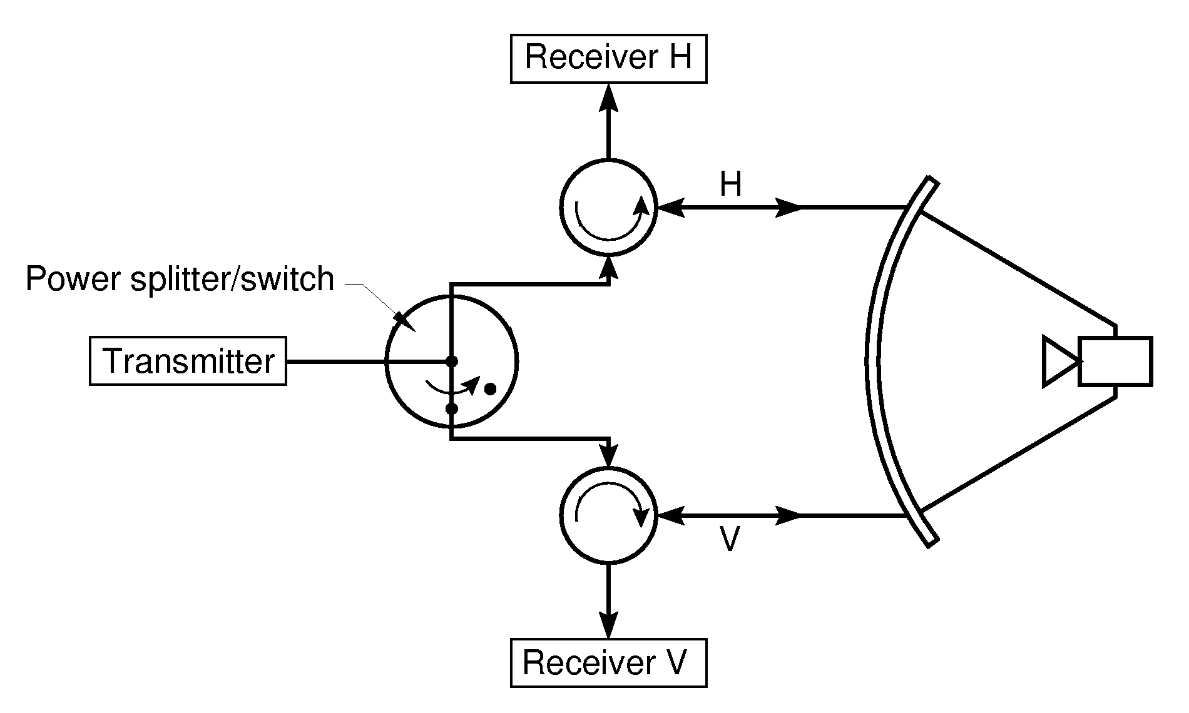
P
N
Dual pol SNR ~P/(2N)
Single pol SNR ~P/N

Fig. 2.1 Block diagram of the SHV dual polarization system.

Herein is the recommendation on how to mitigate some of the effects of sensitivity loss. For the same radar dwell time and at low SNRs (~ less than 5 dB), there would be an increase in standard deviation of estimates if the baseline processing is used. More sophisticated processing in the spectral or autocovariance domain based on maximum likelihood principles could reduce the errors. Also coherent summations of the H and V samples could recover the loss (Melnikov and Zrnic 2004). But, the additional calculations required by either method are not justified. There are other more important computations that the system ought to do at the time of first deployment. Hence, we recommend that the benefits of more sophisticated processing at low SNRs be established. Then, if warranted, such processing could be incorporated into the system.

In the baseline system the default thresholds for displaying and subsequent processing reflectivity and velocity fields are as follows. For reflectivity the SNR threshold is 2 dB and data with significant returns satisfy

10log₁₀(P-N) > 10log₁₀(N)+2 dB, (2.1)

where P is the power estimate at a range location (time delay) and N is the noise estimate obtained from calibrations at end of volume scans. The false alarm due to noise for the threshold defined with this equation and M=17 samples for reflectivity estimates is 1.17×10⁻⁶. It was obtained from theoretical analysis (Appendix A) as well as simulations. For velocity estimates, the SNR threshold is 3.5 dB.

2.2 The solution
The recommended solution is explained in this sub section.

a) Notation and Computations
Let R_{h}(T_{s}) and R_{v}(T_{s}) be the autocorrelations of the horizontally and vertically polarized returns at lag T_{s} (where T_{s} is the pulse repetition time). These autocorrelations are computed from the time series data or from the spectra.

From time series R_{h}(T_{s}) is obtained as

(2.2)

where M is the number of samples, index n refers to time (nT_{s}), and H is the complex return at a specific range location.

From the spectrum S_{h}(k)

(2.3)

Warning! The DFT in (2.3) produces circular autocorrelation which contains the product of the first and last term of the sequence H(n). This product is subtracted from the sum to produce a result that is exactly equal to (2.2). Otherwise errors in the estimate of the autocorrelation would increase. There are other ways to obtain correct value of R_{h}(T_{s}) such as padding at least one zero either at the beginning or end of the sequence. Formulas identical to (2.2 and 2.3) apply to the autocorrelations of the V signals.
On the legacy WSR-88D the computation (2.2) is used. On the ORDA if autocorrelations are computed from the spectra (2.3) should be the choice.
One more correlation function is pertinent to the proposed thresholding scheme. It is the cross correlation
(2.4)
which will be abbreviated with R_{hv}.

Depending on the spectrum width, differential reflectivity, and scatterer type any one of the three correlation functions could have the largest magnitude. An optimum threshold scheme can be constructed from a combination of the correlation functions and other polarimetric variables. In such scheme the conditional probability of threshold crossing by noise would be fixed i.e., p(X>T│noise) = C while the conditional probability of detecting the signal plus noise would be maximized, i.e., p(X>T│signal+noise). X is the vector with elements which are compared element by element to the vector threshold T. Results of this type of optimization will be presented in a subsequent report. Nonetheless, the pertinent probability density and simple considerations for our choice are described in Appendix B.
Meanwhile we proceed with the following intuitive and simple approach. We take the sum combinations of the powers and magnitudes of correlation functions and compare these to a suitable set of thresholds.

b) Reflectivity
We considered the following approach to threshold the reflectivity field:

at SNR_{h} >2 dB (2.5a)
.............................use 2 dB threshold (i.e., given by Eq. 2.1)
at -1 dB < SNR_{h} < 2 dB...
.............................use [2.5b]
where T is the threshold in power units and the multiplicative coefficients α, β, and γ are determined to maximize the probability of detection at tolerable probabilities of false alarm. As of this writing we have not determined the best choice of the multiplicative coefficients, but have used a value of 1 for each. The bold equation number and square brackets emphasize that this and similar expression should be implemented in the RDA.
Concerning the partition into regions of SNR_{h} > 2 dB and -1 dB < SNR_{h} < 2 dB, we have determined that there is miniscule difference in performance if [2.5b] is used exclusively in the full range of SNRs (i.e., some signals with SNR < -1 dB will pass the detection criterion on the strength of their coherencies); for one case, in the whole PPI we noticed four points that differed (by repetitively switching between the two fields and observing the enlarged display).
Evaluation of the “best” tested sum [2.5b] was performed using a set of dual-polarization time series data. This set was collected at the long PRT (unambiguous range 460 km), and the number of time samples M was 17, the same as in the first surveillance cut of VCP11 for reflectivity measurements; the elevation was 0.48º. To investigate the effect of the 3 dB power loss, noise power was doubled in each channel by simply adding the noise samples as:
. (2.6)
The noise power in the H channel is N_{h}, and N is the average noise in the two channels. Each noise sample is generated in MATLAB. Threshold for each approach was set so that the probability of false alarm (PFA) is 10⁻⁵, and the results are summarized in Appendix B. Herein, we present the pertinent reflectivity fields. The original “single pole” PPI is given in Fig. 2.2a.
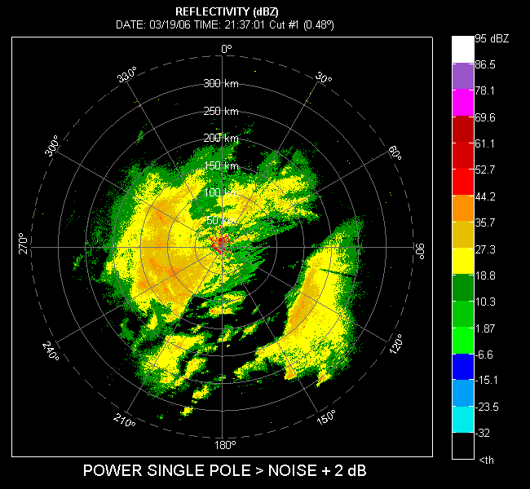

Fig. 2.2 a) Reflectivity field, horizontal channel. Data which exceeds 2 dB in SNR is displayed. Elevation is 0.48 deg, the long PRT (3106.7 μs) was used, and the clutter filter was not applied. Number of samples for estimates is 17.
Doubling the noise power but keeping the previous threshold amounts to lowering the threshold to – 1dB with respect to the double noise power as the test is 10log₁₀(P-2N) > 10log₁₀(N)+2=10log₁₀(2N)-1. Notice the plethora of spurious speckles in the display. This is expected because the PFA has increased from ≈1.2×10⁻⁶ to 3×10⁻³.

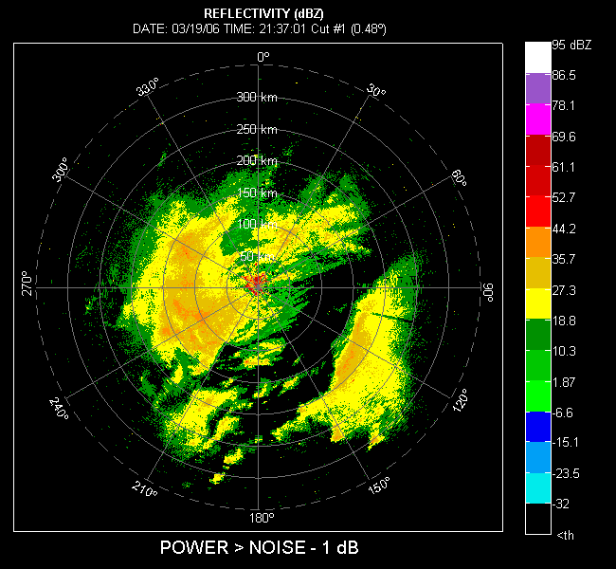

Fig.2.2 b) Same as in 2.2a except the noise power was doubled so that the equivalent SNR threshold is -1 dB.
The case for which the threshold is elevated to 2 dB above the noise level is in Fig 2.2c. If we compare it to the original PPI we notice that the significant portion of the features on the rim of the weather returns has been lost.
For this data set the noise power N_{h} = 1.21 N_{v} (i.e., 0.82 dB) and we find the threshold from Monte Carlo Simulations (for the desired PFA = 10⁻⁵ and M=17 samples) is T = 10.83 N_{h} (i.e., 10.34 dB).

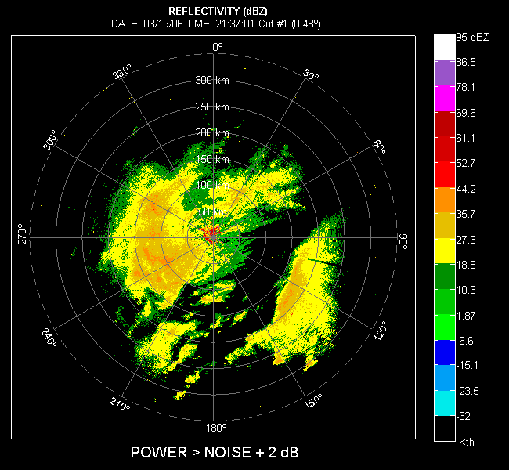

Fig.2.2 c) Same as in 2.2a except the noise power was increased by 3 dB, and the threshold is set to 2 dB above the total noise power.

Application of the sum [2.5b] with this threshold produces the PPI in Fig. 2.2d. We notice that all of the low reflectivity perimeter features have been recovered, and quite a few of previously censored data are now valid. This could be because the probability of false alarm (10⁻⁵) is about seven times larger then if the Legacy (2.1) threshold is applied. We plan to further investigate [2.5b] by varying the threshold and the weights so that a closer match of the fields in Fig. 2.2d and Fig. 2.2a would be achieved. This is very plausible and should be relatively simple to do; just reducing the PFA for data in Fig. 2.2d (to the value achieved in Fig. 2.2a) will inevitably shrink its detected area and bring it closer to the area in Fig. 2.2a.

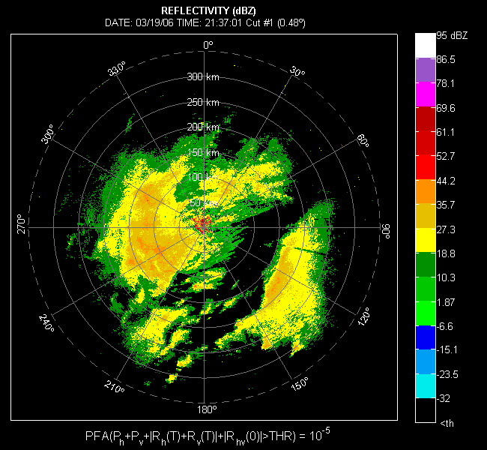

Fig. 2.2d) Same as in 2.2a except the noise power was increased by 3 dB, and the “best of the set” sum for detection has been applied.

Parameters that enter the choice of thresholds are SNR, number of samples M, spectrum width, ratio of noise powers N_{h}/N_{v}, and pulse repetition time T_{s}. Discussion of the optimum choice of the threshold and quantitative evaluation of the performance are the subject of the PhD dissertation by Ivic (2008). He has computed the thresholds for most Volume Coverage Patterns (VCPs). The section 2.3 of our report is extracted from Ivic (2009) and should be consulted for the details of implementation.

c) Velocity and spectrum width
The velocity should be computed from

v= λ arg{R_{h}(T_{s}) + R_{v}(T_{s})}/(4πT_{s}). [2.7]

Similarly, the spectrum width should be computed from the average of the two autocovariances. First the signal powers P_{sh} and P_{sv} are computed; herein the P_{sh} is listed and the same formula applies to P_{sv}.

. (2.8)

The formula (6.27) from Doviak and Zrnic (1993) can be used for computing the spectrum width. Thus

, (2.9)

Where P_{s} = P_{sh} + P_{sv} and R(T) = R_{h}(T) + R_{v}(T).
Another good option for computing spectrum width in the Doppler mode is from lag one autocovariances (Section 3, eq. 3.22).

Fig. 2.3 depicts the standard deviations of velocity estimates for four situations. The figure is obtained from simulations by Melnikov and Zrnic (2004) who also present a detailed study of the subject. It is assumed that the noise powers in the two channels are the same. Note that for a fixed signal power and a threshold of 3.5 dB the Legacy curve indicates an SD of better than 0.9 m s⁻¹. To obtain the SD in the dual polarization mode we look at the value for the SNR = 3.5 – 3 = 0.5 dB. If nothing is done (H channel in the figure) the SD would be about 1.3 m s⁻¹. If the combined R_{h}, R_{v} are used to estimate the velocity as in (2.7) the SD drops to about 1.2 m s⁻¹ and 1.1 m s⁻¹ at the values of Z_{DR} equal to 2 and 0 dB respectively. The results are worse for larger Z_{DR}, but better for smaller ρ_{hv}.

Fig. 2.3 Standard deviation of velocity estimates for the legacy system, the dual polarization system with a 3 dB loss in power (H channel), and the proposed solution (H&V channels) according to (2.7). Parameters in the simulations are Z_{DR} of 2 and 0 dB, spectrum width of 5 m s⁻¹, and unambiguous velocity 25 m s⁻¹ (PRF=1000 Hz and radar wavelength is 10 cm).

Clearly, it is possible to reduce the SD. So at the threshold of 0.5 dB per channel in the dual polarization mode the error would be ~25% larger than in the legacy (pre ORDA) system.

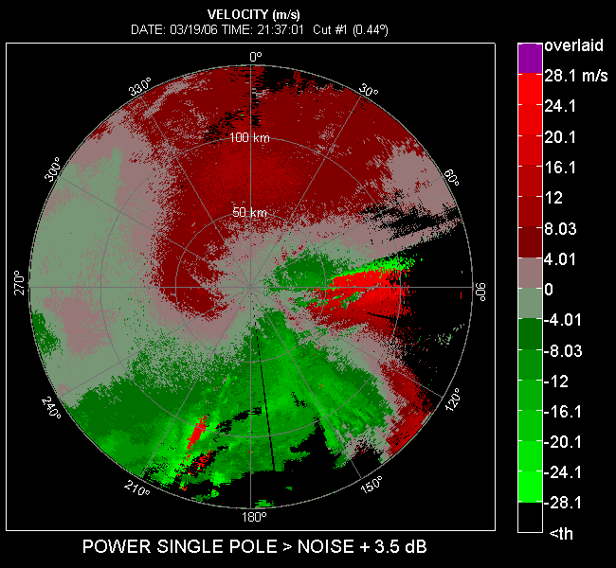

Fig. 2.3 a) Mean velocity field. SNR threshold is 3.5 dB. The short PRT of 986.7 μs was used and the number of samples per velocity estimate is 52.

We have tested the effects of several threshold schemes on the velocity field corresponding to data collected with the KOUN radar on March 19, 2006. In Fig. 2.3 a) velocity field obtained from a single autocovariance (2.2, pulse pair) is displayed for SNRs > 3.5 dB. This is the standard for comparisons because it is currently the default threshold on all WSR-88Ds.
Then, 3 dB of artificially generated noise was added to the time series data (of each the horizontal and vertical channel) and the threshold for displaying the fields was raised by 3 dB. This simulates the loss of 3 dB that would occur in each channel of the dual polarization radar. For comparison we display in Fig. 2.3 b) the velocity field obtained by applying (2.7) to this “noisier” data.
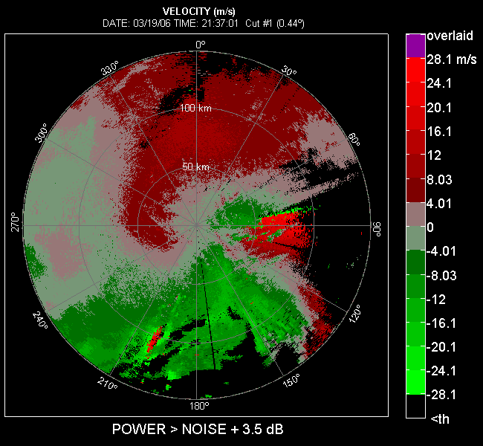

Figs. 2.3 b). Similar to 2.3 a) but for simulated dual polarization case. Three dB of noise was added to time series data used to generate Fig. 2.3a, and the SNR threshold was set to 3.5 dB with respect to the total noise (existing and added). This is equivalent to lowering the signal power by 3 dB and keeping the SNR at 3.5 dB; thus it represents the loss of data that would occur in the dual polarization case.

To recuperate the lost data (in Fig. 2.3b) a lower SNR threshold of 0.5 dB could be applied. The result of such “simulation” is in Fig. 2.3 c). One would expect the velocity field to be more cluttered by speckles after lowering the threshold (as in the case of the surveillance scan). This, however, does not happen; after lowering the threshold to 0.5 dB (for simulating the dual-pol case) the image is still very similar to the one in single-pol with the 3.5 dB threshold. The lack of cluttering from speckles can be explained by examining the false alarm rates for 3.5 and 0.5 dB thresholds. These are very low, 2.3368×10⁻²⁶ and 2.1429×10⁻¹⁰, respectively. Lowering the threshold to 0.5 dB (with M = 52) significantly increases the rate of false alarms compared to the rate if 3.5 dB threshold is applied. Nevertheless, the rate of false detections still remains so low that no significant cluttering in the PPI of the velocity fields is apparent.

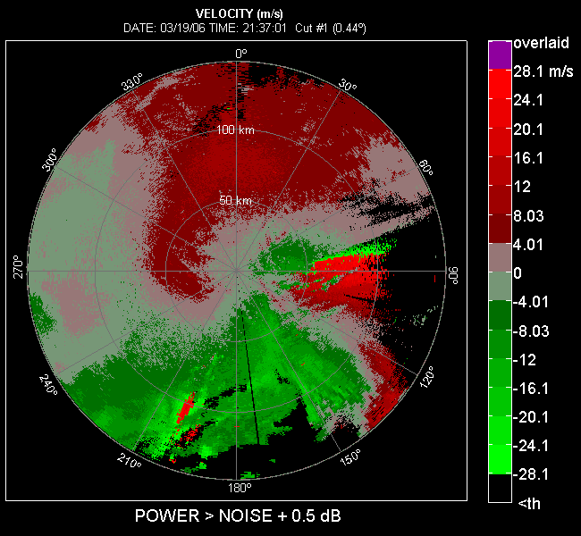

Figs. 2.3 c). Same as in 2.3 b) but the SNR threshold is 0.5 dB.

Next, we show the field after application of the same type of thresholding scheme as for the reflectivity. The velocity field thus obtained is in Fig. 2.3 d). Obviously the area of “useful” data is noticeably larger than in the cases whereby power thresholds were applied. This is not surprising because the false alarm rate for the “best” sum is 10⁻⁵ which is much higher than the false alarm rate for any of the power thresholds. Consequently (see Appendix B, Fig. B.5) the probability of detecting the signal is also higher compared to the probability of detection in cases the power threshold are used. This suggests that lowering the false alarm rate to less than 10⁻⁵ for the “best” sum should be explored (as well as changing the weights); it might be possible at lower false alarm rates to still detect much of the data that would be lost if only the power threshold is used.
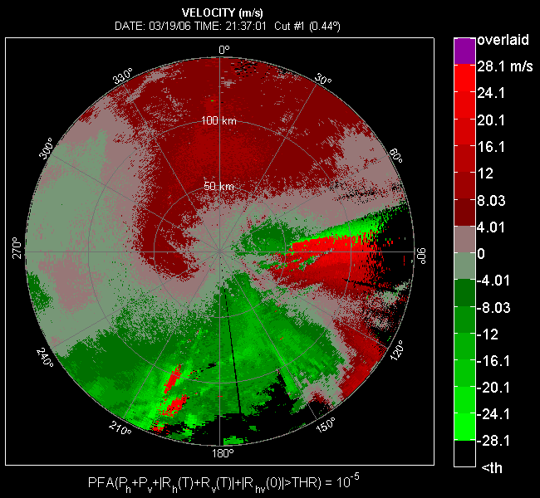

Fig. 2.3 d) Velocity field after application of the threshold scheme given by (2.5b).

As stated, the weights in the detection criterion (eq. 2.5b) were set to one, and quite satisfactory detection of weak signals was achieved. Intuition suggests that unequal weights might outperform our simpler scheme. Meanwhile the “best” threshold as in (2.5b) should be used for displaying and processing the velocity data. The same holds for the spectrum width. Test on the spectrum width and quantitative evaluation of the effects of thresholding remain to be demonstrated. Other more sophisticated possibilities based on the spectra should also be explored.
In the “best” sum case the ratio of noise powers was N_{h}/N_{v} = 1.2 (0.8 dB). For reflectivity estimates M=17 (surveillance scan in the split cut) and the threshold was T=4.7 N_{h.}. For velocity estimates (Doppler scan in the split cut) M = 52; the threshold in the optimum sum was T=4.9 N_{h}. If the signals are perfectly correlated all three covariances would equal signal power; then substituting this in (2.5b) reveals that detection occurs if SNR > - 2.7 dB (for T=4.7 N_{h}) and SNR > -2.4 dB (for T=4.9 N_{h}).
To get an idea at what SNRs the data will be displayed take the optimum threshold as T=5 N_{h} (rather than 4.9) and assume the following extreme cases of weather signal parameters. Full coherency in time (very small spectrum width) and across the channel (ρ_{hv} =1), as in the previous paragraph (see the Table below); this could be uniform wind with no turbulence and small drops. Full coherency in time but no coherency across the channels; uniform wind and chaff (has cross correlation coefficient ~ 0.3). No coherency in time but full coherency across channels; could be very turbulent flow containing small drops. No coherency in time and no coherency across the channels.

Case | Signal to noise ratio
Fully coherent in time and across channels | SNR > -2.2 dB (i.e., > 3/5)
Fully coherent in time but incoherent across channels | SNR > -1.2 dB ( > 3/4)
Incoherent in time but fully coherent across channels | SNR > 1 dB ( > 1)
Incoherent in time and incoherent across channels | SNR > 1.8 dB ( > 3/2)

2.3 Computation of thresholds for various M and N_{v}/N_{h}

This section is a slightly modified version of a section in Ivic (2008). It is self contained and explains how to compute the thresholds in real time. Different threshold based on the ratio N_{v}/N_{h}, should be computed for each M value used in the dwell time. Thus the threshold computation must be done at the end of each volume scan because N_{v} and N_{h} can change and are computed (for calibration of differential reflectivity) at the end of volume scans.
First let us examine the sensitivity of a PFA to a change in N_{v}/N_{h}. The analysis for the uniform sum (Fig. 2.4) indicates the PFA to be very sensitive to change in the N_{v}/N_{h} ratio. Moreover, the plots show that if we want to be within ±10% of the desired PFA, the true ratio N_{v}/N_{h} value must not differ more than 0.5% from the ratio for which the threshold is calculated. More important, though, is how much the resulting POD varies as the actual ratio N_{v}/N_{h} departs from the one for which the threshold was calculated. This is shown in Fig. 2.5 and Table Error: Reference source not found which suggest that the POD is moderately sensitive to variation in N_{v}/N_{h}. For instance, if M is 17 the drop in the N_{v}/N_{h} ratio of 2% results in only 0.5% loss in the detection rate. Moreover, as M increases the loss in POD for the same change in noise power ratio decreases, so if M = 52 the detection rate is merely 0.05% smaller for the 0.02 drop in the N_{v}/N_{h}. To put this into perspective and examine how this reflects on the detection of real signals, the following experiment is performed. The actual measured ratio of noise powers in V vs. H channel is 0.8269, so to assess the consequence of having N_{v}/N_{h} different from the one for which the threshold is found, , the amount of noise power added in the V channel is as follows. Let Δ be the amount by which we want the N_{v}/N_{h} to be skewed (i.e.,the desired difference between the N_{v}/N_{h} ratio for which the threshold is given and the true one). Then the amount of noise power that needs to be added in the V channel to achieve the desired ratio is
(2.10)
The results of choosing various values of Δ are given in Error: Reference source not found and Error: Reference source not found, for M = 17, and M = 52, respectively. These appear in agreement with the simulation results in Error: Reference source not found.
The analysis from the previous paragraph implies that for each M, an efficient method for threshold computation, based on the measured N_{v}/N_{h} ratio, should be devised. In this regard, the plot in Fig. 2.6 shows the threshold as function of the N_{v}/N_{h} ratio for
M = 17
Fig. 2.4 Uniform sum PFA sensitivity to change in the ratio N_{v}/N_{h} for threshold adjusted for PFA of 1.2×10⁻⁶, and the unity ratio N_{v}/N_{h}.

and PFA = 1.2×10⁻⁶. The circle markers in the plot denote the thresholds found for N_{v}/N_{h} ranging from 0.5 to 1 with the step of 0.05. The dashed line is the least squares fit using the gamma function
THR = N_{h} x^{B}e^{A+Cx} [2.11]
where x = N_{v}/N_{h}, to circle markers. As an assessment of the interpolation quality, square red markers are placed on top of the interpolation curve. These represent the estimated thresholds for N_{v}/N_{h} ratio ranging from 0.6 to 0.98 with the step of 0.02. Apparently, the gamma curve obtained as the least squares fit is an excellent approximation and can be used to quickly calculate the threshold for any ratio of noise powers in H and V channels.
Fig. 2.5 Uniform sum POD sensitivity to change in the ratio N_{v}/N_{h} for threshold set to PFA of 1.2×10⁻⁶, for the unity ratio N_{v}/N_{h}, and parameters SNR_{h} = 0 dB, σ_{v} = 2 m s⁻¹, Z_{DR} = 1 dB, ρ_{HV} = 0.96.

Table 2.1 The estimated drop in uniform sum POD vs. the drop in the ratio of N_{v}/N_{h} for threshold set to PFA of 1.2×10⁻⁶, for the unity ratio N_{v}/N_{h}, and signal parameters SNR_{h} = 0 dB, σ_{v} = 2 m s⁻¹, Z_{DR} = 1 dB, ρ_{HV} = 0.96.
Δ N_{v}/N_{h} | -0.01 | -0.02 | -0.03 | -0.04 | -0.05 | -0.06
Δ POD  (M=17) | -2.28×10⁻³ | -4.57×10⁻³ | -6.91×10⁻³ | -9.19×10⁻³ | -1.15×10⁻² | -1.39×10⁻²
Δ POD  (M = 32) | -1.44×10⁻³ | -2.86×10⁻³ | -4.5×10⁻³ | -5.84×10⁻³ | -7.65×10⁻³ | -9.11×10⁻³
Δ POD  (M = 52) | -2.45×10⁻⁴ | -4.71×10⁻⁴ | -6.9×10⁻⁴ | -9.28×10⁻⁴ | -1.16×10⁻³ | -1.41×10⁻³

Table 2.2 The uniform sum detections vs. the difference between the actual ratio of N_{v}/N_{h} and the one the threshold was adjusted for, in case of M = 17, and PFA of 1.2×10⁻⁶.
Δ | 0 | -0.01 | -0.02 | -0.05 | -0.1 | -0.2
Ratio of total detections | 0.984366 | 0.983747 | 0.983924 | 0.983573 | 0.982610 | 0.980850
The Ratio of bounded detections | 0.822027 | 0.814692 | 0.814696 | 0.812835 | 0.800011 | 0.782148
Ratio of additional detections | 0.021714 | 0.021760 | 0.021615 | 0.020041 | 0.018912 | 0.015892

Table 2.3 The uniform sum detections vs. the difference between the actual ratio of N_{v}/N_{h} and the one the threshold was adjusted for, in case of M = 52, and PFA of 1.2×10⁻⁶.
Δ | 0 | -0.02 | -0.05 | -0.1 | -0.2 | -0.4
Ratio of total detections | 1 | 1 | 1 | 1 | 1 | 1
The Ratio of bounded detections | 0.741758 | 0.741758 | 0.741758 | 0.741758 | 0.741758 | 0.741758
Ratio of additional detections | 0.471704 | 0.466731 | 0.457801 | 0.451406 | 0.437871 | 0.404143
Fig. 2.6 Straight line approximation to function that takes the N_{v}/N_{h} ratio as an input and outputs threshold for PFA = 1.2×10⁻⁶.

Table 2.4 Parameters for threshold calculation as THR = max(N_{h},N_{v})·
(min(N_{h},N_{v})/max(N_{h},N_{v}))^{B}·exp(A+C·min(N_{h},N_{v})/max(N_{h},N_{v})).
M/PFA |  |  |  | 5×10⁻⁷ |  | 6×10⁻⁷ |  | 7×10⁻⁷ |  | 8×10⁻⁷ |  | 9×10⁻⁷ |  | 1×10⁻⁶ |  | 1.1×10⁻⁶ |  | 1.2×10⁻⁶
10 |  | A |  | 1.4207 |  | 1.4156 |  | 1.4127 |  | 1.4137 |  | 1.4071 |  | 1.4020 |  | 1.3988 |  | 1.3975
 |  | B |  | -0.1047 |  | -0.1027 |  | -0.1001 |  | -0.0947 |  | -0.0961 |  | -0.0965 |  | -0.0957 |  | -0.0939
 |  | C |  | 0.6079 |  | 0.6062 |  | 0.6030 |  | 0.5968 |  | 0.5990 |  | 0.5999 |  | 0.5994 |  | 0.5973
11 |  | A |  | 1.3904 |  | 1.3873 |  | 1.3762 |  | 1.3697 |  | 1.3709 |  | 1.3668 |  | 1.3653 |  | 1.3615
 |  | B |  | -0.0859 |  | -0.0825 |  | -0.0863 |  | -0.0873 |  | -0.0823 |  | -0.0821 |  | -0.0802 |  | -0.0803
 |  | C |  | 0.5857 |  | 0.5821 |  | 0.5872 |  | 0.5888 |  | 0.5832 |  | 0.5833 |  | 0.5811 |  | 0.5816
12 |  | A |  | 1.3534 |  | 1.3473 |  | 1.3443 |  | 1.3395 |  | 1.3410 |  | 1.3349 |  | 1.3338 |  | 1.3298
 |  | B |  | -0.0767 |  | -0.0758 |  | -0.0736 |  | -0.0731 |  | -0.0681 |  | -0.0697 |  | -0.0676 |  | -0.0679
 |  | C |  | 0.5774 |  | 0.5771 |  | 0.5745 |  | 0.5745 |  | 0.5687 |  | 0.5710 |  | 0.5684 |  | 0.5693
16 |  | A |  | 1.2242 |  | 1.2281 |  | 1.2252 |  | 1.2134 |  | 1.2204 |  | 1.2084 |  | 1.2048 |  | 1.2036
 |  | B |  | -0.0595 |  | -0.0517 |  | -0.0494 |  | -0.0549 |  | -0.0459 |  | -0.0525 |  | -0.0526 |  | -0.0511
 |  | C |  | 0.5650 |  | 0.5551 |  | 0.5530 |  | 0.5606 |  | 0.5496 |  | 0.5583 |  | 0.5587 |  | 0.5570
17 |  | A |  | 1.2201 |  | 1.2175 |  | 1.2099 |  | 1.1990 |  | 1.1965 |  | 1.1936 |  | 1.2064 |  | 1.2039
 |  | B |  | -0.0402 |  | -0.0381 |  | -0.0395 |  | -0.0439 |  | -0.0425 |  | -0.0419 |  | -0.0300 |  | -0.0293
 |  | C |  | 0.5404 |  | 0.5369 |  | 0.5399 |  | 0.5468 |  | 0.5456 |  | 0.5450 |  | 0.5285 |  | 0.5285
21 |  | A |  | 1.1271 |  | 1.1217 |  | 1.1149 |  | 1.1103 |  | 1.1056 |  | 1.1040 |  | 1.1087 |  | 1.1026
 |  | B |  | -0.0351 |  | -0.0353 |  | -0.0359 |  | -0.0364 |  | -0.0369 |  | -0.0356 |  | -0.0292 |  | -0.0319
 |  | C |  | 0.5405 |  | 0.5406 |  | 0.5433 |  | 0.5439 |  | 0.5453 |  | 0.5437 |  | 0.5356 |  | 0.5396
25 |  | A |  | 1.0785 |  | 1.0733 |  | 1.0728 |  | 1.0703 |  | 1.0678 |  | 1.0644 |  | 1.0648 |  | 1.0622
 |  | B |  | -0.0141 |  | -0.0142 |  | -0.0109 |  | -0.0097 |  | -0.0088 |  | -0.0089 |  | -0.0064 |  | -0.0062
 |  | C |  | 0.5180 |  | 0.5181 |  | 0.5145 |  | 0.5133 |  | 0.5125 |  | 0.5129 |  | 0.5098 |  | 0.5100
28 |  | A |  | 1.0457 |  | 1.0408 |  | 1.0378 |  | 1.0352 |  | 1.0326 |  | 1.0313 |  | 1.0282 |  | 1.0280
 |  | B |  | -3.765e-3 |  | -3.416e-3 |  | -2.561e-3 |  | -1.527e-3 |  | -9.055e-4 |  | 5.054e-4 |  | 3.237e-4 |  | 2.192e-3
 |  | C |  | 0.5064 |  | 0.5067 |  | 0.5055 |  | 0.5046 |  | 0.5041 |  | 0.5025 |  | 0.5031 |  | 0.5009
29 |  | A |  | 1.0227 |  | 1.0232 |  | 1.0189 |  | 1.0148 |  | 1.0099 |  | 1.0090 |  | 1.0068 |  | 1.0098
 |  | B |  | -9.285e-3 |  | -5.248e-3 |  | -5.108e-3 |  | -5.286e-3 |  | -6.399e-3 |  | -4.801e-3 |  | -4.322e-3 |  | -2.64e-4
 |  | C |  | 0.5171 |  | 0.5118 |  | 0.5122 |  | 0.5129 |  | 0.5147 |  | 0.5127 |  | 0.5125 |  | 0.5072
32 |  | A |  | 0.9939 |  | 0.9966 |  | 0.9869 |  | 0.9916 |  | 0.9907 |  | 0.9872 |  | 0.9847 |  | 0.9848
 |  | B |  | -1.213e-3 |  | 4.296e-3 |  | 4.25e-4 |  | 5.993e-3 |  | 8.099e-3 |  | 7.707e-3 |  | 7.02e-3 |  | 9.016e-3
 |  | C |  | 0.5103 |  | 0.5028 |  | 0.5089 |  | 0.5005 |  | 0.4986 |  | 0.4994 |  | 0.4994 |  | 0.4970
37 |  | A |  | 0.9472 |  | 0.9462 |  | 0.9430 |  | 0.9422 |  | 0.9409 |  | 0.9374 |  | 0.9354 |  | 0.9350
 |  | B |  | 4.742e-3 |  | 7.631e-3 |  | 8.143e-3 |  | 1.011e-2 |  | 1.143e-2 |  | 1.088e-2 |  | 1.135e-2 |  | 1.268e-2
 |  | C |  | 0.5062 |  | 0.5030 |  | 0.5026 |  | 0.5001 |  | 0.4986 |  | 0.4996 |  | 0.4993 |  | 0.4976
41 |  | A |  | 0.9312 |  | 0.9431 |  | 0.9516 |  | 0.9339 |  | 0.9391 |  | 0.9365 |  | 0.9361 |  | 0.9352
 |  | B |  | 0.0197 |  | 0.0317 |  | 0.0414 |  | 0.0297 |  | 0.0373 |  | 0.0371 |  | 0.0388 |  | 0.0398
 |  | C |  | 0.4873 |  | 0.4710 |  | 0.4588 |  | 0.4737 |  | 0.4661 |  | 0.4662 |  | 0.4646 |  | 0.4634
43 |  | A |  | 0.9271 |  | 0.9382 |  | 0.9343 |  | 0.9375 |  | 0.9125 |  | 0.9247 |  | 0.9221 |  | 0.9155
 |  | B |  | 0.0288 |  | 0.0399 |  | 0.0393 |  | 0.0441 |  | 0.0277 |  | 0.0395 |  | 0.0393 |  | 0.0359
 |  | C |  | 0.4754 |  | 0.4604 |  | 0.4609 |  | 0.4542 |  | 0.4773 |  | 0.4625 |  | 0.4630 |  | 0.4677
46 |  | A |  | 0.9022 |  | 0.9014 |  | 0.8983 |  | 0.9041 |  | 0.9064 |  | 0.8942 |  | 0.8955 |  | 0.8969
 |  | B |  | 0.0275 |  | 0.0301 |  | 0.0304 |  | 0.0372 |  | 0.0416 |  | 0.0340 |  | 0.0372 |  | 0.0394
 |  | C |  | 0.4801 |  | 0.4768 |  | 0.4765 |  | 0.4679 |  | 0.4633 |  | 0.4734 |  | 0.4700 |  | 0.4665
52 |  | A |  | 0.8782 |  | 0.8715 |  | 0.8579 |  | 0.8564 |  | 0.8729 |  | 0.8735 |  | 0.8745 |  | 0.8572
 |  | B |  | 0.0404 |  | 0.0377 |  | 0.0299 |  | 0.0310 |  | 0.0464 |  | 0.0480 |  | 0.0508 |  | 0.0394
 |  | C |  | 0.4673 |  | 0.4699 |  | 0.4806 |  | 0.4793 |  | 0.4602 |  | 0.4573 |  | 0.4543 |  | 0.4704
56 |  | A |  | 0.8368 |  | 0.8422 |  | 0.8406 |  | 0.8431 |  | 0.8411 |  | 0.8359 |  | 0.8368 |  | 0.8342
 |  | B |  | 0.0265 |  | 0.0330 |  | 0.0347 |  | 0.0385 |  | 0.0389 |  | 0.0369 |  | 0.0396 |  | 0.0388
 |  | C |  | 0.4871 |  | 0.4778 |  | 0.4766 |  | 0.4713 |  | 0.4709 |  | 0.4741 |  | 0.4716 |  | 0.4722
60 |  | A |  | 0.8352 |  | 0.8348 |  | 0.8319 |  | 0.8338 |  | 0.8319 |  | 0.8207 |  | 0.8252 |  | 0.8252
 |  | B |  | 0.0405 |  | 0.0430 |  | 0.0429 |  | 0.0469 |  | 0.0467 |  | 0.0405 |  | 0.0451 |  | 0.0467
 |  | C |  | 0.4686 |  | 0.4659 |  | 0.4656 |  | 0.4610 |  | 0.4606 |  | 0.4700 |  | 0.4636 |  | 0.4618
63 |  | A |  | 0.8377 |  | 0.8412 |  | 0.8236 |  | 0.8336 |  | 0.8210 |  | 0.8276 |  | 0.8238 |  | 0.8246
 |  | B |  | 0.0538 |  | 0.0588 |  | 0.0485 |  | 0.0576 |  | 0.0505 |  | 0.0567 |  | 0.0552 |  | 0.0576
 |  | C |  | 0.4528 |  | 0.4457 |  | 0.4607 |  | 0.4476 |  | 0.4588 |  | 0.4497 |  | 0.4515 |  | 0.4492
64 |  | A |  | 0.8202 |  | 0.8211 |  | 0.8107 |  | 0.8160 |  | 0.8100 |  | 0.8085 |  | 0.8121 |  | 0.8052
 |  | B |  | 0.0441 |  | 0.0474 |  | 0.0422 |  | 0.0478 |  | 0.0448 |  | 0.0456 |  | 0.0498 |  | 0.0461
 |  | C |  | 0.4663 |  | 0.4619 |  | 0.4696 |  | 0.4616 |  | 0.4652 |  | 0.4648 |  | 0.4593 |  | 0.4646
70 |  | A |  | 0.8056 |  | 0.8211 |  | 0.7950 |  | 0.7969 |  | 0.8031 |  | 0.8024 |  | 0.7897 |  | 0.7985
 |  | B |  | 0.0525 |  | 0.0673 |  | 0.0492 |  | 0.0532 |  | 0.0594 |  | 0.0602 |  | 0.0521 |  | 0.0606
 |  | C |  | 0.4568 |  | 0.4381 |  | 0.4615 |  | 0.4575 |  | 0.4489 |  | 0.4475 |  | 0.4588 |  | 0.4487
87 | A |  | 0.7601 |  | 0.7510 |  | 0.7447 |  | 0.7379 |  | 0.7324 |  | 0.7542 |  | 0.7433 |  | 0.7718
87 | B |  | 0.0615 |  | 0.0586 |  | 0.0530 |  | 0.0519 |  | 0.0488 |  | 0.0668 |  | 0.0599 |  | 0.0827
87 | C |  | 0.4477 |  | 0.4544 |  | 0.4577 |  | 0.4630 |  | 0.4667 |  | 0.4423 |  | 0.4524 |  | 0.4216
88 | A |  | 0.7150 |  | 0.7596 |  | 0.7450 |  | 0.7438 |  | 0.7495 |  | 0.7417 |  | 0.7495 |  | 0.7407
88 | B |  | 0.0285 |  | 0.0663 |  | 0.0573 |  | 0.0592 |  | 0.0634 |  | 0.0593 |  | 0.0662 |  | 0.0610
88 | C |  | 0.4912 |  | 0.4429 |  | 0.4554 |  | 0.4551 |  | 0.4462 |  | 0.4525 |  | 0.4427 |  | 0.4505
In the batch mode there are cases whereby a small number of pulses are used in the long PRT (i.e., surveillance) chunk. For instance, in VCP 11 a batch mode exists with 6 pulses for surveillance. If power based censoring is used with the threshold set to 3.5 dB above the noise power, the rate of false detections can be obtained from eq. (A.11) in Appendix A, which gives the PFA of 1.1078×10⁻⁴. The coefficients for LS gamma fit, for such case, are given in Table 2.5.
Table 2.5 Parameters for threshold calculation as THR = max(N_{h},N_{v})·
(min(N_{h},N_{v})/max(N_{h},N_{v}))^{B}·exp(A+C·min(N_{h},N_{v})/max(N_{h},N_{v})).
M/PFA |  | 5×10⁻⁵ | 6×10⁻⁵ | 7×10⁻⁵ | 8×10⁻⁵ | 9×10⁻⁵ | 1×10⁻⁴ | 1.1×10⁻⁴ | 1.2×10⁻⁴
6 | A | 1.4783 | 1.4664 | 1.4758 | 1.4558 | 1.4507 | 1.4463 | 1.4424 | 1.4425
6 | B | -0.1114 | -0.1114 | -0.0975 | -0.1054 | -0.1027 | -0.1011 | -0.0991 | -0.0956
6 | C | 0.6228 | 0.6240 | 0.6050 | 0.6168 | 0.6151 | 0.6126 | 0.6105 | 0.6047

Similarly, when 8 pulses are used, the resulting false alarm rate is 1.1713×10⁻⁵. The coefficients for LS gamma fit are given in Table 2.6
Table 2.6 Parameters for threshold calculation as THR = max(N_{h},N_{v})·
(min(N_{h},N_{v})/max(N_{h},N_{v}))^{B}·exp(A+C·min(N_{h},N_{v})/max(N_{h},N_{v})).
M/PFA |  | 7×10⁻⁶ | 8×10⁻⁶ | 9×10⁻⁶ | 1×10⁻⁵ | 1.1×10⁻⁵ | 1.2×10⁻⁴ | 1.3×10⁻⁴ | 1.4×10⁻⁴
8 | A | 1.4396 | 1.4429 | 1.4383 | 1.4358 | 1.4296 | 1.4170 | 1.4263 | 1.4067
8 | B | -0.0965 | -0.0890 | -0.0878 | -0.0857 | -0.0863 | -0.0931 | -0.0822 | -0.0947
8 | C | 0.6016 | 0.5918 | 0.5908 | 0.5881 | 0.5898 | 0.5983 | 0.5850 | 0.6012

3. Computation of polarimetric variables for the simultaneous H, V (SHV) scheme

Computations of polarimetric variables described herein apply to a radar that transmits and receives simultaneously horizontally and vertically (SHV) polarized waves. Demonstration of such concept was made on the KOUN radar and the same is proposed for the WSR-88D upgrade. The computation of polarimeric variables can be done in the time domain or frequency domain. The real time processing on the KOUN (implemented by Sigmet) uses time domain computations. No clutter filter or schemes for mitigating Doppler ambiguities were incorporated into the demonstration. If spectral clutter filter is applied, a natural way to obtain the polarimetric variables is from the complex spectral coefficients. Similarly, if phase coding is applied, it becomes much more efficient to use directly the complex spectral coefficients of the weak echo signal than the time domain techniques for computing the polarimetric variables. This is because the spectral replicas of the weak signal are required for computing its spectral moments.
The purpose here is to present the equations for both time domain and frequency domain computations. Moreover, in case of time domain, two variants for computing the polarimetric variables are given. One is the standard method (employed on the KOUN) the other involves use of autocorrelations at lag 1.
The notation used follows the one in Section 2. It is repeated here for convenience. Assume that the sequence is transmitted at a uniform PRT of duration T_{s}. H_{i} is a complex signal (in-phase and quadrature phase) of horizontally polarized echoes at a fixed range location (same range gate) and, the first echo received is H₀. The spacing between H_{i} samples is T_{s} and the total number of H samples is M (that is the index i goes from 0 to M-1). V_{i} is a complex signal of vertically polarized echoes, these are transmitted at the same time as H samples. Therefore spacing between V_{i} s is also T_{s} and total number of V_{i} samples is also M. So the sequence of samples is (H₀ V₀), (H₁ V₁), (H₂ V₂), (H₃ V₃)…etc.

3.1 Standard method from time series data
The procedure written here is extracted form the paper by Zahrai and Zrnic (1991) and the patent by Zrnic (1996). Estimators of the polarimetric variables incorporated on the KOUN are listed next.

a) Estimation of reflectivity factor
Two powers, one for horizontally the other for vertically polarized signals, are computed as follows

(3.1)

(3.2)

From (3.1), the reflectivity factor for horizontal polarization Z_{h} is computed using system parameters and the radar equation. If the noise power is known (measured) it should be subtracted from (3.1) and (3.2). Otherwise it may be better to subtract the noise in the Radar Product Generator (RPG), or leave it alone. If the signal-to-noise ratios (linear scale) at two polarizations are measured, one can take the noise out by multiplying

Unbiased P_{sh} = P_{h} [SNR_{h}/(1+SNR_{h})], (3.3)

Unbiased P_{sv} = P_{v} [SNR_{v}/(1+SNR_{v})]. (3.4)

Note: The best way is to estimate the noise power separately for each radial; otherwise, use the calibration curve to obtain unbiased P_{h} and P_{v}. If for some reason the unbiasing is not practical, use equations (3.1) and (3.2); at SNR>15 dB the noise bias should not be significant.

b) Differential reflectivity Z_{DR}

Z_{DR} = 10 log (Unbiased P_{h} / Unbiased P_{v}) (dB) [3.5]

c) Differential phase Φ_{DP}

First compute autocorrelation R_{hv} (between H_{i} and V_{i} signals) as follows

. (3.6)

The total differential phase Φ_{DP} is computed from (3.6) as

Φ_{DP} = arg[R_{hv}(0)] (deg) [3.7]

The differential phase computed from (3.7) could be ambiguous and should be assigned to a contiguous 360 deg interval. But first the differential phase of the system must be removed from (3.7) and 25 deg should be added to the result. That way statistical fluctuation would not cause discontinuities in differential phase of storms close to the radar; by starting the phase 25 deg above zero allows for a large increase (close to 360 deg) before aliasing occurs. Thus, the differential phase of the system must be measured. This is done once by recording the histogram of differential phase of ground clutter (Zrnic et al. 2006) and taking its mean value. Alternately, it can be estimated from the value of Φ_{DP} measured in precipitation. Precipitation close to the radar causes small differential phase shift (less than 1 deg) so that the bulk of the difference is due to the system. To illustrate, let the system phase be -40 deg. The measurement may indicate some value close to -40 deg (could be a little more of less due to statistical uncertainty). Then 65 deg should be added to all the differential phases, 40 deg to remove system phase and 25 deg margin to eliminate aliasing at close ranges.

Note: Because in general the complex signals might not follow the convention assumed here (that is they might be conjugates of what is given herein) the differential phase could decrease in rain. If that happens, change the sign or switch the I,Q lines, or ask Ann Landers.

d) Mean Doppler Velocity v
The formulas presented here are a repeat from Section 2. These are suitable in cases that do not involve the clutter filter or phase coding. Two autocorrelations can be estimated to compute the Doppler phase shifts.

(3.8)

(3.9)

Let
ψ = arg(R_{h} + R_{v}), (3.10)

then the Doppler velocity is computed as

v = - λψ/(4πT_{s}), (m s⁻¹) [3.11]

where λ is the wavelength (about 0.01 m, the exact value should be computed from the known frequency, and T_{s} should be in s). At SNRs larger than 3.5 dB it may suffice to use only one autocorrelation and that should be R_{h} because it is usually stronger. Both should be definitely used at SNRs between 0.5 and 3.5 dB (see Section 2 eq. 2.5).

e) Spectrum width σ_{v}
Use equation (3.8) and (3.1) or (3.3), depending on how you compute the powers. The spectrum width is then

σ_{v} = λ [ln (P_{h}/|R_{h}(T_{s})|)]^{1/2} /(2πT_{s}√2) (m s⁻¹). [3.12]

If the argument under the logarithm is smaller than 1 set the spectrum width to 0 or to missing value. (See equation 6.27 in Doviak and Zrnic 1993). There are other ways to compute the spectrum width, such as from spectral processing, lag 2 and lag 1 autocorrelations (implemented in the SZ-2 phase coding), and so on; you can choose any that you trust.

f) Correlation coefficient at zero lag ρ_{hv}(0)
To compute ρ_{hv}(0) use (3.1), (3.2), or (3.3), (3.4) and (3.6). The result is

. [3.13]
Equations numbered bold, bracketed with [], and offset to the right represent the six variables that the primary signal processor should provide. Computation of specific differential phase, various thresholds, noise subtraction, and censoring should be done in the RPG.

3.2 Method based on autocovariances

Let R_{h}(T_{s}) and R_{v}(T_{s}) be the autocorrelations of the horizontally and vertically polarized returns at lag T_{s} (where T_{s} is the pulse repetition time). These autocorrelations are computed from the time series data or from the spectra.
From time series R_{h}(T_{s}) is obtained as

(3.14)

where M is the number of sample pairs, index n refers to time (nT_{s}), and H is the complex return at a specific range location.
From the spectrum S_{h}(k)

(3.15)
Identical formulas apply to the autocorrelations of the V signals.

We follow the notation in Doviak and Zrnic (1993) hence the autocorrelation (3.14 or 3.15) has the form

R_{h}(T_{s}) = P_{sh} ρ. (3.16)
Similarly
R_{v}(T_{s}) = P_{sv} ρ, (3.17)

where ρ = │ρ│exp(jω_{d}T), and P_{sh} and P_{sv} are signal powers (same as S_{h} and S_{v} in Doviak and Zrnic 1993).

Following Melnikov and Zrnic (2004) two cross correlation at lag T_{s} are expressed as:

, (3.18)
and

. (3.19)
where ρ_{hv} is the copolar correlation coefficient.

From equations (3.16, 3.17, 3.18 and 3.19) the polarimetric variables Z_{dr} (in linear units), and ρ_{hv} should be computed as (see details as well as errors in Melnikov and Zrnic 2004)

[3.20]
and
. [3.21]

These estimates are not biased by noise, but have somewhat larger standard errors.

Similarly, there is a spectrum width formula which is also not biased by white noise (see Melnikov and Zrnic 2004). The formula reads

, [3.22]

where . (3.23)

The arithmetic average of the two autocorrelations in (3.21) and (3.22) can be replaced with the geometric mean, that is

│R_{hv}(T_{s}) R_{vh}(T_{s})│^{1/2}. (3.24)

This was done and tested on simulated signals in the SNR range of 2 to 20 dB. Practically there were no differences between the errors obtained with either of these two variants.
Formulas in this section produce estimates that are not biased by white noise. Hence we recommend these for Doppler scans if the white noise is not estimated at each radial. For the long PRT surveillance scans and at larger spectrum widths these formulas could produce estimates with larger statistical errors. In such cases adaptive estimators can be applied, so that the estimate would be either from autocovariances or standard depending on the values of the correlation coefficients.
Last a brief suggestion on how to use the covariance estimates in cases of staggered PRT or batch mode. Take the staggered PRT. There are two autocorrelation pairs, R_{h}(T₁), R_{v}(T₁) and
R_{h}(T₂), R_{v}(T₂). Each of the autocorrelations can be estimated from the usual sum of lagged products. Then the combination of ratios (for example to compute Z_{dr}) would need to be used in either an arithmetic mean or geometric mean like

(3.25a)
or . (3.25b)

Analysis of (3.25a) and (3.25b) needs to be made to determine under which conditions one of these prevails. Adaptive estimators should be also considered for this case.

3.3 Spectral Computations

Let the complex spectrum coefficients be A_{h}(k) and A_{v}(k), where k is the spectral index. Because there are at most M spectral coefficients, it is possible to obtain the polarimetric variables from sums involving all of these coefficients. But often several spectral coefficients are discarded because they are either heavily contaminated by clutter, could be due to noise, or are not available (as in case of weak trip spectra of phase coded signals). In such cases, the remaining L spectral coefficients should be used with the following caveat. The significant coefficients must come from the same subset of the spectrum of both H and V signals. Preferably, there should be no additional manipulations of the spectral coefficients (such as interpolation) other than use of the same window on the H and V time series. The cross correlation between the H and V spectra is computed as

, (3.26)

where L is the number of coefficients which are significant. Similarly, the powers are computed from
(3.27)

(3.28)

The spectral noise powers should be subtracted from |A_{v}(i)|² and |A_{v}(i)|² to obtain unbiased values. Then, equations (3.5), (3.7), and (3.13) are applicable for computing the spectral moments and polarimetric variables.

3.4 Estimation of the noise powers

In the current WSR-88D, receiver noise power is estimated at the end of every volume scan and applied to data from the subsequent scan. Such procedure produces accurate results most of the time. Nonetheless, the noise power is not constant. It increases if there is precipitation along the beam because particles radiate noise. Further, at low elevations, contribution from the earth increases the noise level and there are incoherent radiation sourced that also appear as white noise. In the polarimetric WSR-88D, noise powers in both receiving channels must be estimated. If the estimates of noise powers are made at the end of every volume scan, then it would be advantageous to use the unbiased estimates of polarimetric variables (i.e., from autocovariances, section 3.3). Excepted are the cases where spectral computations (as with clutter filters, or ambiguity mitigation techniques) are required.
If noise powers are estimated in each radial then the standard method would work well.

4. Polarimetric measurements and mitigation of range velocity ambiguities

General overview of computations to obtain the polarimetric variables and mitigate ambiguities in range and velocity are presented herein. For the most part the proposed computations have been tested on time series data and/or via simulations. The discussion indicates preferred computations which are explained in sufficient detail to enable incorporation into the signal processing system of the ORDA. It should be understood that the capability of the signal processor and time constraints of the developers might require a phased approach. Such would initially incorporate less complicated, faster to run, test, and code procedures. These would then be improved through an evolutionary process.

4.1 Processing flow in the ORDA
In Fig. 4.1 plotted is a block diagram of pertinent subsystems envisioned for the time of polarimetric upgrade. Two channels, one for horizontal the other for vertical polarization are indicated. The current design contains one channel consisting of the first two blocks in the H path. Addition of the vertical polarization requires a second channel. There might be few variants in the actual implementation but these would not change the essence depicted in Fig. 4.1. For example the operations on the I & Qs could be done sequentially, or a physical separation into parallel streams for processing might be made. Decision on the optimum configuration should be made at a time closer to implementation when the tradeoff between cost and performance will be easier to quantify.

Fig 4.1. Data flow and major computation blocks in the dual polarization radar with simultaneous transmission/reception o horizontally and vertically polarized signals.
V- Digital
Receiver
H - Digital
Receiver

Combining the
H and V
signals to obtain cross-
covariances
and polarimatric
variables

to RPG
Processing H signals to obtain
autocovariances,
spectra, and
moments
Processing V signals to obtain
autocovariances,
spectra, and
moments

Processing of oversampled
(pseudo whitening?)
Autocovariances or spectra
Clutter Filtering
R/V mitigation

H - Digital Receiver
oversampled
Quality control: choice of
valid autocoavariances and
spectra (50 m spacing)
Combining autocovariances and spectra for 250 m spacing
Computation of
spectral moments
Dual Polarization
Cross covariances or
cross spectra
Quality control: choice of valid cross spectra and
cross coavariances
(50 m apart)

Combining cross spectra and cross covariances for 250 m
resolution
Computation of
polarimetric variables
H
V
Processing of oversampled
(pseudo whitening?)
Autocovariances or spectra
Clutter Filtering
R/V mitigation

V - Digital Receiver
oversampled
Quality control: choice of
valid autocoavariances and
spectra (50 m spacing)
Combining autocovariances and spectra for 250 m spacing
Computation of
spectral moments
Control

Fig. 4.2 (Previous page). More detailed flow of information and computations. The left side represents the flow for a single (H) channel and in the middle are operations and data flow (dashed lines with arrows) for dual polarization. The flow for the V channels is on the right side, and it is essentially identical to the H channel. The control above the red curve signifies that some computations in the V channel depend on the computations in the H channel. The two blocks “Computation of spectral moments” are actually connected as some of the moments (i.e., mean velocity and spectrum width) require combination of signal autocovariances at the two polarizations.

The Digital receiver block performs down conversion of IF signals to base band and digital filtering (matched, if needed). The Sigmet design allows output sample spacing, length of the filter (in range time), and pulse length to be independent. Therefore the length of the filter can be larger than the output sample spacing. This is important for conventional processing of oversampled (in range) signals. The sequence of operations on the I,Q samples is as follows (see the blocks on the left of Fig. 4.2).

Procedure
1- Samples are corrected for phase discontinuity in range. This is now part of the standard procedure implemented on the RVP8.
2 - Oversampling – initially 2.1 (see next paragraph) might be used. At a later time 2.2 or a variant thereof could supersede it.
2.1 - Oversampling with subsequent averaging.
The samples could be spaced 50 m apart so that there would be 5 samples within one pulse (250 m). The digital filter will be matched to 50 m (in the digital receiver block). In the processing block there will be two steps, one consists of identical processing (as without oversampling) on each I,Q (oversampled), the other will recombine the intermediate results to a resolution of 250 m.

2.1.1 First step: will depend on the choice technique for R/V mitigation.
2.1.1.1 Phase Coding – split cut: The procedure is exactly as documented in the NSSL report (Torres et al. 2004). It includes determining location of overlaid echoes, decoding for the desired recovery, and ground clutter filtering with the GMAP filter.
2.1.1.2 Staggered PRT: The procedure (without clutter filter) has been tested in real time and documented in the NSSL’s report (Torres et al. 2003). The proposed clutter filter will use GMAP (or variant) to identify clutter components. Removal of these at or close to zero can be done with the GMAP or a similar procedure. Replacement of clutter spectral components with correct weather components at other four locations (where clutter had been superposed due to staggered PRT) will be done according to the procedure developed at NSSL (Sachidananda 1999, Torres et al. 2005). This procedure has been tested on data collected with the RRDA and it works very well.

2.1.2 Second step:
Intermediate results such as autocovariances and spectra at 5 consecutive range locations will be combined (averaged) into one autocovariance (spectrum) from which spectral moments at 250 m range interval will be computed. Prior to averaging the intermediate results, data quality control could be applied to determine if some (or all) of the intermediate results should be censored. A simple consensus can be applied so that only estimates which agree (say three or more out of five) are combined. Other refinements should be examined. Suppose four out of five estimates are heavily contaminated by ground clutter (or AP), then it would make sense to retain the uncontaminated estimate. Clearly there will be several improvements which will evolve once oversampling is implemented.
2.2 Oversampling and whitening or pseudo whitening
The principal feature of whitening or pseudo whitening is that blocks of 5 consecutive oversampled signals will be transformed into blocks of 5 independent (I,Q) signals (almost independent in case of pseudo whitening). Each of these five is processed to obtain intermediate results which are then combined into spectral moment estimates at 250 m interval. Phase coding will be included in the processing similar to the procedure in 2.1.

Issues – Ground clutter filtering in the case of oversampled signals needs to be examined.

Thus far, the described procedure is equally applicable to single and dual polarization radar. But, in dual polarization mode there are additional computations and some constraints that need attention. These are explained next.

4.2 Polarimetric variables
In the simultaneous transmission scheme the polarimetric variables can be estimated from sums of operations on returns from single pulses (Section 3.1). That is, the estimation is similar as done for reflectivity in that no cross product of returns from successive pulses is required. Hence, if it were not for velocity measurements, polarimetric variables could be obtained with no range ambiguities whatsoever. That is how the data were obtained during the JPOLE experiment. Uniform PRTs have been the norm during JPOLE because at the time Sigmet processor was configured to accept only uniform pulse trains. Because Doppler measurements are also required, there are some specifics pertaining to estimation of polarimetric variables that need to be addressed if using a scheme to mitigate the effects of range velocity ambiguities.
Polarimetric variables can also be estimated from cross products of returns on successive pulses (Melnikov and Zrnic 2004, see also Section 3.2) or spectral processing (Section 3.3) can be used to enhance the quality of estimates. These techniques have been tested on times series data.
Two choice techniques to mitigate R/V ambiguities to be soon implemented on the WSR-88D are systematic phase coding and staggered PRT. NSSL recommends a volume coverage pattern with phase coding at the lowest elevations (one or two) and staggered PRT at higher elevations. Thus, herein we discuss ways to compute polarimetric variables and also mitigate the effects of range and velocity ambiguities. First, we briefly outline what procedure to employ in standard VCPs that have surveillance and Doppler scans at low elevations, batch at intermediate elevations, and Doppler at higher elevations.

4.2.1 Standard VCP

Polarimetric variables should be computed in both surveillance and Doppler scans. Then they should be sent to the RPG for further preprocessing. In the RPG, we recommend combining the polarimetric variables (and/or various correlation functions) from the two scans in the following manner.
If there are no overlaid echoes or the strongest trip power is larger by 20 dB (depending on the variable this number could be 15 to 25 dB) from the sum of weaker powers take the average of each variable (correlation functions if appropriate) from the two scans. If there are overlaid echoes take the variables from the long PRT. Then preprocess the new composite PPI to obtain K_{DP} and smooth data for classification and quantitative precipitation estimation.
The main thing here is to produce two streams of polarimetric data (or correlations) and, in the future, combine the two into one in the RPG.

4.2.2 Phase coding
Ground clutter requirements and possibility to perform spectral analysis suggest phase coding at the lowest one or two elevations. Further, requirement for un-obscured measurement of reflectivity to ~ 460 km favors separate scans for Z and v; thus long and short PRTs as in the current VCP are recommended. In this case, the polarimetric variables can and should be computed from both PRTs. The main thing here is to produce two streams of polarimetric data and combine the two into one in the RPG.

a) Surveillance scan
Estimates from the long PRT are free of overlaid echoes but have larger statistical errors. Standard formulas for computing these estimates are listed in Section 3.1. And this is how the computations were made on the Sigmet processor which we used in the JPOLE experiment. Improvements in estimates might be achieved through spectral processing, and this needs to be explored. Note that the spectrum of the long PRT data would occupy a relatively large part of the Nyquist interval therefore filtering of noise would be less effective compared to what is possible with Doppler PRTs. For the same, reason the autocovariance estimators of the polarimetric variables (Section 3.2) might not be as effective as in the case of Doppler scans. This should be quantified.

b) Doppler scan
Estimates from short PRTs in regions where there is no overlay of echoes can be used to supplement the estimates from long PRTs. These estimates could be the same as currently done, or might involve other more advanced techniques which will be examined in the near future. Improvements in sensitivity, noise rejection, and some reduction in statistical errors can be achieved by spectral processing of the signals.
We recommend one lag estimators for the polarimetric variables, because these are free of noise bias (Melnikov and Zrnic 2004). The functional description is in Section 3.2.
Regions of overlaid echo should be recognized- as currently done in the R/V mitigation scheme (SZ-2 or the legacy system).
Processing to obtain the polarimetric variables requires some additional steps. Ground clutter filter should be as recommended in the NSSL report (Torres et al. 2004) and subsequent modifications (Torres et al. 2005). It is the Sigmet’s GMAP filter with minor enhancements (such as preservation of phases of the amplitude spectrum) needed for phase coding. The sequence of operation remains as suggested in the report.
Section 4.5 contains the description of computations of the polarimeric variables from the short PRT. The essence is to compute the complex cross correlation from the complex spectrum. That is the echoes are cohered for the strong trip. The complex coefficients (two or more spectral replicas) for the weak trip furthest away from the strong are identified. These coefficients are injected into formulas (3.25, 3.26. 3.27) for computing intermediate results and then the differential reflectivity, the correlation coefficient, and the differential phase are calculated (as in Section 3.1). Censoring criteria should be similar (possibly more stringent) to the ones proposed for velocity and spectrum width estimates.

Issue: Censoring criteria and thresholds need to be determined.

c) Ground clutter filter and polarimetric variables
The ground clutter filter should be a spectral filter in which the coefficients containing clutter have been removed (Fig. 4.3). There should be no interpolation over the zero velocity gap to reconstruct the weather signal power. This applies to all the polarimetric variables. The exception could be in computing Z_{h}, v, and σ_{v} for which the GMAP could be used as is. The data in the H channel should determine the parameters of the clutter filter; these must be replicated exactly (range gate to range gate) in the V channel as depicted in Fig. 4.3. That way, each of the remaining spectral coefficients (after clutter filtering) in the H channel will have a matching coefficient in the V channel. If v and σ_{v} are computed as in (2.7) and (2.9) then GMAP should be applied to both H and V channels before combining the autocovariances. Elements of the GMAP (as in Fig. 4.3) should be used to identify which coefficients (notch width W) must be removed prior to computation of the polarimetric variables.

W
H
GMAP

Notch
width=W
Spectral
Filter
Notch=W
V
Z_{h}, v, and σ_{v}
Computation of Z_{DR}, ρ_{hv,} Φ_{DP}, from the
spectra of H and V
Fig. 4.3 A possible clutter filtering procedure. Alternatives are to interchange H and V in this figure or to use adaptively as master the channel in which clutter has more power.

After removal of the clutter spectral components the remaining complex spectra of the H and V signals should be used to compute the Z_{DR} and complex ρ_{hv}. A spectral SNR threshold should be applied to reduce noise contamination.

Issue: Clutter canceling followed by computation of polarimetric variables should be demonstrated on time series data.
Issue: Ground clutter power in the V channel is more often higher than its power in the H channel. Therefore an adaptive (gate to gate) choice of which channel to assume master control might be a better option than exclusive control with the H channel.

4.2.3 Staggered PRT
The 2/3 stagger ratio scheme is illustrated in Fig. 4.4. This scheme is recommended for elevations where echoes can not extend beyond a delay of T₂. In case that the echo extends up to 2T₁ censoring can be made so that such data are removed.
T₁
T₂
I II I II III

Fig. 4.4 Overlaid echoes in the staggered PRT scheme. It is assumed that there the scatterers are present up to the time delay T₂.

Examination of powers within the short PRT interval (regions I) and in region I of the long PRT interval can reveal overlay from the short PRT into the long PRT interval. Comparison of powers in region II of T₁ and region II of T₂ establishes if the echo extends beyond the T₂ interval. The choice T₁ and T₂ should be such that this does not happen. Therefore and for simplicity assume that the echo does not extend beyond the T₂ interval (this limit is shown in the figure 4.4). Then the powers, differential reflectivity, and cross correlation can be computed in the standard manner for intervals I and II within T₁, and II and III within T₂. The estimates from the interval II of each PRT should be combined to reduce statistical errors. Computations of Z_{DR} and ρ_{hv} should also be made in the region I of T₂ at range locations where there are no overlaid echoes. If there is no overlay it is advantageous to sum the powers and to sum the intermediate autocorrelations from regions I of T₁ and T₂. Then appropriate ratios can be taken (to obtain Z_{DR} and ρ_{hv}). Other techniques to compute the polarimetric variables should be explored.

4.4. Filtering ground clutter
NWS has accepted GMAP for clutter filtering on uniform PRT sequences. This filter or a modification will also be used on phased coding sequences. For example application of the filter should be different for estimation of reflectivity from application for estimation of differential reflectivity. Normally, before computing Z_{h}, the notch identified by GMAP is filled with a portion of a Gaussian shaped spectrum which approximates the spectrum of the weather signal. The same notch filter determined for the H signal must be used for the V signals (this is indicated with the control line in Fig. 4.2 or withd W in Fig. 4.3). Further, to avoid possible bias in Z_{DR} (which would be caused by artificial addition of the interpolated powers) there should be no interpolation of the spectral coefficients across these notches. Identical reasoning applies to the computation of the cross-correlation coefficient ρ_{hv}.
Another improvement dealing with clutter that the GMAP can make is in the mode whereby clutter is filtered in an operator-defined sector. Whereas now, at the short PRTs, the filter is applied to all data in the sector it would be advantageous to selectively apply the GMAP. This can be done by using the GMAP on the long PRT to determine which locations have clutter power (that is the powers above some threshold that the GMAP has removed). Then these locations could serve as instantaneous clutter map for application of GMAP at the short PRT. This would be important for regions where clutter is intermittent such as in cases of AP.
Polarimetric variables that we have used routinely had been obtained without clutter filtering. We have also examined polarimetric data after the time series have been filtered with the GMAP and other spectral clutter filters.
The polarimetric variables obtained before clutter filtering could be used as a proxy for an instantaneous clutter map. That might require two data streams within the RDA, one not filtered and the other filtered. Suggestions on how to generate the instantaneous clutter map using polarimetric spectral analysis are in conference paper by Zrnic and Melnikov (2007).
Finally, to reiterate, filtering data for estimating Z_{h} should differ from filtering data for estimating Z_{DR}, ρ_{hv}, and Φ_{DP}. Full GMAP is suitable for Z_{h}. But for computing the other polarimetric variables only a part of GMAP should be used. That is, only the notch provided within GMAP should be applied to the time series data and there should be no reconstruction of powers within the notch.

Issue: The effect on polarimetric variables of this proposed scheme. How the polarimetric variables are affected with this proposed scheme and/or any other clutter filtering scheme need to be explored.

Clutter filtering of staggered PRT sequences (Sachidananda 1999) should be modified for application on dual polarization data. Aside from having to filter two sequences (H and V), we must preserve the phases of reconstructed spectra which are needed for computation of differential phase. The phase reconstruction is described in a recent paper and it works very well (Sachidananda and Zrnic 2006). As previously argued, in filtering of the sequence pair, one sequence (H polarization) determines the exact filtering procedure which is then applied in an identical manner to both sequences.

Issue: Threshold for each polarimetric variable, including spectral moments. These need to be quantified.

4.5 Phase coding and computation of polarimetric variables
Computation and censoring of polarimetric variables should be similar to what is currently done on the velocity and spectrum width. The censoring thresholds might have to be different for each of the polarimetric variables.
In case of the strong trip echo overlaid with a weak echo the lag one estimators (Section 3.2) should be used to avoid bias.
For the weaker trip, the essence is to compute the variables from the complex spectrum. That is, the echoes from the H channel are cohered for the strong trip. The complex coefficients (two spectral replicas) for the weak trip farthest away from the strong are identified. The weak trip spectral coefficients in the V channel must occupy the same band as in the H channel (that is indicated by the control line in Fig. 4.2). That is, the notch width position for the V channel must be the same as for the H channel. That way, the two spectral replicas in the H and V channels would overlap completely. These coefficients are injected into formulas for computing the differential reflectivity, the correlation coefficient, and the differential phase (see Section 3.3 and 3.1). Censoring criteria should be similar (possibly more stringent?) to the ones proposed for velocity and spectrum width estimates.

Issue: Censoring thresholds for the polarimetric variables in the SZ-2 algorithm.

The functional description of processing the signals to obtain the polarimetric variables and use the systematic phase code (SZ) follows. For simplicity and to highlight the essence only two echoes are considered.

a) Assumptions and notation
Assume that two echoes are overlaid and have powers P1 and P2 measured with the long PRT.
We start with horizontally polarized signals h(i) at a range gate, where i is time index. We do not list the windowing to shorten this discourse, but a suitable window (as in the implementation of the SZ-2 on the ORDA) should be applied.

Notation: h1, h2 horizontally polarized signals cohered for trip 1 and trip 2 (that is the non cohered trip signal has the modulation code);
H1, H2 complex spectra of h1, h2;
v1, v2 vertically polarized signals, trip 1 and 2;
V1, V2 complex spectra of v1, v2;
R1 and R2 are autocorrelations of signals (at lag 1) cohered for trip 1 and 2 respectively, but without separation of trip powers;
P1h, P1v, P2h, P2v powers are for trip 1, 2 but the powers have been separated in the spectral domain; subscripts h and v refer to polarization;
Similarly ρ1_{hv}, ρ2_{hv} refer to complex correlations;
Φ1_{DP} = arg (ρ1_{hv}), Φ2_{DP} = arg (ρ2_{hv}).

b) Algorithm

1 Cohere trip 1 to get h1 and estimate autocorrelation at lag 1, R1(1). Cohere trip 2, to get h2 and estimate R2(1).
2 IF |R1(1)| and |R2(1)| are within X dB from each other.
3 Fourier Transform h1 and h2 to obtain H1 and H2
4 Fourier Transform v1 and v2 to obtain V1 and V2
5 IF |R1(1)| > |R2(1)|
6 Compute the mean velocity from R1(1) and thus the spectral index k where the spectrum H1(i) is centered.
7 Center the notch processing filter on k and retain at least two spectral replicas, total 2d coefficients farthest from k (on the circle). That is, take the index j from jmin = k+32-d to jmax = k+32+d. Note, an odd or even number of coefficients could be used, and there could be three spectral replicas!
8 Compute the powers by summing over j from jmin to jmax.
$P2_{h}=\sum_{j\text{min}}^{j\text{max}}{H1(j)H1^{}(j)}$ and $P2_{v}=\sum_{j\text{min}}^{j\text{max}}{V1(j)V1^{}}(j)\text{.}$

9 Compute Z2_{DR} as Z2_{DR} = 10log(P2_{h}/P2_{v})
10 Compute the complex correlation ρ_{hv} from
11 take the magnitude, and the argument equals Φ2_{DP}
12 Estimate the second trip velocity (and spectral index) from filtered data by recohering the spectral replicas from jmin to jmax.

Take the H2 (FFT(h2) obtained in 3) and repeat the steps 7 to 11 (that is interchange the numerals 1 and 2) to get Z1DR, ρ1_{hv}, and Φ1_{DP}. Skip step 12!
At this point the steps 7 to 11 have been done twice, first on the cohered spectra H1 and V1 to obtain the pol variables of trip 2!, then on H2 and V2 to obtain the variables of trip 1.
ELSE
Do the same computation as indicated by 6 to 12 except start with h2 and v2
First pass from 6 to 11 yields Z1_{DR}, ρ1_{hv}, and Φ1_{DP} then in step 12 the first trip velocity is obtained from filtered data. A second pass 7 to 11 will give Z2_{DR}, ρ2_{hv}, and Φ2_{DP}.
ELSE

Next are computations if one signal is considerably (X dB to be determined) stronger than the other. This is the case where the weaker signal might not be recoverable? Note – next we start arbitrarily with line No 20.

20 IF |R1(1)| > |R2(1)|
21 Compute the mean velocity from R1(1) and thus the spectral index k where the spectrum H1(i) is centered.
22 Retain about 2d spectral coefficients of H1 centered on k. An adaptive scheme can be used to find d, similar to GMAP, or Hildebrands Sekhon procedure or else. Also, one could retain an even or odd number of coefficients.
23 Compute the powers by summing j symmetrically with respect to k
$P1_{h}=\sum_{j=k−d}^{j=k+d}{H1(j)H1^{}(j)}$ and $P1_{v}=\sum_{j=k−d}^{j=k+d}{V1(j)V1^{}}(j)\text{.}$

24 Compute Z1_{DR} as Z1_{DR} = 10log(P1_{h}/P1_{v})
25 Compute the complex correlation ρ_{hv} from
$ρ1_{\text{hv}}=\frac{\sum_{k−8}^{k+8}{H1^{}(j)V1(j)}}{P1_{h}^{1/2}P1_{v}^{1/2}}$
26 take the magnitude, and the argument equals Φ1_{DP}

ELSE
Repeat steps 21 to 25 but with the H2 to obtain Z2_{DR}, ρ2_{hv}, and Φ2_{DP}.
END

5. Recommendations for initial implementation of polarimetric capability

This section contains the recommendation for processing in the RDA that should be implemented at the time of deployment. Its essence is to retain all the existing capabilities of the single polarization system, apart from a 3 dB loss of power per channel. Thus, potent capabilities offered by polarimetry are not utilized at this time, nor are other advances recommended. These are left for evolutionary enhancements over the forthcoming years. Current state of development on the ORDA guaranties that the capability at the time of dual polarization upgrade would include super resolution, and phase coding at the lowest two elevation scans. There is a slim chance that staggered PRT might be available in some VCPs. Sections herein contain the specific recommendation in terms of reference to either this report or other documents.
5.1 Calibration
Calibration of the reflectivity factor for horizontal polarization Z_{h} should be the same as on the current ORDA. Differential reflectivity should be calibrated according the report No. 2 by Zrnic et al. (2007). Determination of the system differential phase at time of deployment should be from the histogram of ground clutter (Zrnic et al. 2006) and unwrapping of phase should follow discussion on page 19, first paragraph after Eq. [3.7]
5.2 Determination of noise level and threshold for the variables
The two noise levels N_{h} and N_{v} should be measured at end of volume scans as currently done for N_{h}. Adjustment for various elevations should be as is for N_{h} and this procedure should be repeated for adjustment of N_{v}.
To recover the 3 dB sensitivity loss, the ORDA should combine H & V channel autocorrelations to compute velocity and spectrum width as in [2.7] and (2.9). A novel thresholding scheme for displaying Z and the other spectral moments will use the sum of powers and correlations as in [2.5b] with the weights (α, β, and γ) set to 1. The threshold in [2.5b] could be set to T=5 N_{h} in case that N_{h} > N_{v} and to T=5 N_{v} otherwise, but a better option might be 5(N_{h} + N_{v})/2.

5.3 Computations of polarimetric variables
At low elevations where surveillance scan (long PRT) precedes the Doppler (short PRT) scan, the polarimetric variables should be computed at both scans. Censoring thresholds for the polarimetric variables should be the same as for reflectivity estimates.
Issue: The threshold settings and combining the polarimetric variables from the two scans need to be further analyzed.
The variables should be computed from standard formulas: (3.1 and 3.2) for Z_{DR} with adjustment for noise as explained in the paragraph following (3.2). Differential phase is computed from [3.7] and adjusted to span an interval from 0 to 360 deg as explained in the paragraph following [3.7]. Cross correlation coefficient is computed directly as in [3.13], after the noise powers have been removed from the denominator terms in that equation.
Ground clutter filter must be identical for the H and V channels. Therefore minor modification of the GMAP filter needs to be made so that it can identify the coefficients to be removed; this has already been done on the version of the GMAP for SZ-2 scheme. The coefficients identified for removal in the H channel must be also removed in the V channel. And the polarimetric variables should then be computed from the remaining complex spectral coefficients in the two channels. See section 4.2.2 c) and equations (3.25, 3.26, and 3.27).
Computation of polarimetric variables in case of SZ-2 phase coded data should parallel the computation of Doppler velocity. That is, the polarimetric variables will follow the same paths (logic and analogous computations) as the mean velocities. In case of no overlaid echo, computation is from standard formulas. With overlaid echoes, for the strong trip use direct computations (possibly in the spectrum domain and take one half of the spectral coefficients around the peak of the strong trip spectrum). For the weak trip, use spectral computation on the two replicas as explained in sections 4.2.2 and 4.5.
For Batch and higher angle CD (continuous Doppler) scans, polarimetric variables should be calculated for 1 deg azimuth intervals, the same as the legacy moments. To reduce the errors in estimates, all pulses from longer and shorter PRT should be used. That is: calculate P_{h1} from the long batch PRT and use these to identify range overlay that can occur in the short batch PRT. The powers should be accumulated across the two PRTs so that the total P_{h} = P_{h1}(from long PRT) + P_{h2} (from short PRT). The Z_{v}, and R_{hv} should be computed from the continuous accumulation of values over the two batch PRTs unless range overlaid echoes are detected in the long PRT. In that case there are two possibilities. If the echoes are present but contamination is acceptable use all samples (batch of long and short PRT) for computing the variables. If the overlaid powers preclude accurate estimation from the batch of short PRTs only the batch from the long PRT should be used for computing the polarimetric variables. These should then be passed to the RPG. Decision will be made in the RPG whether and how to use these data.

Appendix A
Probability of false alarm for the Legacy Threshold scheme of the Z field
The threshold (2.1) on the signals in the surveillance mode produces very low probability of false alarm (PFA) so that false detections do not clutter the PPI images. Also, because meteorological radars deal with distributed scatterers, missing a few out of 1000 might be an acceptable trade-off for achieving low PFA. Consequently, calculation of PFA for a given threshold requires integral evaluation within the tail of probability density functions (pdf). Thus, Monte Carlo methods for evaluating these become very time consuming making it advantageous to obtain analytical expressions for the pdf. Herein we present an analytic expression from which one can evaluate the pdf.
The probability density of power samples from a single return is exponentially distributed. Let’s denote this pdf as f = exp(-y/θ)/θ, where θ is the mean power.
It is a well known that the sum
, (A.1)
of M independent exponentially distributed random variables (in our case powers) X_{m} with:
, (A.2)
has gamma distribution. For completeness the proof follows.
Proof: The moment generating function for each X_{m} is:
. (A.3)
Hence,
. (A.4)
This is the same as the moment generating function for gamma distribution with parameters:
. (A.5)
The formula used for power estimate is:
, (A.6)
with the mean and variance P and P²/M, respectively. Equating these values with the mean and the variance for (A.5), (i.e., Mθ and Mθ²) we get:
, (A.7)
which after replacing P with the noise power N gives us the following PFA for a certain threshold T:
, (A.8)
where P(x,α) is the incomplete gamma function defined as:
. (A.9)
We can express T as a function of N as:
, (A.10)
where T_{dB} is the threshold expressed in dB relative to the noise power N. Note that in the WSR-88D the known noise power is always subtracted from the estimate. Hence, the effective threshold for (A.6) is expressed as in (A.10). Now we can calculate the PFA for the power threshold as:
. (A.11)
If we put the power threshold to be 2 dB above the noise level this gives us low PFA of only 1.1749×10⁻⁶. If the threshold is lowered to -1 dB above noise the PFA increases to 3×10⁻⁶.

Appendix B

Combinations of correlation functions for censoring radar data

Ten candidates to threshold the data are compared herein. These are:
- OR OR
- OR OR
All thresholds were calculated with respect to the desired Probability of False Alarm (PFA). Given that a PPI has about 360*1000 = 360000 points, if PFA is taken to be 10⁻⁵ that would yield only 3.6 false detections per sweep. Consequently, this PFA value was taken as reference for comparisons using real data.
From the available radar data, noise powers were calculated for both the horizontal and the vertical channel. These values are (in the internal processor power units):
  - N_{h} = 3.4174 10⁻⁶ for the horizontal channel
  - N_{v} = 2.8259 10⁻⁶ for the vertical channel.
To choose the threshold for each approach and obtain a desired PFA (e.g., 10⁻⁵) we simulated time series data of the H and V components. Then we computed the various correlations, combined these into sums, and compared to thresholds. A total of 10⁸ trials were used to calculate the PFAs. For the first 8 approaches the results are shown in Fig. B.1 for the case when M = 17. In Fig. B.2 these approaches are compared in terms of Probability Of Detection (POD). From these plots it becomes obvious that the approach
(B.1)
yields the best results; it is referred to as the best of the set or simply “best”.
Figure B.1. PFAs for different approaches.
To evaluate the OR combinations (i.e. the last two approaches) thresholds were changes through a set of values. For each threshold combination PFA was found. Then, POD was calculated for each combination. The results together with the outcome for the best sum are in Fig. B.3. It is apparent that the best sum performs significantly better.
Next, we examine how the optimal sum behaves in terms of the POD for the preset PFA of 10⁻⁵. Using the values obtained through simulations (shown in Fig. B.1) exact threshold was calculated by straight-line interpolation between two values closest to 10⁻⁵. In total, 50000 trials were used to calculate each POD. Using the Chebyshev’s inequality, we get the confidence level of 99.982%, for ε = 10⁻², and p = 0.1. When normal approximation is used, the confidence level obtained is 100% for all practical purposes. In Figs. B.4 and B.5, PODs are examined for a various SNR and Z_{DR}, respectively.

Figure B.2. POD comparison.
Figure B.3. POD comparison for OR combination.
Figure B.4 POD versus SNR. For comparison, the optimal sum curve is plotted against the case if there were no 3 dB loss, and the 3 dB loss with the threshold 2 dB above noise.
Figure B.5 POD versus ZDR.

Appendix C

Computation of the noise level

Radar antenna intercepts thermal radiation from various sources including ground, precipitation, sun, sky, or man-made radiators. Further, abrupt change in receiver gain can cause wrong estimation of the SNR. Consequently, and depending on where the antenna is pointing, the receiver noise power will routinely vary by few dBs. In extreme cases of man-made interference (e.g., from other radars, etc.), the noise can increase by tens of dB. Therefore, to obtain best quality of polarimetric radar data it is desirable to estimate receiver noise for each radial and account for it in the computation of the radar variables.
Besides removal of noise from reflectivity, the noise should also be removed from the cross correlation coefficient and the differential reflectivity estimates. Noise can be estimated from powers in the several range gates at the end of PRTs. Here, we examine the number of samples needed to obtain accurate noise power which when subtracted from the total power will produce acceptable accuracy of ρ_{hv} and Z_{DR}. Because noise power samples are uncorrelated, the standard deviation of the estimates is N₁/√M, where N₁ is the mean power for a single return.

Testing if noise is white
A possible procedure to estimate the noise level could be as follows. Start from the last range gate in the surveillance scan (long PRT) and move forward by about 20 range gates; the suggested numbers are in this appendix.
Test the cross correlation function obtained from 17 samples (standard number per radial in the long PRT) to see if it is above a threshold. Let N be the noise power estimate from the previous radial or a default from calibration at the end of volume scan. The value at the end of volume scan is needed for cases where the noise can not be determined in a single radial.

Therefore,
if │R_{hv}│> γN ---------- discard that point. (C.1)

If (C.1) does not hold, the noise is most likely white and that data point could be accepted as due to noise. This remains to be tested. It is known that returns from chaff, or ground (under anomalous propagation conditions) have low cross correlation coefficient, and it is possible that some storms at such large range would exhibit small values of the cross correlation function.
Thus, there might be a convincing argument to test for whiteness. In that case the Kolmogorov-Smirnov test on the spectral coefficient can be performed. How to precisely apply this test on the Doppler spectra of weather signals is describes in detail by Urkowitz and Nespor (1992). This algorithm is also part of the GMAP ground clutter filter implemented on the ORDA. Thus, the code exists, and could be applied with minor modifications (elimination of the DC removal and clutter identifier) to determine the color of the signal. NSSL will provide (if needed) to the NWS the functional description of how the white noise power should be obtained.

Requirement for the correlation coefficient
The number of samples needed for a specified accuracy of the correlation coefficient is discussed next. Because we are concerned only with the accuracy of noise power which must be subtracted, we assume that the signal plus noise powers P_{h} and P_{v} and cross correlation function R_{hv} in the formula have no error. Further, we assume that the error in noise power equals the standard deviation and can be positive or negative. Consequently, the signal powers can be biased high or low. Thus, for short, we condense the notation, express the signal powers as S_{h} = P_{h} ± N_{1h}/√M, S_{v} = P_{v} ± N_{1v}/√M , and present the following equation for the biased

(C.2)

Consider the case Z_{dr} > 1 (in linear units) which prevails in weak signal regions. Further, for our purpose, set R_{hv} = (P_{h} P_{v})^{1/2} (because for precipitation the ρ_{hv} is high) and N_{1h}= N_{1v}= N₁. The formula (C.2) reduces to

(C.3)
This biased should not deviate from the true value by more than a specified tolerance δ and the worst case is if the symbol ± is replaced with the minus sign (-). Assume that the true value of ρ_{hv} is 1; one could use other values and reduce proportionately R_{hv} but this has little bearing on the minimum M needed for estimating the noise power. Therefore, we impose the condition

. (C.4)

It follows that if
, (C.5)
the inequality (C.4) will be satisfied. Thus, from (C.5), we find the value of M

M≥(Z_{dr}/(δ snr))², (C.6)
where snr = S_{h}/N₁ in linear units and both the signal and noise powers are per pulse (single sample of I,Q).
Before discussing the choice of M we turn to the required noise accuracy for Z_{dr} estimates. This is because the more stringent condition on the accuracy of the two determines the needed M.

Requirement for the differential reflectivity
Similar to the correlation coefficient the equation for the biased differential reflectivity Z_{drb} in linear units is

(C.7)

and the number of samples is found from the inequality

1-ε ≤ Z_{drb} ≤1+ε . (C.8)

Consideration of all the possible combinations of the plus and minus signs produces the following inequality for the number of samples M.

(C.9)

Discussion
Clearly δ and ε have very significant influence on M. The desirable δ is in the range 0.01 to 0.02 and ε is in the range of 0.02 to 0.05 (corresponding to 0.1 to 0.2 dB). Therefore, it follows that if (C.6) is satisfied (C.9) will be true.
Let’s next take parameters relevant to the WSR-88D. Polarimetric variables should provide superior measurements of precipitation to about 100 – 150 km; say 150 km. In the SHV mode the reflectivity factor corresponding to the receiver noise power at 150 km is 5 dBZ. We can further stipulate that snow with Z=15 dBZ should be quantified and/or discriminated with the polarimetric radar. This is an illustrative and reasonable assumption. Thus the accuracy should be maintained down to the SNR of at least 10 dB. Value of 3 dB (2 in linear units!) is reasonable for the differential reflectivity in snow. Then, (C.6) with δ = 0.01, snr = 10, and Z_{dr} = 2, produces M ≥400. With 17 returns per dwell time (radial) it follows that one would need 24 range gates to achieve the desirable accuracy. This is realistic and very practical.
If one relaxes δ to 0.02, M becomes 100. Suppose that one keeps M = 400; it follows that the SNR at which the 0.02 bias is maintained drops to 7 dB (i.e., linear 5). Therefore, at 150 km range snow with Z = 2 dBZ should be measured very well.

References:

Doviak, R.J. and D. S. Zrnic, 1993: Doppler Radar and Weather Observations. Academic Press. Second Edition, San Diego Cal., 1993, p. 562.

Doviak, R. J. and D. S. Zrnic, 1998: WSR-88D Radar for Research and Enhancement of Operations: Polarimetric Upgrades to Improve Rainfall Measurements, NOAA/NSSL Report, 110 pp.

I. Ivic, 2008: Decision thresholds for spectral moments and polarimetric variables. PhD dissertation, University of Oklahoma, Department of Electrical and Computer Eng. p 152.

Melnikov, V. M., and D.S. Zrnic, 2004: Simultaneous transmission mode for the polarimetric WSR-88D – statistical biases and standard deviations of polarimetric variables. NOAA/NSSL Report, 84 pp.

Sachidananda, M., 1999 (part 3): Signal Design and Processing Techniques for WSR-88D Ambiguity Resolution, NOAA/NSSL Report, Part 3, 81 pp.

Sachidananda, M., and D.S. Zrnic, 2006: Ground clutter filtering dual-polarized staggered PRT sequences. J. Atmos. Oceanic Technol., 23, 1114-1130.

Torres S., M. Sachidananda, and D.S. Zrnic, 2005 (part 9): Signal Design and Processing Techniques for WSR-88D Ambiguity Resolution: Phase coding and staggered PRT. NOAA/NSSL Report, 112 pp.
Torres S., M. Sachidananda, and D.S. Zrnic, 2004 (part 8): Signal Design and Processing Techniques for WSR-88D Ambiguity Resolution: Phase coding and staggered PRT, implementation, and clutter filtering. NOAA/NSSL Report, 157 pp.
Urkowitz, H. and J.D. Nespor, 1992: Obtaining Spectral Moments by Discrete Fourier Transform with Noise Removal in Radar Meteorology. Proceedings of the IEEE GRS Conference, Huston, 12-14.

Zrnic, D., V. Melnikov, and A. Ryzhkov, 2006: Correlation coefficients between vertically and horizontally polarized returns from ground clutter. J. Atmos. Oceanic Technol., 23, 381-394.

Zrnic, D., S. V. M. Melnikov, J. K. Carter, and I. Ivic, 2007: Calibrating Differential Reflectivity on the WSR-88D, Part II, NOAA/NSSL Report, 16 pp.

Zrnic, D., S. V. M. Melnikov, 2007: Ground clutter recognition using polarimetric spectral parameters. 33rd International Conference on Radar Meteorology, CD. AMS, Cairns, Au.

