Calibrating differential reflectivity
on the WSR-88d

PART II

National Severe Storms Laboratory Report
prepared by: Dusan S. Zrnic, Valery M. Melnikov, John K. Carter, and Igor Ivic

April 2007

NOAA, National Severe Storms Laboratory
120 David L. Boren Blvd, Normal, Oklahoma 73072

Calibration of Z_{DR}, simplification of the procedure

The purpose herein is to describe a simplified, but more robust, version of calibration procedure proposed by NSSL in the report by Zrnic et al. (2005). Elimination of few steps reduces the number of error sources. Critical element in the calibration procedure are also identified. A quick description of input and output points taken directly from that report (but slightly embellished), follows.
The block diagram in Fig. 1 captures the gist of the KOUN radar with points labeled 1 to 4 that are relevant for the subsequent discussion. The single line arrow

Transmitter
TR

El
Rot
Calibration
Port
Digital
Receiver
4
1
2
3
PS
S
Internal
Generator
Fig. 1 Diagram of the KOUN system with crucial points for calibrating Z_{DR}.

connects Transmitter to the Power Splitter (PS) and corresponds to the waveguide on KOUN which goes from the transmitter to the pedestal. Block arrows indicate two channels H and V as well as direction of signal flow. The H and V signals are simultaneously transmitted and received.
Point 1 represents coupler for transmitter power measurement. Point 2 represents two couplers above the elevation rotary joints for power measurements. Point S is the sun’s radiation flux at the antenna (outside of the radome). Point 3 corresponds to calibration couplers near the input to the low noise amplifiers (LNAs). Between the coupler and the LNA are the waveguide filter (bandwidth ~ 16 MHz) and the receiver protector. A variable attenuator (under computer control) is connected to a signal generator (or noise generator) for calibrating automatically the receiver. This is standard on the WSR-88D and it is crucial for maintaining calibrated Z_{DR}. Point 4 represents output of the digital receiver, that is digital I, Q values of both H and V components; from these one computes various powers, noises, and differential reflectivity. Absolute values of these powers do not matter, the ratios do matter.
The premise behind the procedure is to partition calibration into parts which are constant (time invariant) and parts which can vary with time. The time invariant part is measured once to establish the constant bias valid for the full dynamic range. The slowly varying part (see Appendix C) is tracked over the full dynamic range from volume scan to volume scan analogous to the AGC calibration in the Legacy system.
Bias between any two points is denoted with the symbol Δ_{ij}, where the first subscript (i) is the input point and the second (j) is the output. Although Δ_{ij} = Δ_{ji}, some of the bias can be easily measured only in one direction because of the placement of couplers which restrict signal flow. Hence, in general the signal flow direction both during measurement and actual operation is from the port indicated by the first index.

1. BIAS MEASUREMENT PROCEDURE
In this section we describe what was established so far (April, 2007), and list the organization which made the measurement. NSSL’s measurements are from the report and more recent verifications; they were made on the KOUN with the Sigmet’s dual polarization system. NCAR’s measurements are from the presentation to the TAC in October 2006 and were made on the S-Pole radar.

Established facts:

1) The Sun is a good calibration source for the receiver path (NSSL, NCAR).
2) The time varying part of the path drifts slowly; but, occasionally on the KOUN (WSR-88D) it exhibits sudden shifts of about 0.8 dB. These are caused by differenced in the LNA attributed to temperature controls in the housings of the two units.
3) There is coherent leakage associated with the internal signal generator, and it affects measurement of the bias at SNRs smaller than about 30 dB.
4) Uncertainty in the differential reflectivity bias from the sun measurement is 0.023 dB (NCAR) and 0.028 dB (NSSL). Mean value is zero.
5) Uncertainty in the values from the couplers is <0.1 dB, (NSSL).
6) The two (H, V) transfer gains of the receivers are linear over the whole dynamic range (NSSL).

The simplified procedure calls for two sets of measurements and continuous calibration at the end of volume scans.

1.1 TRANSMISSION CHAIN - FIRST SET
a.1) Point 1 to point 2:
Differential reflectivity in the transmission chain must be measured at the time of retrofit.
Deviation from 0 is the bias Δ₁₂. (1.1)

ISSUE 1: What is the accuracy (bias) and precision (standard deviation about the mean of this measurement)?

Recommendation and discussion: The V channel in the transmission path should be constructed of the same components as on the existing H channel. That way the differential attenuation between the two will be minimized. The bias Δ₁₂ should be recorded at the time of retrofit for the particular radar site. If it is larger than 0.1 dB consider adding it in the total correction. But do the measurement again. If it is less than 0.1 dB ignore it at the time of retrofit, because it might be a measurement error. It should be possible to deduce the error from the data later. Two major reasons for the bias are 1) an extra waveguide switch in the H channel (see the appendix A, and Zrnic et al. 2005), and 2) the dual rotary joint. Using a single azimuth rotary joint and placing the power splitter above it would eliminate cause 2). If the dual rotary joint is used we recommend measuring bias on all the dual rotary joints prior to installation. Cause 1) can be eliminated if one gives up the option of transmitting single H polarization, which is what we recommend.
Desirable measurement: The coupling losses of the two couplers. If these are measured with an accuracy of 0.03 dB, then the bias Δ₁₂ should be accounted for. If the accuracy is about 0.1 dB then larger bias should be corrected and smaller ignored.
Rationale for possibly ignoring this bias: The total specified attenuation from the splitter (excluding the 3 dB division and < 0.2 loss through the splitter) to point 2 of the H channel is 0.48 dB (Appendix A). In the V channel of the KOUN configuration it is 0.43 dB. The difference of 0.05 dB is within acceptable error.

a.2) Point 2 to outside of radome:
This is more involved and round about because it is deduced from measurements in the receiving chain; see the report by Zrnic et al. 2005.

The bias is denoted with Δ_{2S}. (1.2)

Recommendation: Ignore this bias in the transmitter chain. Rationale: the total attenuation in the H channel from above the El rotary joints to the outside of the radome is 0.3 dB. According to the adaptation data (Appendix A) it is comprised of:

-Loss through the coupler = 0.1 dB (the couplers in the H and V channels are the same so the losses should be the same). Thus the difference should be an order of magnitude smaller.
-Loss from the coupler to the antenna = 0.1 dB.
-Loss through the radome = 0.1 dB.

The difference in attenuation between the H and V channels must be significantly less than 0.3 dB, likely few hundredths of dB, and can be ignored. The total loss in the channel for the horizontal path (H) from the splitter (excluding 3 dB split and 0.2 dB pass through loss) to outside of radome is 0.68 dB. In the vertical channel (V) it is 0.63 dB.

ISSUE 2: What is the actual bias?

1.2 RECEIVER CHAIN - SECOND SET
The procedure requires permanent connection of the internal generators to the input of the LNA in the V channel. The existing line that goes to the H channel must be split, one end reconnected to the LNA of the H channel and the other to the LNA of the V channel, as done on the KOUN.

b.1) Point 3 to point 4: Use the internal generator, split the output, and apply to both couplers. (If there is coherent leakage in the circuits between the generator and the LNAs, the internal noise generator should be used at low values of SNR, see Zrnic et al. 2005. Such leakage was measured on the KOUN.) Change attenuation (of the internal attenuator, on the WSR-88D this is under computer control) in steps of 2 dB over the whole dynamic range. Generate the curve of Δ₃₄ (Z_{DR}) vs power P_{hk}, as in Fig. 2, where P_{hk} is the value of attenuated power in the horizontal channel at the output of digital receiver and k is the setting index. This power is in units internal to the digital receiver (i.e., digital numbers which are uniquely related to the input powers at the antenna – but that relation is immaterial for computing the bias!). Ideally this bias curve should have the value of 0 dB over the whole dynamic range;
deviation is the non calibrated bias Δ₃₄(P_{hk}). (1.3)

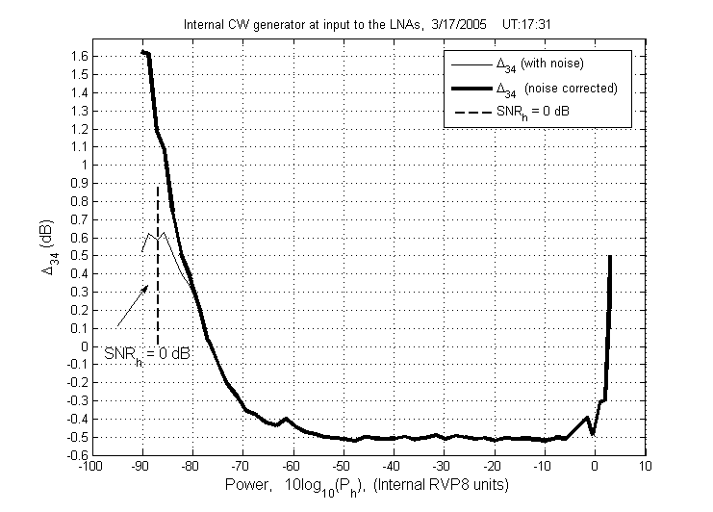
Extrapolation
Sun Z_{DR}
Adjustment

Fig. 2 Bias Δ₃₄ curve (black thick line). The red line is obtained from a least squares fit over the interval between -10 and -50 dB, and extrapolated to lower values. The calibration point from the Sun is at -79 dB. The final calibration is the gray line obtained by adjusting (raising) the red line to the level indicated with the calibration from the Sun.

This is not calibrated because it contains the part from the generator to the point 3 as well as the difference in the gains of the two channels (point 3 to point 4).
Note that the bias in Fig. 2 is constant at output powers between -10 dB and -50 dB. In general there could be a trend in this bias, so we recommend checking and fitting a line if needed. Indications are that it will not be the case!! Nonetheless the bias graph should be plotted at each site for inspection. The line is extrapolated to the low values of power and to the high values. At low values we have verified that the extrapolation is accurate, the deviation from the line in Fig. 2 is caused by coherent leakage (Zrnic et al. 2005). At high values saturation occurs and the bias in Z_{DR} could be few tenths of dB. This is of no practical consequence because the reflectivity at saturation is so high and would be a sufficient indicator of strong hail, or heavy rain/hail mixture; occurrence of saturation is generally rare.

ISSUE 3: Is the bias measured with the internal noise generator equal to the bias measured with the internal signal generator? On the KOUN this was the case. If it is not, use the value inferred from the noise generator to adjust the one from the signal generator. (Frequency spectrum of noise is similar to the one from the weather signal).

b.2) Immediately after b.1: Use sun scan and record differential reflectivity bias
Δ_{S4}(P of sun) (1.4)

This is the calibrated bias (at one power level, that of the sun’s radiation, yellow circle in Fig. 2) from the outside of the radome to the output of the digital receiver. It is the standard, the one that will calibrate (1.3).

b.3) Repeat b.1, and if the change is less than about 0.03 dB at the power (output of digital receiver) of the sun (i.e., at P_{hk} = Psun) then keep the curve (1.3). Otherwise offset the curve (vertically up or down) so that at the power of the sun the bias is given by (1.4). Label the new curve Δ_{34CAL}(P_{hk}) i.e., it should be used for bias removal (gray line in Fig. 2). NOTE, this curve is calibrated (compensated) for all the biases including the Generator to 3 and S to 3! Clearly the offset Δ_{C} is

Δ_{C} = Δ_{S4}(P of sun) - Δ₃₄(P_{hk} = Generator power = sun power). (1.5)

{Δ_{34CAL}(P_{hk}) = Δ₃₄(P_{hk}) + Δ_{C}}

The change in calibration should be tracked by performing automatically 1.3) at the end of each volume scan. (Amen).

c) Calibration

At the end of volume scan the correction Δ(P_{hk}) should be

Δ(P_{hk}) = Δ_{C} + Δ₃₄(P_{hk}) + Δ₁₂ , if Δ₁₂ ≤ 0.1 (1.6a)

Δ(P_{hk}) = Δ_{C} + Δ₃₄(P_{hk}) , if Δ₁₂ > 0.1 (1.6b)

To summarize:
Δ₁₂ is the bias due to the possible differences in the transmission chain, it is measured once. On the KOUN this bias is about -0.06 to -0.09 dB (see the Appendix A), and the bias from the Elevation rotary joints to outside the radome is 0.06. Thus the two almost cancel, or is it a coincidence? It is highly likely that the total bias on transmission on other WSR-88D radars will be similar; in which case the uncertainty in measuring it would be larger than its value.
Δ_{C} is the offset bias of the receiver. It contains all the inherent biases and uncertainties. It is completely determined from the sun scan and the internal generator. Further, its uncertainty could be made arbitrarily small. It is non intrusive.
Δ(P_{hk}) is the bias over the dynamic range of the receiver. It must be updated at the end of volume scan. It contains the variable part due to the difference in receiver gains.
Δ_{2S} is the bias on transmit between the coupler above El joints and outside of the radome. It is ignored because it is likely about 5 times smaller than the total loss along the H or V path.
The major uncertainty is in the measurements of transmitter power at the two couplers above the elevation rotary joints. Some further inquiry into this issue is in order.
For example measurements of losses through several couplers should be made to determine the accuracy (i.e., is it better than the stamped 0.1 dB values).
The knowledge obtained by performing the measurements as in the report and Zrnic et al. (2005) paper was crucial in making this recommendation. Further, the details on how to measure the bias constituents reported herein are also contained in the aforementioned papers.

Appendix A – Losses in the Transmission chain

Losses specified in the adaptation data of the KOUN are discussed herein, and related to the Z_{DR} bias. Description of measurement and detail configuration of the radar are in the report by Doviak et al. (2002). A power splitter and at least one waveguide switch are needed for two modes of operation: simultaneous H,V, (SHV) and H only. The simplified diagrams from Zrnic et al. 2005, are in Fig. A.1a and A.1b. On the KOUN this functionality is accomplished with two switches as in Fig. A.1a. Clearly the H channel contains one more switch than the V channel. This certainly contributes to the bias in differential reflectivity of 0.1 dB measured from the splitter to the output of the two circulators (Doviak et al. 2002). If the one switch configuration (Fig. A.1b) is adopted, the H wave would pass through that switch while the V would not thus unbalancing the system.

Recommendation: Give up on the single (H) polarization mode. That way there is no need for the waveguide switch. The bias of Z_{DR} on transmission would be reduced and it would be easier to house the dual polarization microwave circuits in the pedestal.

SP
S
H
V
T
SP
S₁ 111₁ ₁₁₁₁
H
V
T
S₂
a) b)

Fig. A.1 a) Configuration for transmission of simultaneous H and V signals on the KOUN radar; S₁ and S₂ are four port microwave switch and SP is the power splitter. The lines within the switch indicate which input ports are connected and the switch rotates 90º into its second position. Simultaneously activating both switches changes the SHV mode (in the figure) to H only mode. The circulators and receiver channels are not shown, but would connect to the H and V lines. b) Same as in a) except one switch accomplishes the actions of the two switches in a).

The losses of various components on the KOUN are indicated in the following table.

TABLE: Losses from the Transmitter to the feed horn; H channel

TR-17 | Arc Detector | 0.05
TR-18 | Harmonic filter | 0.15
TR-19 | Circulator | 0.2
TR-20 | Spectrum Filter | 0.2
TR-21 | Excess Loss | 0.05
TR-22 | Coupler – straight through | 0.05
TR-24 | Wave guide switch at Transmitter | 0.05
TR-25a | Wave guide to Switch at Pedestal | 1.6
S₁ | Wave guide switch | 0.05
SP | Splitter | <0.2
S₂ | Wave guide switch | 0.05
TR-25b | Circulator | 0.2
TR-26 | AZ rotary joint | 0.1
TR-27 | Wave guide to EL joint | 0.08
TR-28 | EL rotary joint | 0.05
TR-29 | Coupler through | 0.1
TR-31 | Wave guide to feed horn | 0.1

The TRs followed by numbers represent elements in the transmission path for horizontal polarization as listed in the adaptation data (values are in black font). The S₁ and SP are common to both channels (all in black fonts are) and the S₂ is unique to the az channel (it is in red font); these are not in the adaptation data. Rather, they have been measured or specified (values in orange, Doviak et al. 2002). The TRs in blue font are separate and mostly identical components in the H and V channel. The attenuation through the splitter (apart from the 3 dB split power) is from specifications and would be present in both channels. The splitter is made with machines under computer control and thus is very symmetrical, therefore no bias is expected.
The TR-25 (1.8 dB loss) from the adaptation data is split into 1.6 dB up to the switch S₁ and 0.2 through the circulator because we have modified the path by adding the circuit in Fig. A.1a. Adaptation data indicates 0.2 dB loss through the circulator in the shelter close to the transmitter (hence we took the same value for the one in the pedestal).
Measurements from the point T (into the switch S₁) to the output of the circulator (connected at the H and V arrows in fig. A.1a, but not shown) indicate the loss in H is 3.4 dB and in V it is 3.3 dB (Doviak et al. 2002). Clearly the excess loss (above the 3 dB by the splitter) is 0.4 in H and 0.3 in V channel.
It is instructive to compare the losses of the H and V powers in the parts of the channels that are physically separate. Thus from S₂ to the feed horn the loss in H channel is 0.68 dB. In the V channel it is 0.63 dB (because there is one switch less for the wave to traverse). The difference between the two is - 0.05 dB (i.e., the gain in H is -0.05 dB with respect to V). It is difficult to directly verify this bias, but our measurement (above the elevation rotary joints, see Appendix B), of ~ -0.06 is consistent with the adaptation data and partial measurements made earlier (Doviak et al. 2002).

Appendix B - Measurements above the rotary joints

To check consistency of previously estimated bias in power splitting above the El rotary joints several of measurements were made in Nov 2006. In the first set two power meters were connected to the couplers above El rotary joints and the transmitter was repeatedly turned on and off fifteen times. The results (in dB) follow.

Measurement 1:
TRANSMITTER HORZ VERT

7.07 10.47 10.82
7.07 10.46 10.82
7.10 10.50 10.86
7.09 10.49 10.85
7.10 10.50 10.86
7.11 10.51 10.87
7.08 10.48 10.85
7.12 10.52 10.88
7.11 10.51 10.87
7.12 10.52 10.88
7.12 10.53 10.88
7.10 10.50 10.86
7.13 10.54 10.89
7.13 10.54 10.89
7.11 10.52 10.87
Test made by Richard Wahkinney and Mike Schmidt, Nov 17, 2006. HORZ and VERT indicate powers above the EL rotary joints in the horizontal and vertical channels, and the left column is the power of the transmitter. The mean difference is: Mean = -0.3573 dB; The difference in couplers is -0.3 dB (i.e., P_{hc} – P_{vc} = -0.3 dB), after taking it out we obtain the correct mean of -0.0573 dB; SD = 0.0059 dB.

Measurement 2:
The second set of measurements produced the following results:

RADAR XMTR CHANGES 2
11/21/2006

TRANSMITTER HORZ
7.09 10.49
7.16 10.55
7.18 10.58
7.17 10.57
7.18 10.58
7.18 10.58
7.18 10.58
7.20 10.60
7.18 10.58
7.20 10.60

TRANSMITTER VERT
7.19 10.98
7.20 10.98
7.17 10.95
7.19 10.98
7.18 10.97
7.19 10.98
7.20 10.99
7.18 10.97
7.20 10.99
7.19 10.97

Test made by Richard Wahkinney, Mike Schmidt, and Mark Benner. This test is using one power meter at the transmitter and one power meter at the couplers above the El rotary joints. We disconnected the meter at the antenna port between each measurement. Transmitter ON for 25 seconds and OFF for approximately 1 minute. Mean = -0.3880 dB, take out -0.3 dB (couplers), true mean = -0.088 dB and SD = 0.0042 dB. The mean values from both measurements agree very well with the -0.06 measured in 2005 (Zrnic et al. 2005).

Measurement 3:
One more measurement was made on April 4, 2007 by Schmidt, Wahkinney, and Zrnic. This time we took several readings but chose to compute the bias from those in which the digital readout of the transmitter power was very stable (several seconds of no change in value). The measured bias was -0.67 dB (if coupling loss stamped on the coupler is used). Note that the measured value of coupling loss differs by 0.04 dB from the stamped value; its inclusion produces a bias of -0.71 dB. This is clearly a very stable and repetitive outcome.
At that time the total loss (H channel) from the transmitter coupler to the coupler above the EL rotary joint was measured to be 5.61 dB (including 3 dB in the splitter). Our adaptation data indicate 5.43 (it is 2.43 dB without the splitter). The difference 0.18 dB could be due to some values that were taken from manufacturer’s specifications but not measured or measurement error. Still, for absolute measurements this accuracy is very good.

Conclusion: The manufacturer’s stamped values of coupling loss (on the KOUN radar) are good to 0.1 dB. For the one time calibration at upgrade make a measurement with a single power meter above the elevation joints (switch between measurements) but monitor the power of the transmitter (and adjust accordingly the bias). Ignore this bias if it is < 0.1 dB.
Recommendation: Verify that the couplers are calibrated to better than 0.1 dB. If this is not so, then it is desirable to measure the coupling loss.

Appendix C - Variation of the bias with time

The automatic procedure to calibrate the receiver chain has been implemented on the Research RDA. It can be activated at the end of volume scans or used in a computed control mode. Herein the results from a measurement over several hours are presented (Fig. C.1).

Fig. C.1 Variable bias measured on March 22-23, 2007. Time 0 min corresponds to about 4:30 pm local time.

For most of the measurement the variation in the bias is insignificant (400 to 1000 min). The change of about 0.025 dB occurs between 6:30 and 8:30 pm local time. This is caused by temperature change at sunset. There is no change in the morning hours (end of measurement is at about 9 am), because there was little temperature change at sunrise; the skies were overcast with thick clouds.

Appendix D - Verification of bias

An indirect verification of the bias correction is presented herein. It is done on data from drizzle that occurred on Feb. 6, 2005.

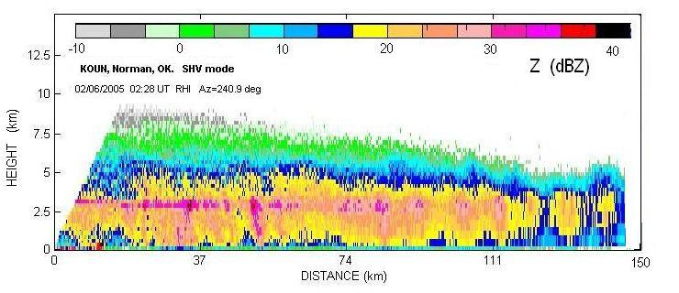

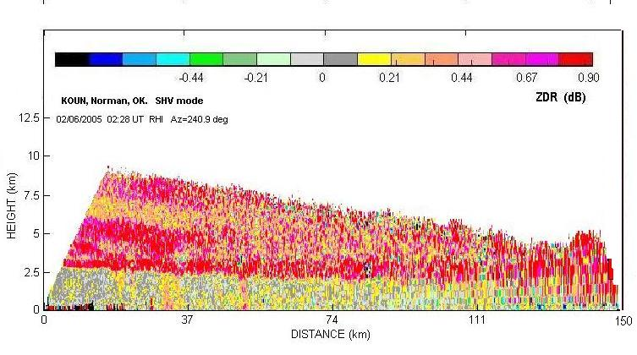

Fig. D.1 Vertical cross section of reflectivity factor field (top) and differential reflectivity (bottom). Data enclosed in the rectangle are used to obtain Z_{DR}.

The Sun scan was used for absolute calibration, and the bias in the transmitter path was ignored. On this day the bias from the SUN was computed to be 0.65 dB negative. So 0.65 dB was added to all the values of Z_{DR} in the figure. Histogram was obtained from the region enclosed with the rectangle in Fig. D.1 (0.5 to 2.5 km in height and 0 to 35 km range); it is displayed in Fig. D.2.

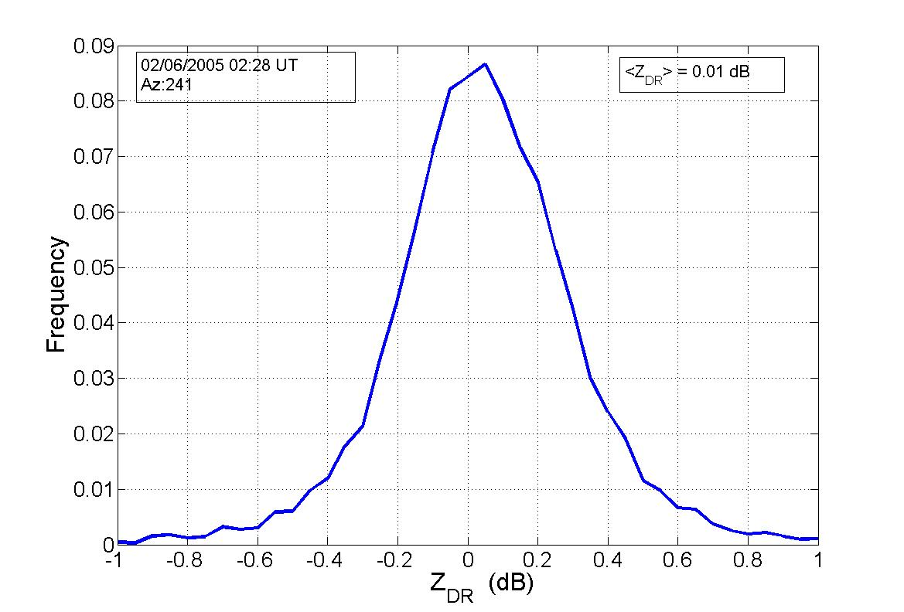
Adjustment using
only Sun’s Z_{DR}

Fig. D.2 Histogram of differential reflectivity. The absolute calibration made with the sun scan is indicated. The mean value of the histogram is 0.01 dB and the peak is at 0.04 dB.

Considering that drizzle was observed at the radar, that the reflectivity of the data in the histogram is between about 10 and 23 dB, we would expect that peak (or mean) to be somewhere between 0 and 0.1 dB. The extremely good match with intuitive expectation could be a coincidence. The KOUN is the only one polarized WSR-88D. Thus, we have no other samples to compare it with. Comparison with other radars brings more unknowns and uncertainties because the hardware is quite different.

References:

Doviak, R.J., and D.S. Zrnic, 1993: Doppler radar and weather observations. Academic Press. p 562.

Doviak, R.J. and D.S. Zrnic, 1998: Polarimetric upgrades to improve rainfall measurements. NSSL report, April 1998. p 110.

Doviak, R. J., J. Carter, V. Melnikov, and D.S. Zrnic, 2002: Modifications to the Research WSR-88D to obtain Polarimetric Data, NOAA/NSSL Report, 49 pp.
Lee, J-S., K.W. Hoppel, S. A. Mango, and A. R. Miller, 1994:
Intensity and Phase statistics of multilook polarimetric and interferometric SAR imagery. Trans. Geosci. Remote Sensing, 30., 686-696.

Melnikov, M.V., and D.S. Zrnic, 2004: Simultaneous transmission mode for the polarimetric WSR-88D. Statistical biases and standard deviations of polarimetric variables. NSSL Report, June 2004. p 84.

Sachidananda, M., 1999: Signal Design and Processing Techniques for WSR-88D Ambiguity Resolution, NOAA/NSSL Report, Part 3, 81 pp.
Torres S., D. Zrnic, and Y. Dubel, 2003: Signal Design and Processing Techniques for WSR-88D Ambiguity Resolution: Phase coding and staggered PRT, implementation, data collection, and processing. NOAA/NSSL Report, Part 7, 128 pp.

Torres S., M. Sachidananda, and D.S. Zrnic, 2004a: Signal Design and Processing Techniques for WSR-88D Ambiguity Resolution: Phase coding and staggered PRT, implementation, and clutter filtering. NOAA/NSSL Report, 157 pp.
Torres S., D. Zrnic, J. Hubbert, G. Meymaris, S. Ellis, and M. Dixon, 2004b: NEXRAD Range-Velocity ambiguity mitigation SZ-2 algorithm recommendation. FY2004 NSSL-NCAR interim report.

Torres S., M. Sachidananda, and D. Zrnic, 2005: Signal Design and Processing Techniques for WSR-88D Ambiguity Resolution – Phase Coding and Staggered PRT

Urkowitz, H., and J.D. Nespor, 1992: Obtaining spectral moments by discrete Fourier transform with noise removal in radar meteorology. Geoscience and Remote Sensing Symposium, IGARSS ‘92, International, Houston TX, 12-14.

Zrnic, D.S., 1996: Simultaneous Differential polarimetric measurements and co-polar correlation coefficient measurement. US Patent No. 5500646.

Zrnic D.S., and Z. Zahrai, 2003: Evolution of weather surveillance radars, NSSL’s perspective. Preprints 31st Conference on Radar Meteorology (Volume II), AMS, Seattle WA. 939-941.

Zrnić, D.S., Melnikov, V.M., and J.K. Carter, 2005: Calibrating differential reflectivity on the WSR-88D. NOAA/NSSL Report, 34 pp. abridged version is in J. Atmos. Oceanic Technol. 23, 944-951.

