Dangerous Weather Condition & Safety Tip
4 of 5
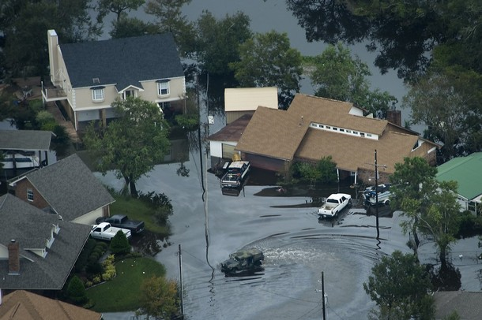
FLOODS

What is it?
Floods are one of the most common disasters. They can be small - just in your neighborhood. They can be large - in many states at the same time. All floods are not alike. Some floods grow slowly. They can grow over many days. Other floods grow quickly. They can happen in just a few minutes, even when it’s not raining!

How will you know it is coming?
Watch your local television and listen to radio newscasts, check www.weather.gov, and purchase a NOAA Weather Radio. Monitor your community’s river levels at www.weather.gov/water.

Safety Tips
- Turn around - don’t drown! Never walk or drive into flood water
- Evacuate if officials tell you to do so
- Move to higher ground right away
- Set up campsites on high ground. Never camp in a flood plain, beside a swollen river, or in a valley during heavy rain

