Dangerous Weather Condition & Safety Tip
1 of 5

HURRICANES
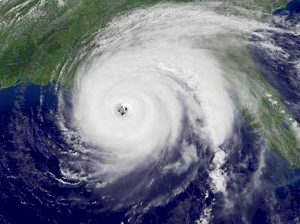
What is it?
A type of tropical storm that has thunderstorms and strong wind. Hurricanes travel quickly across ocean waters. They can cause serious wind and flood damage to coastlines and nearby places.

How will you know it is coming?
Fortunately, hurricanes develop over the ocean and move slow enough to give us advanced warning before one makes landfall. Watch your local television news, listen to the radio, check www.weather.gov, and purchase a NOAA Weather Radio to stay informed about a hurricane’s path, its intensity, and what local officials are advising you to do.

Safety Tips
- Know your community’s evacuation routes and emergency shelters
- Have a family evacuation plan and use it if authorities say to do so
- Prepare your house for high wind by boarding up windows
- If you stay, remain indoors, away from windows
- Have a disaster supply kit ready, including fresh water

