Dangerous Weather Condition & Safety Tip
3 of 5
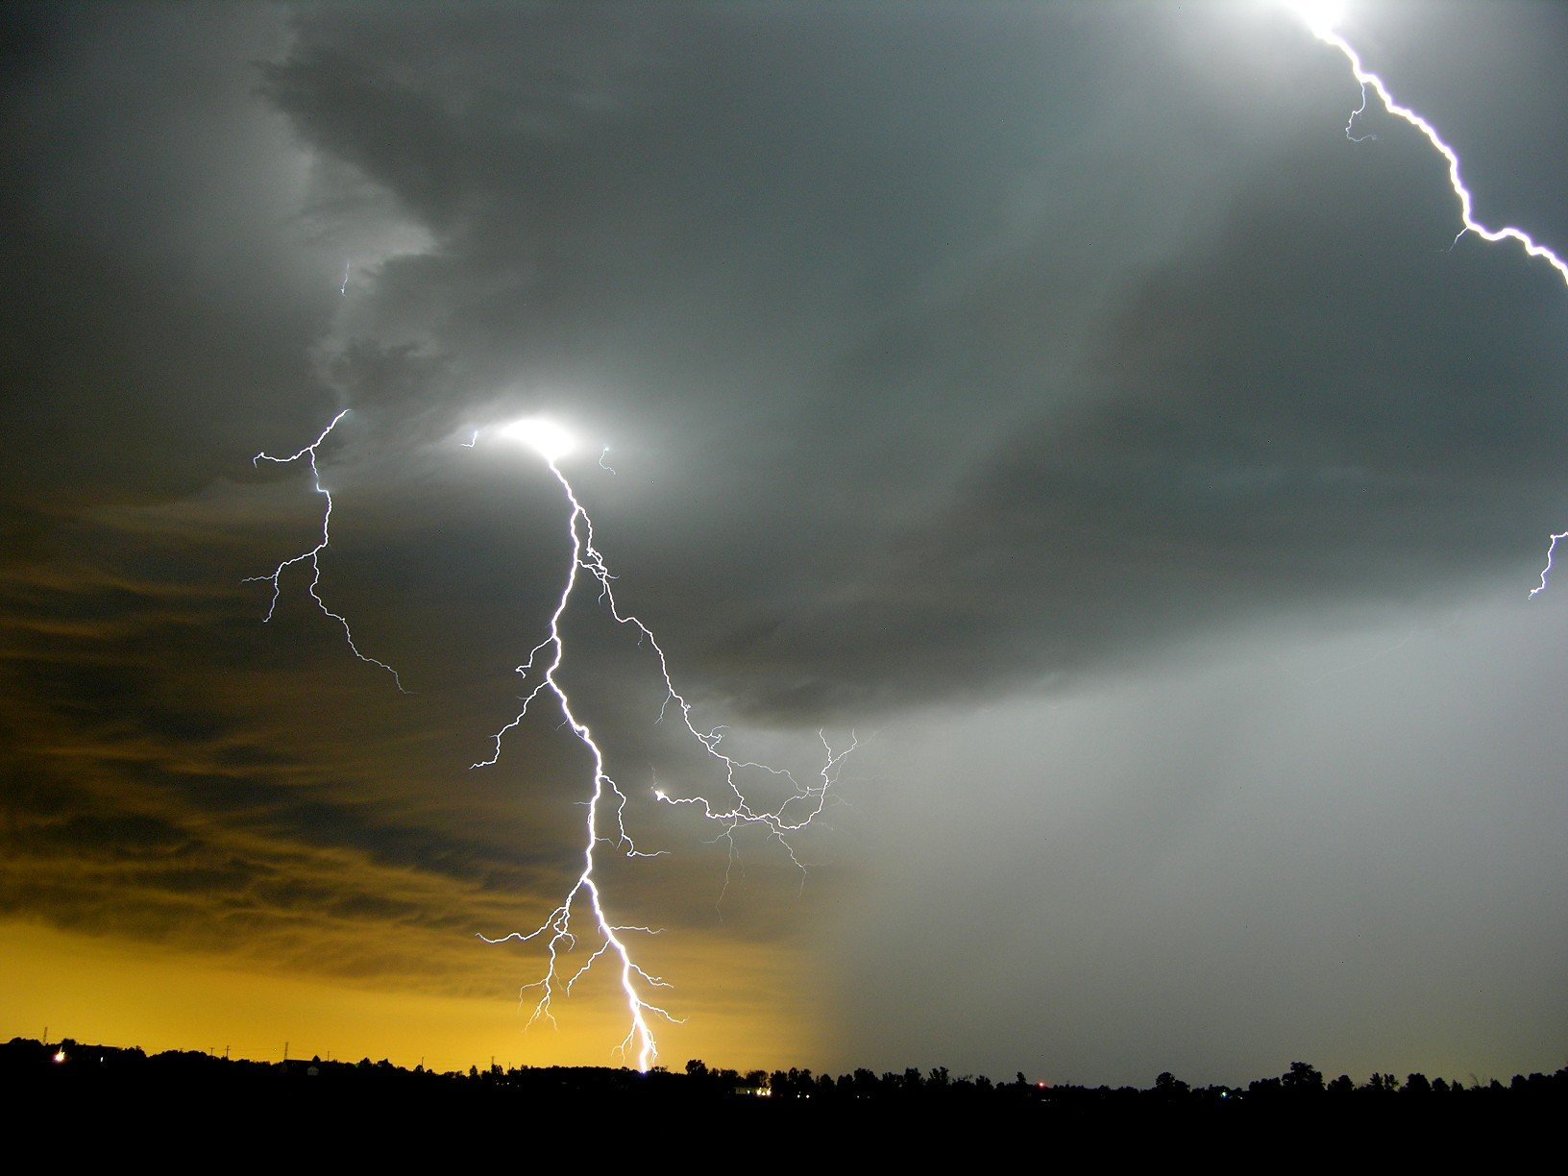

LIGHTNING

What is it?
On a hot day, clouds build up in the sky. They grow larger, towering higher and higher. They darken. As clouds develop, water droplets freeze and collide causing the clouds to become charged with electricity. When the charge breaks down the insulating layer of air under the cloud, it connects with the opposite charge from the ground and the result is lightning.

How will you know it is coming?
Lightning hits the highest objects, such as a tall tree, a tall house, or a person standing alone in a field. Plan ahead for outings by watching your local television news, listen to the radio, check www.weather.gov, and purchase a NOAA Weather Radio. If thunderstorms are in the forecast, reschedule any outing or outside activity that requires you to be far away from a sturdy building or car.

Safety Tips
- When Thunder Roars, Go Indoors! - Get into a sturdy building (one with four walls, a roof, electricity, and plumbing) or hard-topped car immediately. Stay inside until 30 minutes after the last thunder clap
- If you are in water, get out. Get away from the beach and off a boat
- Before you go backpacking, know the weather patterns of the area so you can plan your hikes around severe weather. Check the weather forecast before you go, and carry a portable NOAA Weather Radio so you can receive severe weather warnings
- Do not place your campsite in an open field or on top of a hill or ridge
- If you are in the backcountry and cannot get to safe shelter, stay away from tall, isolated objects like trees. Do not seek shelter in a shallow cave. Stay away from metal objects such as fences, poles and backpacks
- If you are in a forest, and there is not an acceptable building or car nearby, then stay in a lower stand of trees

