Dangerous Weather Condition & Safety Tips
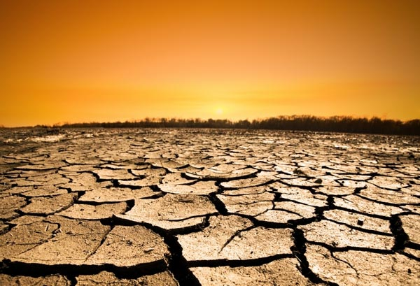
5 of 6

EXTREME HEAT

What is it?
Heat is the number one weather related killer in the U.S. When the temperature and humidity climb to dangerous levels, people have a hard time keeping themselves cool. If the body temperature gets too high, your body begins to shut down. Serious illness or even death can result.

How will you know it is coming?
Watch your local television and listen to radio newscasts, check www.weather.gov, and listen to a NOAA Weather Radio.

Safety Tips
- Slow down and take frequent breaks in the shade or air conditioning.
- Wear lightweight, light-colored clothing to reflect heat and sunlight.
- Drink plenty of water or other non-alcohol or decaffeinated fluids.
- Eat less. (Foods, like meat and other proteins that increase metabolic heat production also increase water loss.)
- Don't get too much sun. (Sunburn reduced your body's ability to dissipate heat.)

